The Repeater | 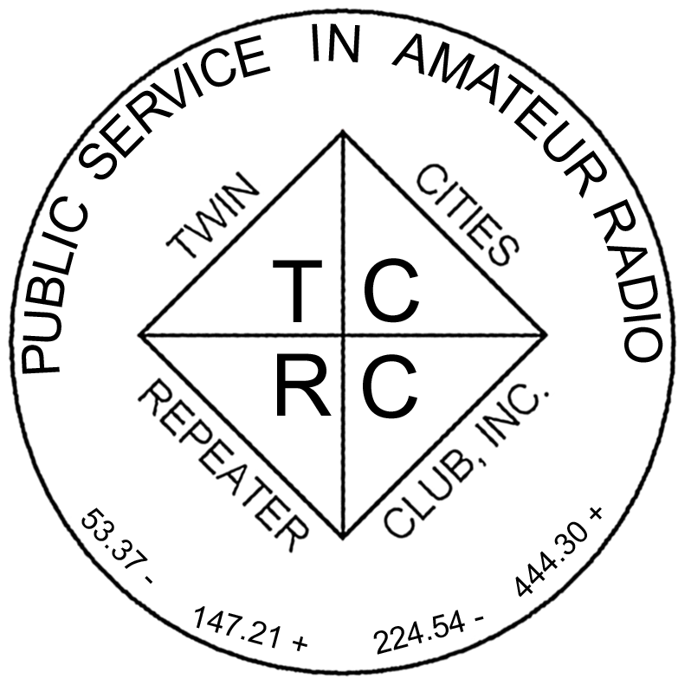
The Official Publication of the Twin Cities Repeater Club, Inc.

Mission Statement of the Twin Cities Repeater Club, as Adopted on September 20, 1993
The purpose of the TCRC is to facilitate the local communication needs of its members by owning and operating a state of the art wide area coverage two meter repeater system. The club will further involve itself in secondary activities intended to (1) promote the exchange of ideas and information related to amateur radio, (2) strengthen the fellowship and camaraderie among the members, (3) serve the local amateur radio community, and (4) increase local public safety.

Spring 2012
Volume 35, Number 1

Inside this issue

Mission Statement………………………1
President’s Letter………………………..1
Field Day, 2012………………………….2
MetroSkywarn Classes…………………2
TCRC Pet Project Day……….…………3
Musings on February 7…………………3
New Members………………….………..4
Roving Southern Minnesota……………4

Please Join Us
at the
Midwinter
Madness Hamfest
3/31/12 8:00 AM at Buffalo Civic Center

Talk-In on the 147.00 Repeater

Stop by the TCRC Club Table and See the Slide Show

PRESIDENT’S LETTER

Greetings and hello again to the TCRC group. We have had a very good year here at the TCRC. Some equipment was up and down as usual. We had our ups and downs; fun times and not so fun times.

We had a great field day. Good participation and we moved the stations to better utilize the CW station. The CW station utilized the communications truck lent us by Dale Morgan, KCØTCP. The Phone station used my camper, and the “Get On The Air” station was in the food tent. Several antennas were built and tried and some people brought their own rigs to try on these antennas. A good time was had by all with no thunderstorms, etc. We had some good times, alright. Next year we will be at a different location, however.

Later we had a mini-field day at the new field day site at Casperson Park in Lakeville. This was a club picnic with heavy overtones of Field Day. We had a shelter set up and some makeshift antennas. The grill was on, food was eaten, and even some DX was worked. Several new friends were met and some old friends joined up too. We had a mini Tail Gate Hamfest too. It was a lot of work to set up and tear down. We discovered that a canopy that has a peaked roof will act like a wing in just the right wind conditions. A gust made it lift right up and then let it down again, slightly bent but not too bad
.
Our tech committee was finding it more difficult to balance ham radio with work and family issues, and since this is a HOBBY first, it makes sense to train a new committee and get them up and running. With a heartfelt THANKYOU to the previous committee, I am looking for bigger and better things ahead. We now have some new folks along with a few grey beards, to learn and maintain the repeater systems and continue with the ambitious upgrade project started a few years ago. We made a pilgrimage to the main repeater site and did a lot of fall cleanup and site maintenance. We are still looking for more Tech committee members, so if you feel you would like to learn about repeater systems, with hands on experience, please let myself or other board members know of your interest.

Lastly, our Official Meeting was November 29th at the Burnsville City Hall Basement followed shortly afterwards by a video program recapping the year’s events. The current officers were re-elected.

So since the sun spot cycle is rising and 10 meters is open to Europe, again, I will say 73, de WBØJMG, Arthur C. (Artie) Johnson, President of the TCRC.

President of the TCRC.

The Repeater is published quarterly by the Twin Cities Repeater Club, Inc. (the TCRC). The TCRC is organized as a nonprofit corporation in the State of Minnesota, with Articles of Incorporation and Bylaws. The club elects officers annually. These officers are simultaneously elected for a two-year term on the Board of Directors. The Repeater Trustee is a permanent member of the Board of Directors. Unlike the other Officers and Board Members, the Trustee may select a proxy to serve in his place at meetings of the Board. Membership in the TCRC is $25 per year. The TCRC is an official ARRL affiliated society.
TCRC Officers:
President: Artie Johnson, WBØJMG
Vice President: Dave Ventura, KEØNA
Secretary: Tanna Morse, KCØURO
Treasurer: Craig Larsen, KCØDMF
Board Members:
All of the above Officers, plus…
Chris Buck, WØHO, Club Trustee
Appointed: Phil Lefever, KBØNES
Appointed: Ken Lewis, K3FMK
Appointed: Jeff Goodnuff, WØKF
Appointed: Rod Freeborg, KC9HT
Technical Committee (a/k/a Tech Team):
Kevin Uhlir, NØBEL, Chair
Phil Lefever, KBØNES, Vice Chair
Doug LaBore, NØBIS
Rich Kenney, WØRFK
John Toscano, WØJT
Jeff Goodnuff, WØKF
Art Johnson, WBØJMG
Field Day Committee:
Tanna Morse, KCØURO, Chair
Open, Vice-Chair
Kevin Uhlir, NØBEL, Site Setup Manager
Open, FØOD Station Manager
Information Services Committee:
Kevin Uhlir, NØBEL, Chair and Head Webmaster
Phil Lefever, KBØNES, Assistant Webmaster
John Toscano, WØJT, Assistant Webmaster
Jeff Goodnuff, WØKF, Web Calendar Maintainer
Membership Committee:
Craig Larsen, KCØDMF, Chair
Tanna Morse, KCØURO, member
Dave Ventura, KEØNA, member
Newsletter Committee:
John Toscano, WØJT, Editor

Net Control Operators:
Chair: Jeff Goodnuff, WØKF
1st Tuesday: Jeff Goodnuff, WØKF
2nd Tuesday Rod Freeborg, KC9HT
3rd Tuesday: Artie Johnson, WBØJMG
4th Tuesday: Phil Lefever, KBØNES
5th Tuesday Open

Metro Skywarn Liaison:
Jeff Goodnuff, WØKF

Minnesota Repeater Council Liaison:
Chris Buck, WØHO

Emergency Services Coordinator:
Janet Skovran, KBØZFB

TCRC Club Trustee:
Chris Buck, WØHO
ARRL FIELD DAY 2012
By Tanna Morse, KCØURO
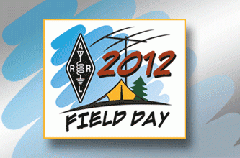
It is nearly time to begin gearing up for the 2012 ARRL Field Day weekend, taking place June 23-24. In previous years the Twin Cities Repeater Club has set up operations in fields and parks around the south metro area. For 2012 we are scouting a new location and hope to secure a site within or immediately surrounding the city of Burnsville where our club is based. Your fellow amateur radio operators from the Twin Cities Repeater Club, along with thousands of other hams across the United States and Canada, anticipate a weekend of fun while scoring contacts and enjoying the camaraderie of our members, families and friends.

Join us for this “family reunion” of amateur radio operators. Plan to bring your family and friends to our potluck picnic supper on Saturday, June 23rd, operate a station with your friends and fellow club members and relish the excitement generated when new contacts are made at our “Get on the Air” station.

Watch the Twin Cities Repeater club website for information about planning and informational meetings, beginning at the end of April, and for our new location. Come join the party!
● ● ●
TCRC Sponsored Skywarn Classes

This year, as has been our policy in the past, the TCRC is sponsoring two Skywarn spotter training classes. The first class was conducted on March 3, 2012 at the Open Circle Church in Burnsville and was attended by 47 future spotters. The last class will be on May 19, 2012 at the same location and will start at 9:00 AM. The class is free and no reservation is required. Other MetroSkywarn training classes are listed on www.metroskywarn.org/cgi-bin/classes.pl. Remember spotters are required to retrain every other year. For further information call Jeff, WØKF, at 952-927-0201.

TCRC Pet Project Day
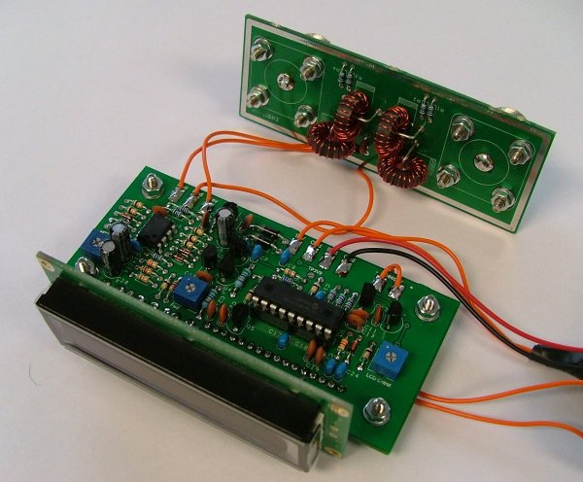
So….you’ve been meaning to work on that antenna, electronic keyer, SWR bridge, power supply unit…but you just haven’t had the time to devote to your project. Plan to tote that project to the TCRC’s “Project Saturday” on the afternoon of March 24th. Commiserate with your friends and make headway on your homebrewed design; take a break if you’d like to join your fellow club members for the CQ Worldwide WPX SSB contest that same weekend.

Carry, push or hoist your project to Craig’s home (KCØDMF) at 8149 Curtis Lane, Eden Prairie, MN. Please, BYOT (bring your own tools). Your fellow club members will be there from noon until four p.m. We will make headway on our pet projects while participating in or listening to the contest. Snacks will be provided.

If you have questions or would like directions please contact Craig at (952) 373-1454.
● ● ●
February 7, 2012
By Artie Johnson, WBØJMG

Will this winter never end (It tried to start a few times, but just couldn’t get going.)

As I sit here in Caribou coffee, with each of us here doing something with a small electronic instrument, my thoughts start to flow from idea to idea as I ponder how Ham Radio relates to modern technology. It seems less and less relevant. Here is an excerpt of my so-called mind:
When I started with the hobby, having a piece of gear that would talk across the country and the world was really cool. Having a walkie talkie that could let you talk across the twin cities area from the little (rather large and heavy by today’s standards) radio in your hand. Now you can do that from your cell phone and talk to anyone in the world. Of course, you have to have the number. You could, I suppose, dial a random number and see if they would talk with you.

Ham radio has always had a basic contradiction. On the one hand, it is designed to train operators and train people in the technology of radio and TO ADVANCE THE RADIO ART AND SCIENCE. On the other hand, it is set up and licensed by government agencies who are, of course, suspicious of anything they don’t understand. So they can’t have it get too far ahead. This is why there is a prohibition of the use of codes and ciphers in Ham radio. (read spys) For many years, one had to ID in CW or another standard mode that is in the clear when using RTTY, TV, etc. One could not have 2 hams create their own mode and experiment with it.

A digital mode is also a cipher because it cannot be decoded unless someone has the way to decipher (convert) the digital information back to letters or sound. Even non encrypted text is just so many zeros and ones. Now we have a couple of digital modes D-star and the one Yaesu/Motorola is promoting that uses a variant of the public service digital system. These are not designed for weak signal work.

These digital systems are made to perform very well for strong signals. As the signal level decreases the data is increasingly being corrupted. At a 1 percent bit error rate, the audio just shuts off. There is no attempt to present the noisy signal. FM will continue to be useful at these signal levels down to another 12 dB or so. The human ear can pick out audio in a great deal of noise. These commercial systems are made to give superior audio performance and fidelity, but not for low level signals.

Perhaps this is just a rant from a gray beard, but it just seems to me that radio has become so commonplace as to be taken for granted. Even sitting here, I am connected to the world wide web via WiFi in the local coffee shop. My mouse pointing device is connected to the computer by an RF link. Almost everyone else here is on a cell phone or computer wirelessly connected to the ether. Everywhere people are seemingly talking to themselves until you notice the Bluetooth device in their ear. RF is everywhere, but not on Ham Radio. Where are the hams?

Why do most new hams not get on the air? Perhaps it is a lack of mentoring of new hams. I personally know about 5 persons with call letters that maybe used them once, if that. What’s with that? Is it the cost of new equipment? Is it the economy? Is it that when they do get on the newbie accent keeps people from talking to them? I don’t know. Perhaps it is a combination of all the above factors. What if, when they get their license, they start to make a new circle of friends to talk to? How do you get the new folks on the air? Ideas?
● ● ●
Welcome, New Members!

The following folks have joined the ranks of the Twin Cities Repeater Club since 2011. Please welcome them the next time you hear them on one of our repeaters! We thank them for their willingness to participate in the club.

KØSXR | Max | Van Riper
NØFAU | Bryan | Appel
WAØDUN | Howard | Helberg
NØLZB | Brian | Soderlund
KDØOJE | Robb | Morin
NØDSH | Franklin | Haugen
WØRNR | Jeff | Worner
KDØPON | Gary | Sorenson
W9QED | Christopher | Nelson
WØZL | Chris | Arneson
KDØPDG | Joseph | Skinner
KØHAQ | Dewey | White
ACØWR | Steve | Aldridge
KDØOXG | Michael | Wyatt
KDØOVU | Bruce | Campbell
WØQEI | James “Charlie" | Anderson
KC7FYS | Jonathan | Haynes
KA5NHU | Lee | Durrwachter
KCØLZA | Jim | Hall
Experiences Of A Second Year Contest Rover
By Craig Larsen, KCØDMF
Last February I participated in the Minnesota QSO Party as a rover for the second time. It proved to be an amazing experience.
Purpose
The Minnesota QSO Party is an annual contest the purpose of which is to invite all operators to work as many Minnesota stations as possible. The secondary challenge is to work all 87 Minnesota counties during the contest. In order for this to happen, some operators have to drive to those counties and put them on the air (activate them). This year our team was one of 17 teams that operated the contest as a mobile operator (rover).
Preparation
I had two friends with me on this year: Frank Baldwin, NØSFF and Kevin Jankowski, NØXWJ. Initially we planned to use the same route as last year. We focused on low population counties that had few rovers visiting them. The thought was that we would be activating rare counties and it would be more exciting for us since other operators would want to contact those rare counties and we would be their only chance.
Frank and Kevin have experience going mobile for R/C glider contests and this proved invaluable to us. Some of the preparations they learned could be used for our mobile operation for the contest. I had Minnesota maps that showed county borders, so we photocopied these maps onto 8.5x11" sheets of paper, numbered the sheets and highlighted the intended route, making it easy for the driver. We also created a sheet listing the counties we would be visiting. Next to each county was listed the time we expected to arrive, the county's abbreviation and its phonetics. This made it easy for the operator and gave both operator and driver a way of seeing if we were on schedule. We also had a sheet with the patter we would use in the contest. Included in the patter was a statement we would occasionally say to encourage the operator to contact us again, to view my QRZ.com page for information about the contest and how to track us on APRS. This was just for the logistics. We also had preparation for radios, antennas, and laptops (along with backups in case of related failures). Overall, I'd say we were well prepared for the contest.
Route
Friday night before the contest we headed to Fergus Falls and stayed in a hotel. This gave us plenty of time to relax and prepare for the 8am start Saturday morning. When Saturday morning arrived we got up early, loaded the car, had breakfast, and headed west while doing a final shake-down of the equipment. From Fergus Falls we headed west to the Minnesota border and then south until we reached the southern border of the state. From there we went east zigzagging across the southern most counties in Minnesota. Initially we planned to reach 17 counties, however, because we had a third person, the two not on the radio worked on route alternatives in order to pick up more counties. We thus increased the counties activated from 17 to 24. It only added to the fun.
Reflection
The contest for me was a huge success! In the 10 hours of the contest, we traveled roughly 600 miles (not including the 200 miles to Fergus Falls). We doubled our score from last year and almost doubled the number of QSOs making 515 total. Both of these are new personal bests! One of the highlights for me was near the end of the contest when I made an unexpected contact with Venezuela! That was really cool.
Final
Overall, I had a great time. I get no credit for working a "Minnesota Winter" which was one of the warmest winters we've seen. But I did get the experience, for which I am grateful. Thanks to Pat Cain, KØPC and Jon Platt, WØZQ who got me started in this fun time-sink of a contest. Special thanks go out to Frank and Kevin, who made this an amazing team! Here's to many more!
If you are interested in pursuing something like a contest or some special event then I encourage you to get involved. You are also welcome to contact me at KC0DMF@tcrc.org. I'd be happy to share in the excitement.
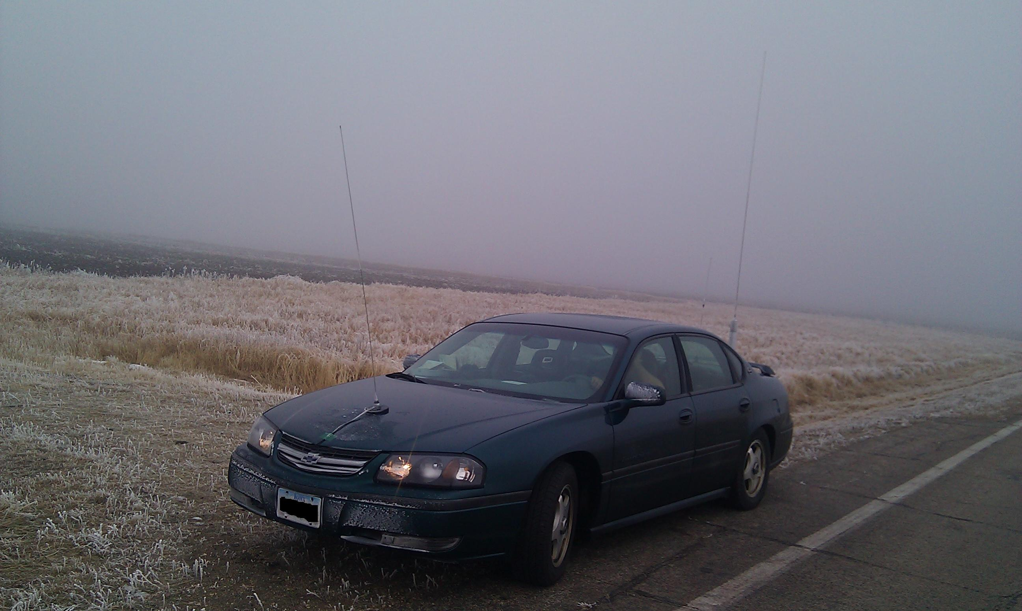

KCØDMF Rover in Southern Minnesota

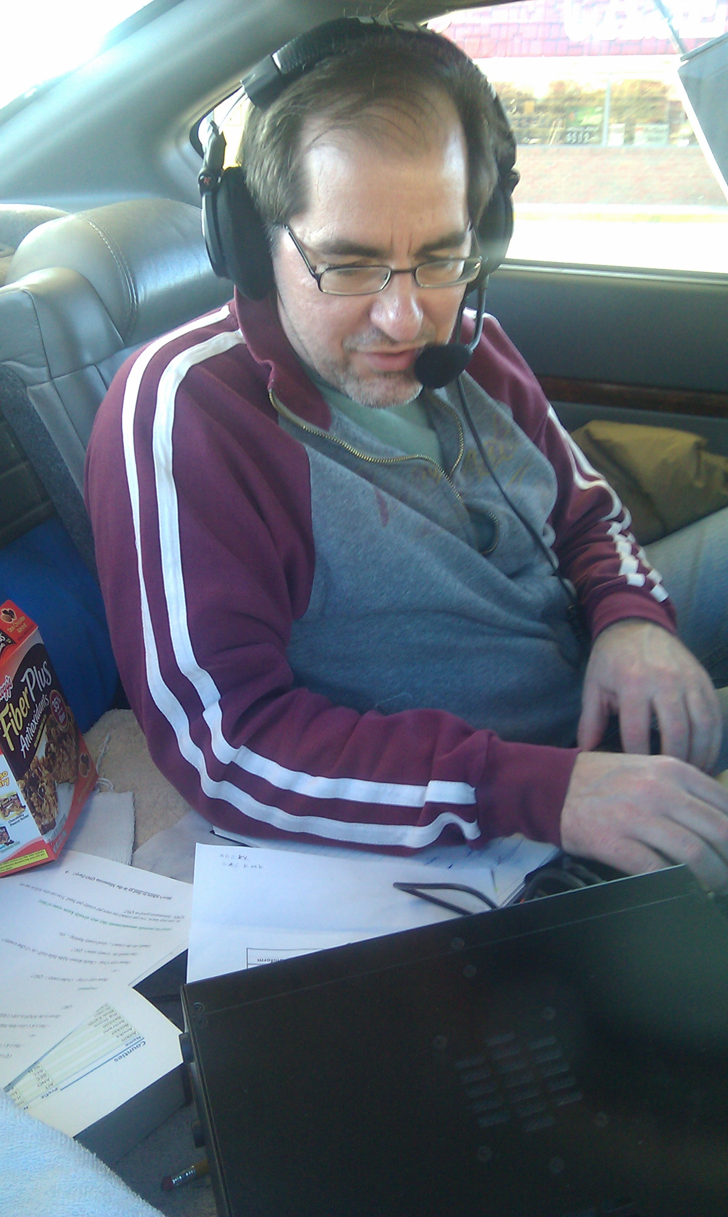

The author hard at work in the operating position of the rover

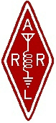 | Twin Cities Repeater Club, Inc.  P.O. Box 11534  St. Paul, MN 55111-0534 |  | Place  Stamp  Here

Your Membership Dues Have Expired.
Please Renew your Membership Today!

Join the Twin Cities Repeater Club!
P.O. Box 11534, St. Paul, MN 55111-0534
http://www.tcrc.org
There are two ways to register:
- Return this completed application form (to the mailing address indicated above) along with your $25 check payable to: Twin Cities Repeater Club
OR
- You can fill out this form electronically (at the web address indicated above) and pay online using PayPal.

(Please check one) This is ___New Application ___Renewal ___ Change Date _____________________
Name Callsign
Address License Class
City State Zip
Home Phone Work Phone Cell Phone
E-mail Address
Please note: For your privacy, an e-mail alias will be set up using yourcallsign@tcrc.org. E-mails sent to this alias will be redirected to the e-mail address you indicated above.
May we list your address in club publications? ___Yes ___No
May we list your phone in club publications? ___Yes ___No
Are you available for Emergency Service? ___Yes ___No
Are you a member of the ARRL? ___Yes ___No
Are you a member of Metro Skywarn? ___Yes ___No; (if Yes) spotter ID:
Are you a member of ARES? ___Yes ___No
Would you like a club ID badge? ___Yes ___No (free to new members, otherwise $5.00)

