The Repeater | 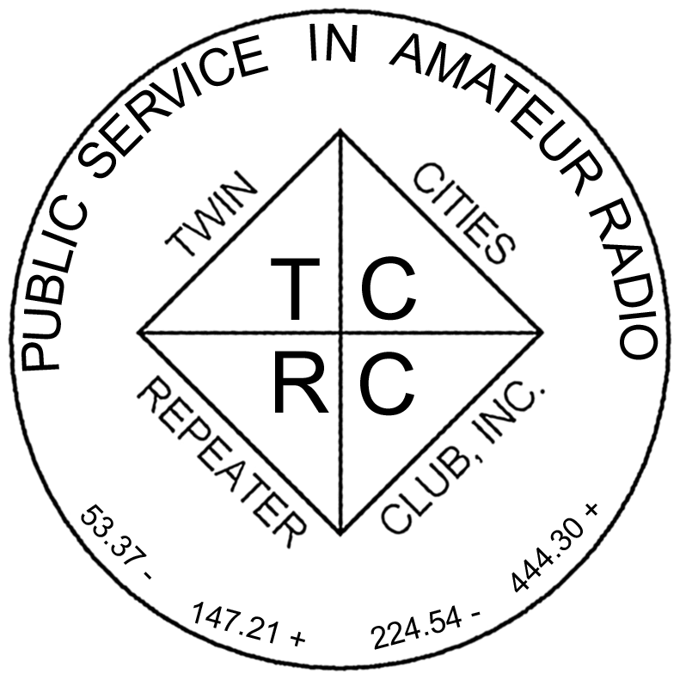
The Official Publication of the Twin Cities Repeater Club, Inc.

Mission Statement of the Twin Cities Repeater Club, as Adopted on September 20, 1993
The purpose of the TCRC is to facilitate the local communication needs of its members by owning and operating a state of the art wide area coverage two meter repeater system. The club will further involve itself in secondary activities intended to (1) promote the exchange of ideas and information related to amateur radio, (2) strengthen the fellowship and camaraderie among the members, (3) serve the local amateur radio community, and (4) increase local public safety.

Spring 2011
Volume 34, Number 1

Inside this issue

Mission Statement 1
President’s Letter 1
Midwinter Madness 1
The Thrill of Radio Communications 2
Skywarn Training Class 4
Important Message from ARRL 4
My First MNQP Contest 5
Facebook Tutorial 6
Membership Application 12

Please Join Us
at the
Midwinter
Madness Hamfest
3/26/11 8:00 AM at Buffalo Civic Center

Talk-In on the 147.00 Repeater

Stop by the TCRC Club Table and See the Slide Show
PRESIDENT’S LETTER

Years ago, when I first heard of being able to use electromagnetic fields to communicate, I would grab my magnet and battery and go out into the corn field and shout CQ CQ CQ with little effect. Later, I heard about actually using a radio for this and my results were greatly improved.
Actually, I had vaguely heard of something called amateur radio when I was in grade school. I met some hams at the state fair but did not really get much information from them. My father had a contact, so I phoned him and talked with him, but we were not able to get together. Hams back then were a solitary lot who usually only used CW or AM on HF bands and the few on VHF all knew each other after a few days on the air. A newcomer really could not comprehend ham radio. If your parents or relatives were not hams you did not hear much of the culture of ham radio or the wonderful world it contained. I liked electronics, built lots of gizmos, and learned more than most of my teachers or parents knew about radio. I got a set of walkie-talkies and my brother and I would try to work DX from one end of the block to the other. “Can you hear me now?” and that was about it.
As time progressed I learned more about ham radio, but we moved to the Iron Range and out of the Twin Cities. This turned out to be fortuitous because the local hams in town could be identified by their antennas, and in a town of 2500 they all knew each other. It did not hurt that everybody (nearly) worked for the Mining Company. Thus it was pretty easy for a kid to find where the Hams were and learn about antennas. Soon I met some of the local hams and learned that even some of my classmates’ fathers were hams.
I learned code by walking to school and repeating “dah dit dah dah, Y…Dah dit dah dah, Y” I was a pretty weird kid at that time, talking to myself with nonsense phases as I walked to school. A classmate and I both got interested in it and, with a key, a little oscillator made from a CB crystal, and a borrowed Drake 2B receiver, I learned CW on a local net. A town you could literally see across was simple enough for this. In a month or so, I had the code down. A fellow in a neighboring town, (father of a classmate, and later, it turns out, brother to the priest that performed my marriage) gave me the Novice test. I borrowed a transmitter and made an antenna. On key down, I wiped out all TV in the entire block! Just front-end overload from fringe TV reception. I could only transmit late at night when the TV stations went off the air. I made just a few contacts as a Novice. There is much more to the saga, but not at this time. (continued on page 2)

The Repeater is published quarterly by the Twin Cities Repeater Club, Inc. (the TCRC). The TCRC is organized as a nonprofit corporation in the State of Minnesota, with Articles of Incorporation and Bylaws. The club elects officers annually. These officers are simultaneously elected for a two-year term on the Board of Directors. The Repeater Trustee is a permanent member of the Board of Directors. Unlike the other Officers and Board Members, the Trustee may select a proxy to serve in his place at meetings of the Board. Membership in the TCRC is $25 per year. The TCRC is an official ARRL affiliated society.
TCRC Officers:
President: Artie Johnson, WBØJMG
Vice President: Dave Ventura, KEØNA
Secretary: Tanna Morse, KCØURO
Treasurer: Craig Larsen, KCØDMF
Board Members:
All of the above Officers, plus…
Chris Buck, WØHO, Club Trustee
Past VicePresident: Phil Lefever, KBØNES
Appointed: Ken Lewis, K3FMK
Appointed: Jeff Goodnuff, WØKF
Appointed: Rod Freeborg, KC9HT
Technical Committee (a/k/a Tech Team):
Kevin Uhlir, NØBEL, Chair
Phil Lefever, KBØNES, Vice Chair
Doug LaBore, NØBIS
Rich Kenney, WØRFK
John Toscano, WØJT
Jeff Goodnuff, WØKF
Art Johnson, WBØJMG
Field Day Committee:
Tanna Morse, KCØURO, Chair
Open, Vice-Chair
Kevin Uhlir, NØBEL, Site Setup Manager
Open, FØOD Station Manager
Information Services Committee:
Kevin Uhlir, NØBEL, Chair and Head Webmaster
Phil Lefever, KBØNES, Assistant Webmaster
John Toscano, WØJT, Assistant Webmaster
Jeff Goodnuff, WØKF, Web Calendar Maintainer
Membership Committee:
Craig Larsen, KCØDMF, Chair
Tanna Morse, KCØURO, member
Dave Ventura, KEØNA, member
Newsletter Committee:
John Toscano, WØJT, Editor

Net Control Operators:
Chair: Larry Jenkins, KØLEJ
1st Tuesday: Jeff Goodnuff, WØKF
2nd Tuesday Mark Newman, KCØITP
3rd Tuesday: Artie Johnson, WBØJMG
4th Tuesday: Phil Lefever, KBØNES
5th Tuesday John Toscano, WØJT

Metro Skywarn Liaison:
Jeff Goodnuff, WØKF

Minnesota Repeater Council Liaison:
Chris Buck, WØHO

Emergency Services Coordinator:
Janet Skovran, KBØZFB

TCRC Club Trustee:
Chris Buck, WØHO
President’s Letter Cont’d
The Mesabi Wireless Club was a local club located in the eastern Iron range area and had started and stopped several times in the 40s, 50s and 60s. A group of people got interested in putting up a 2 meter repeater and that became a meeting place and financial source for maintaining the repeater. The club thrived because of the contacts people could make and keep. In the pre-repeater days, the group had a 75m net but not everybody had 75 meters. Repeaters are not the key to amateur radio. Rather, sociability is. Technology is fun and a means to an end. The end is being social and connected to others. Relating to others is the key.
So, don’t just stand in your field and shout, get on the radio and become outstanding in your field.
73,
Artie, WBØJMG
TCRC President and Chief Cheerleader
• • •

THE THRILL OF RADIO COMMUNICATIONS
by Ken, K3FMK
My first experience with ham radio came upon my discovery that a neighbor of ours back east, who also repaired our TV, had a ham shack in his split level home. While playing with his kids, we went in and I saw the radios in his shack. It hit the curiosity button in my mind so, when I got into high school and I was on the stage crew, the guy who was head of the stage crew talked about the QSO’s he would make. His car had a two meter rig under the dashboard and a three-ring halo antenna on the rear bumper.

Several of us decided to study for the tests. My best friend and his father studied for and passed the General Class license, passing the 13 WPM element at the FCC offices in Philadelphia, as did several other friends. Not having a receiver that would enable practice sessions, 5 WPM was my best. One of the friends who had passed the General Examination gave me the Novice Examination a month or two later and I passed it and received my Novice license, KN3FMK, which I proudly framed, but have since lost the paper copy.

One weekend we went to the Franklin Institute in Philadelphia for a seminar and were shown the shack in that part of the science museum where electronics was featured. The seminar put on by that club had us assembling a low cost voltmeter, which we would end up completing on our own because of the time limitations. I remember being awestruck at seeing the rig that they used. It was a Collins KWM-2, complete with a dual trace oscilloscope at the side and a Vibroplex Iambic keyer. We were in heaven!
(continued on page 3)

Field Day is coming!!
By Mark Neuman (KCØITP)

Some time after we got home, my best friend and his father put together an excellent shack of their own, complete with a Collins 75-S1 and a 32-S1, a Vibroplex iambic keyer, a Tektronix dual trace oscilloscope. They also had a Model 19 RTTY that they were rejuvenating. His dad was winding the coils for it and when it was ready, we could receive pictures that other hams would create using the characters on the keyboard.

Because I had no short wave receiver where I could practice the code, and had some problems understanding the Technician Class license material, I let my license expire. But the radio bug had bitten me and when I went into the Navy, my choice of service schools led me to Avionics Fundamentals A School. I was told it was in Memphis, Tennessee. It wasn’t until I arrived in Memphis, that they had me take a taxi to Millington, Tennessee, about an hour’s drive east of the airport, on their nickel, of course. The crash course in avionics was supposed to last 16 weeks, but I crashed the crash course after only 10 weeks, thanks largely to my ham license and the electronics circuit experimentation and simple construction I had done on my own.

When I was stationed out here at what was N. A. S. Twin Cities, I discovered another guy in the Intermediate Maintenance shop also had a General Class license. This piqued my interest, but an accident ended up getting me medically retired from the Navy and my interest in ham radio sat on the back burner for a few more years.

When we moved to Burnsville and we were living almost a mile west of I-35W, somehow this ham radio club surfaced. It was the TCRC and they were meeting Saturday mornings for breakfast at a restaurant called Benjamin’s. After coming to several breakfasts, the interest in ham radio was reawakened, but I was not sure I could pass the tests because of memory problems from the accident that got me out of the Navy. One member would prod me now and then with the statement that he didn’t believe I would get my license back. It was almost enough to urge me to prove him wrong. But it wasn’t until I found out that Stillwater Amateur Radio Association was offering a class for the Technician Class license, a number of years later, that I finally got the urge to, as Larry the Cable Guy says, “Git it on!” (Editor’s note: I think he means “Git er done!”)

The trek to Stillwater was 45 miles one way, but for ten weeks I would anxiously drive in anticipation of passing the test. Various members of the club taught different aspects of the test and although we were a small group, they would make it worth our effort. The classes were never boring and when the tests were finally given, I don’t remember anyone failing! As a matter of fact, I even took the General Class license examination that evening and missed passing by only two questions. The more advanced material in the General examination came a lot easier I believe because of the Navy’s A school.

I was told that the Apple Valley club was giving the General Class examination in about two weeks, so I was determined to take and pass that test, which I did! My next hurdle was be the Amateur Extra license, but I thought I would need several years of “on the air” experience and more training.

Four of us from SARA formed our own class and agreed that we would “teach the other three” in areas of the Extra Class license material where we felt comfortable in our knowledge. This was from the previous question pool and I must admit that the class didn’t work out as well as I had hoped. At the end of the series of classes, three of my classmates took the test. I still lacked the confidence that I could pass so I had opted out. Of the other three, two managed to pass. I was still looking for a series of sessions taught by someone more knowledgeable in the field than I was, so I asked several club members from TCRC and SARA about classes, but was told that only the Technician Class license classes were offered in The Twin Cities area, so far as they knew. I confess it kind of cooled my spirit, especially since now I had what I originally thought was the top license I could ever get. I was wrong.

Within the very recent past, two friends have moved up from Advanced to Amateur Extra. After considering studying, again, I decided to borrow a best friend’s copy of Gordon West’s book and CD’s for the Amateur Extra Class license examination. The package was good and re-stimulated my interest. Some of the material was definitely implanted on my brain, but some was proving a bit more difficult. Dave, KE0NA, recommended that I just continue to take the practice exams and focus on the areas where my knowledge was weak, and so I did. It was frustrating when I could not remember some of the spots I had covered the day before, but after several repetitions, it started to sink in

I was determined that unless I could pass the practice exams with at least an 80% grade, continued practice exams would be a good teaching tool. At the Coffee QSO’s on Tuesday night, or the breakfast meetings on Saturday morning, I would take any questions I had written down on a sheet of paper and ask others for answers. This helped on numerous occasions and it lead to a decision to go to Gander Mountain on February 9, 2011, and give the exam a shot.

Nervously, I took the exam, leaving the questions blank for which I had no immediate answer and moving on. After answering question number 50, I returned the previously unanswered questions for reconsideration. Taking the test papers up to the VE’s present, I waited anxiously to see the score. I felt that I might just have passed and was very glad when they made that affirmation!

Now, I had no more tests to take, or so Jeff told me --- at first. But then he told me about the VE exam. As of this writing, I am in the process of taking that exam. I discovered it is an “open book” exam and both the book and the exam are downloaded from the ARRL website. After that, there will be no more examinations, unless I make the mistake of letting my license lapse like I did the Novice license. But now I have a motivation to keep my license active because I’ve been on the air for several years now and it’s fun doing the net and going to Field Day, among other things. The only way I will ever lose my license is when I become a Silent Key!
• • •
Skywarn Training Classes

On Saturday March 5, 32 students attended the TCRC sponsored MetroSkywarn Spotter class from 9:00AM until 1:00PM at the Open Circle Church, 2400 Highland Drive, Burnsville, Minnesota. Spotter re-certification is required every two years, so if you didn't take a class last year you must take one this year. A complete list of MetroSkywarn classes is available on the MetroSkywarn web-page:
http://www.metroskywarn.org/cgi-bin/classes.pl

Another (last one this year) class will be offered on Saturday, May 21 at the Open Circle Church from 9:00AM until 1:00PM. There is no cost to you. Reservations are not needed. Be there at 9:00AM sharp and bring a pencil.

If any questions arise do not hesitate to contact Jeff, WØKF at 952-927-0201.

• • •

Important Message

From Skip Jackson, KSØJ, ARRL SM

A serious threat has developed to the amateur radio privileges on 440 MHz. There has been legislation proposed to take this band away from amateur radio and reissue it for commercial purposes. Your action is required. Go to http://www.arrl.org/hr-601 for the complete story and what you can do to help educate our lawmakers about how important this band is for public service and how serious a mistake it would be to take it away. Please help the ARRL protect our frequencies.
• • •
My First MNQP Contest
by Craig, KCØDMF

I have always been interested in contesting but never done a mobile contest before. So in order to rectify this situation I decided to participate in the Minnesota QSO Party (MNQP) this year. I had a great time! This article will describe the thrills of doing my first mobile contest.
I won't go into the specifics of the MNQP or general amateur radio contesting, but suffice it to say, in this contest one could participate as a mobile operator by driving around activating as many counties as possible (editor’s note: also referred to as a “Rover”). There are several ways one can perform mobile operations in this contest. I chose to go with a friend to rotate the duties of driving and operating.
Pat, K0PC, was the person responsible for talking me into giving the MNQP a try. Unfortunately he already had a driver so I had to find someone else. I decided to ask my Iowa friend Frank, N0SFF, to team up with me. Frank and I have shared an enthusiasm for contesting and have even done a Field Day together so he was the natural choice. He gave an excited yes so I was committed to go through with it.
Part of the fun is always in the preparation that has to be done beforehand. Frank worked on hardware. The previous summer he had picked up an Elecraft K3, so this would become our mobile radio. He acquired filters for the radio and fixed up a nice 20 through 80 meter antenna with a tuning coil. The most impressive part was the killer trailer hitch mount for the antenna that he created to fit my car! It was very impressive! He used software to work out the specs and put in a tilt-back design to control the antenna height. With the welded metal plates, this puppy appeared to be built for hurricane force winds! Frank doesn't skimp on quality.
While Frank worked on hardware, I focused on logistics. One of my first tasks was to figure out which counties we would activate. Frank suggested that we should work some of the more rare counties as that would likely mean more people would try to contact us and we were up for that challenge! Putting together the route for these counties was a lot of fun. Not only did I want to focus on rare counties; I had to get them in comfortably within the contest's timeframe.
Another task was to get my car ready for the trip, however, this was more work than fun. My car needed a lot of repairs. The last thing you need in the middle of a contest is to break down. The APRS needed fixing and I needed to add a second power line from the car battery to the rear of the car for the K3 and the antenna coil. I even needed to buy new tires and wiper blades! Thankfully, it all came together.
The weekend before the contest was to begin; I drove down to Iowa to do a final shakedown of the entire system. Almost everything worked flawlessly, and with only a couple small changes, we were ready to go.
The Friday before the event Frank came up from Iowa, we got my vehicle ready and drove up to Fergus Falls. That evening we poured over maps and plotted out our route. I was a bit excited about the contest, not sure what to expect, yet I felt we were well prepared.
Our route took us from Breckenridge through the western-most counties southward
until we got to the southwest corner of Minnesota. Then the route zigzagged along the southern counties until we made it to St. James. This route was 422 miles or about 8 hours and covered 17 counties. It was a comfortable schedule with gaps for bio-breaks and gas stops.
Remember the "flawless" dry run the week before? It never works like that in the field, does it? When we had gone over the route the night before, I had used my laptop. This time I forgot the power cable so I had to run off of batteries. Not a big deal, I thought. We had an inverter in the car to charge the batteries and we had tested things the weekend before. So what could go wrong? However, during the dry run, I had used a fully charged battery. Thirty minutes into the contest I discovered that the
inverter was not charging the laptop. In a last ditch effort we picked up another inverter, which looked sadly like the one we already had. It didn't work either so we were forced to switch over to paper logs one hour into the contest. Using paper logs is a lot more work! Thankfully it was our only major setback.
By the end of the contest we had quite a following. It was great! We were getting requests for nearby counties, which we attempted to satisfy as best as we could. It was like we were family. One of our regulars was a mobile station from Hawaii on 20 meters. Very cool!
In review, this was an absolute blast! I thought we did pretty well hitting stations as far as Rhode Island, Florida, California, Hawaii and West Virginia. It was a lot of work and we accomplished so much. I'm thrilled we pulled it off. Next year I hope to do it again.


A new and improved TCRC fanpage…
Do you want up-to-the-minute information on the latest club and local ham radio happenings? Well you don’t need to belong to Facebook to be in the know. Just point your web browser to www.facebook.com/TCRC.hamradio and check out features and recent improvements made to this site.

Here is what you see first:
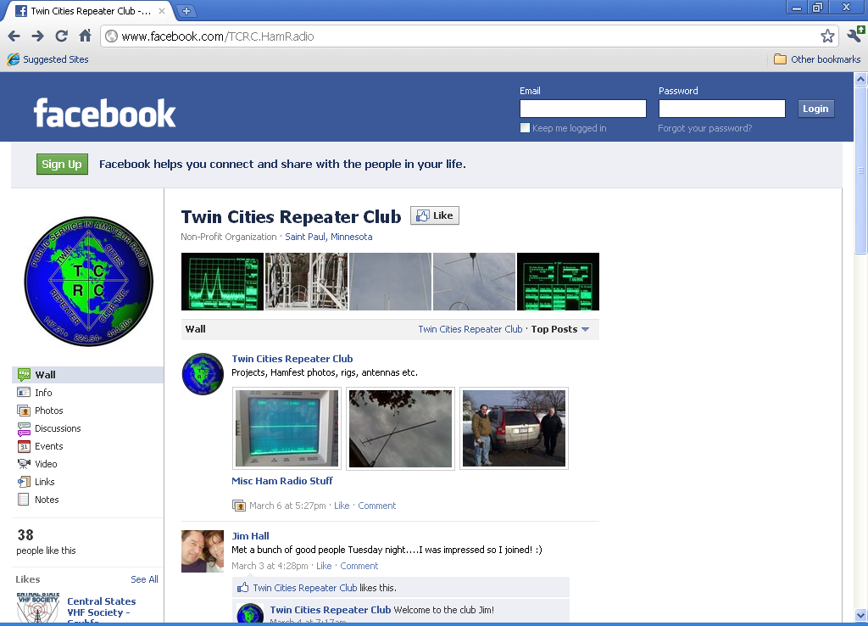

This home page is known as the “Wall” in facebook, recent postings and changes are summarized and displayed. Scroll up and down to view more.
Underneath the TCRC logo on the left side is a list of clickable links that will take you to different pages in order to view events, club photo albums, and even videos made by club members.

For example, do you want to know what club or local ham radio events are happening today, this week or next month?

Click on the “Events” link to see what’s coming up:
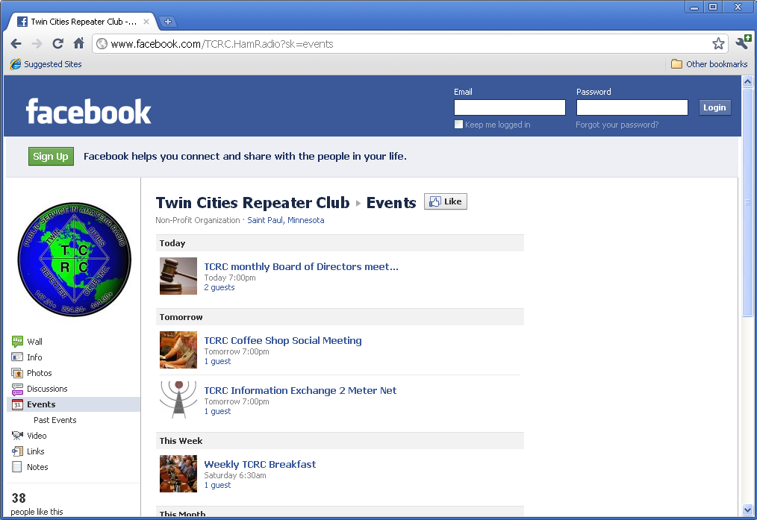

Want detailed information on an event, like the “TCRC Coffee Shop Social Meeting?” Click on the event name and you will be presented with this screen:
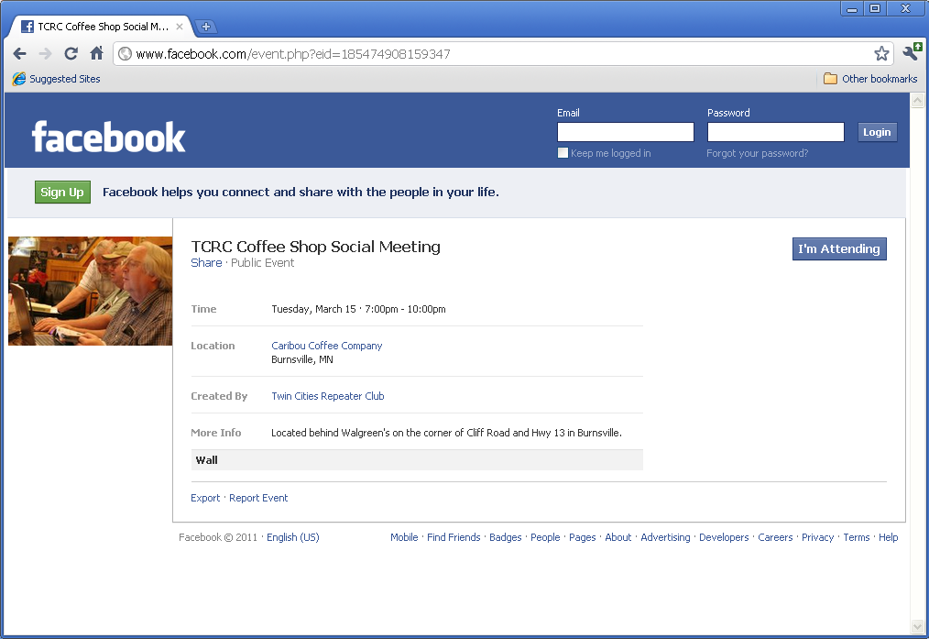

You can return to the home page (Wall) at any time by clicking on the “Twin Cities Repeater Club” link or click the back arrow on your browser.

Let’s check out the photo albums by clicking the “Photos” link on the home or “wall” page:
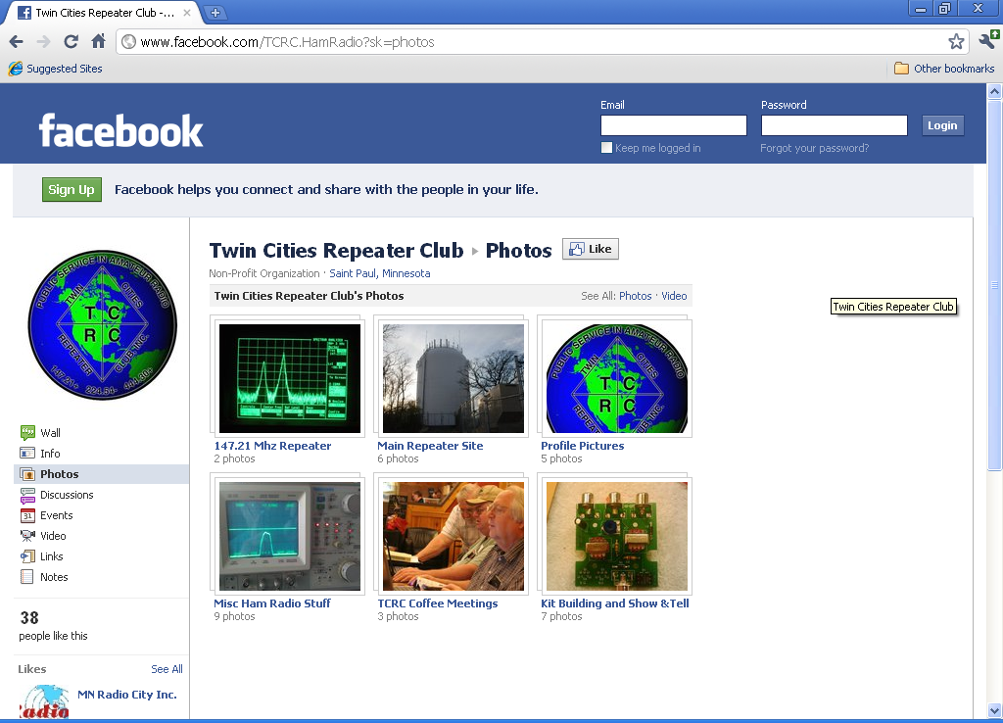

Pretty neat, huh?

Now let’s check out those photos of the main repeater site that Phil, NBØNES, just posted. Just click on the image or the link “Main Repeater Site” just below the picture:
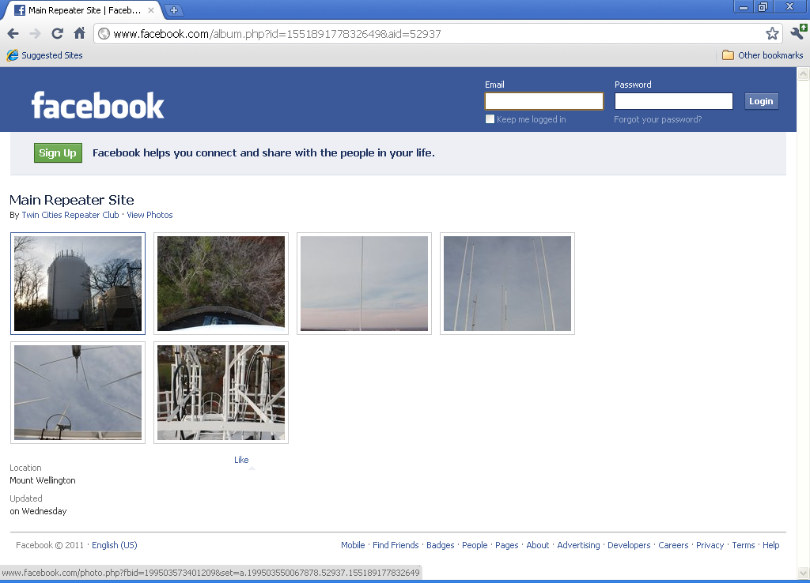

Now if you click on an individual image, you will get a large image along with a caption and comments made by club members:
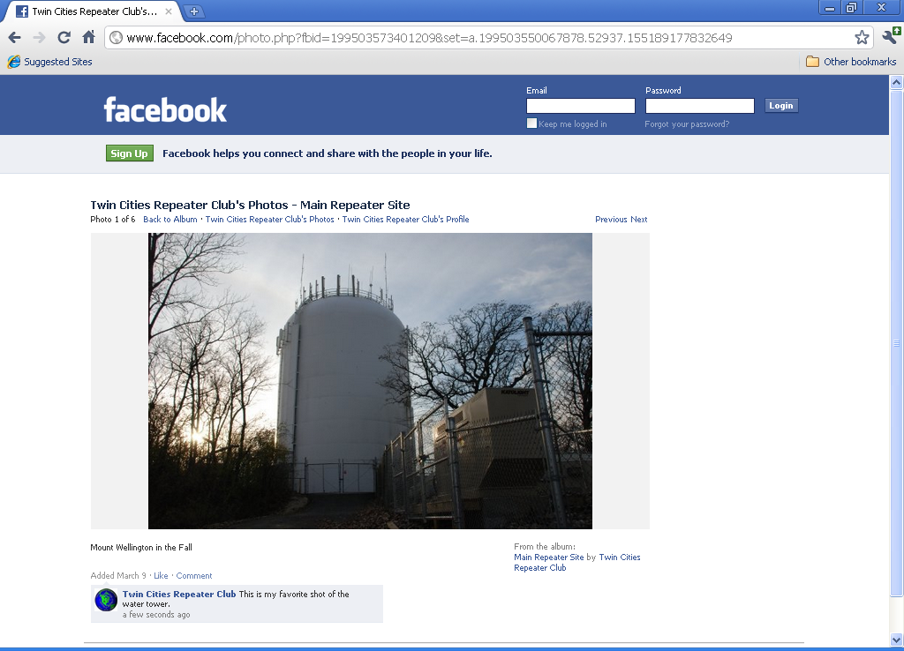

We hope you enjoyed this short tour of the site. Continue to explore other features of TCRC Facebook fanpage by clicking on remaining links and be sure to check out the field day videos.
Remember that you do not have to belong to facebook to view and enjoy the fanpage site.
If you have any suggestion for improvements, post them on the facebook fanpage (if you are a facebook member) or send them to my email at ke0na@tcrc.org.

Thanks and 73,
Dave, KEØNA

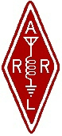 | Twin Cities Repeater Club, Inc.  P.O. Box 11534  St. Paul, MN 55111-0534 |  | Place  Stamp  Here

Your Membership Dues Have Expired.
Please Renew your Membership Today!

Join the Twin Cities Repeater Club!
P.O. Box 11534, St. Paul, MN 55111-0534
http://www.tcrc.org
There are two ways to register:
- Return this completed application form (to the mailing address indicated above) along with your $25 check payable to: Twin Cities Repeater Club
OR
- You can fill out this form electronically (at the web address indicated above) and pay online using PayPal.

(Please check one) This is ___New Application ___Renewal ___ Change Date _____________________
Name Callsign
Address License Class
City State Zip
Home Phone Work Phone Cell Phone
E-mail Address
Please note: For your privacy, an e-mail alias will be set up using yourcallsign@tcrc.org. E-mails sent to this alias will be redirected to the e-mail address you indicated above.
May we list your address in club publications? ___Yes ___No
May we list your phone in club publications? ___Yes ___No
Are you available for Emergency Service? ___Yes ___No
Are you a member of the ARRL? ___Yes ___No
Are you a member of Metro Skywarn? ___Yes ___No; (if Yes) spotter ID:
Are you a member of ARES? ___Yes ___No
Would you like a club ID badge? ___Yes ___No (free to new members, otherwise $5.00)

