The Repeater | 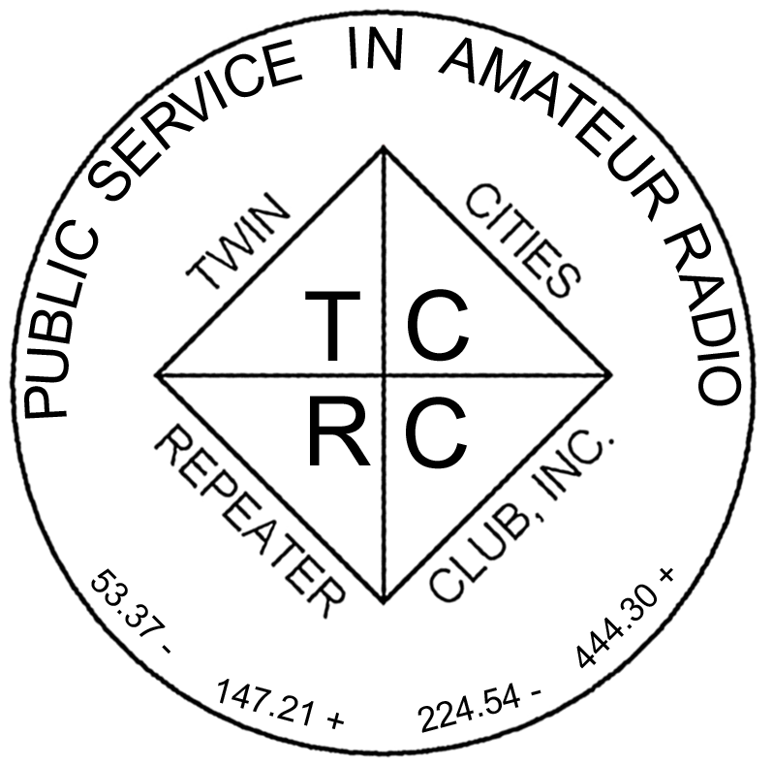
The Official Publication of the Twin Cities Repeater Club, Inc.

Mission Statement of the Twin Cities Repeater Club, as Adopted on September 20, 1993
The purpose of the TCRC is to facilitate the local communication needs of its members by owning and operating a state of the art wide area coverage two meter repeater system. The club will further involve itself in secondary activities intended to (1) promote the exchange of ideas and information related to amateur radio, (2) strengthen the fellowship and camaraderie among the members, (3) serve the local amateur radio community, and (4) increase local public safety.

Winter, 2010-2011
Volume 33, Number 2

Inside this issue

Mission Statement 1
Annual Meeting is Almost Here! 1
Note from Newsletter Editor 1
CQ DE WBØJMG 2
New Ham Radio Class 3
Social Networking & Ham Radio 3
Safety at Field Day 3
Accessory Odyssey 4
Terminating Tinned Ground Braid 6
Membership Application 10

Please Join Us
for the
Annual Membership Meeting
12/08/10 7:30 PM at Burnsville City Hall

Talk-In on the 147.21 Repeater

Abbreviated Net Starts at 7:00 PM
Annual Membership Meeting is Almost Here!

The annual (required) meeting of the TCRC will be held on Tuesday December 7th, at the Burnsville City Hall. We plan to begin the meeting at 7:30PM.

The agenda will include: the election of club officers (President, Vice-President, Secretary, Treasurer), one or more reports from the tech committee, and voting for the Arne Pung award, which is given annually to member for his or her service to the amateur radio community.

Dave, KEØNA, will give a short presentation and demonstration of WSPR (see the November issue of QST).

Please join us!

A Note from the Newsletter Editor

This issue was planned to be in your mailbox several days ago, so it could be the official announcement of the annual membership meeting, as required by the club's by-laws. Unfortunately, life got in the way, and I am late in getting this issue to you. Fortunately, you all should have received a postcard in the mail with the announcement of the meeting, to comply with the by-laws. Therefore, I presume (hope?) that I will not get "strung up" when I show up for the meeting. I hope to see many of you there.

John, WØJT, Your Tardy Newsletter Editor
The Repeater is published quarterly by the Twin Cities Repeater Club, Inc. (the TCRC). The TCRC is organized as a nonprofit corporation in the State of Minnesota, with Articles of Incorporation and Bylaws. The club elects officers annually. These officers are simultaneously elected for a two-year term on the Board of Directors. The Repeater Trustee is a permanent member of the Board of Directors. Unlike the other Officers and Board Members, the Trustee may select a proxy to serve in his place at meetings of the Board. Membership in the TCRC is $25 per year. The TCRC is an official ARRL affiliated society.
TCRC Officers:
President: Artie Johnson, WBØJMG
Vice President: Phil Lefever, KBØNES
Secretary: Tanna Morse, KCØURO
Treasurer: Craig Larsen, KCØDMF
Board Members:
All of the above Officers, plus…
Chris Buck, WØHO, Club Callsign Trustee
Appointed: Mark Neumann, KCØITP
Appointed: Dale Morgan, KCØTAP
Appointed: Jeff Goodnuff, WØKF
Appointed: Kevin Uhlir, NØBEL
Technical Committee (a/k/a Tech Team):
Kevin Uhlir, NØBEL, Chair
Phil Lefever, KBØNES, Vice Chair
Doug LaBore, NØBIS
Rich Kenney, WØRFK
John Toscano, WØJT
Jeff Goodnuff, WØKF
Art Johnson, WBØJMG
Field Day Committee:
Tanna Morse, KCØURO, Chair
Open, Vice-Chair
Kevin Uhlir, NØBEL, Site Setup Manager
Open, FØOD Station Manager
Information Services Committee:
Kevin Uhlir, NØBEL, Chair and Head Webmaster
Phil Lefever, KBØNES, Assistant Webmaster
John Toscano, WØJT, Assistant Webmaster
Jeff Goodnuff, WØKF, Web Calendar Maintainer
Membership Committee:
Craig Larsen, KCØDMF, Chair
Tanna Morse, KCØURO, member
Dave Ventura, KEØNA, member
Newsletter Committee:
John Toscano, WØJT, Editor

Net Control Operators:
Chair: Larry Jenkins, KØLEJ
1st Tuesday: Jeff Goodnuff, WØKF
2nd Tuesday Mark Newman, KCØITP
3rd Tuesday: Open
4th Tuesday: Phil Lefever, KBØNES
5th Tuesday John Toscano, WØJT

Metro Skywarn Liaison:
Jeff Goodnuff, WØKF

Minnesota Repeater Council Liaison:
Jeff Goodnuff, WØKF

Emergency Services Coordinator:
Janet Skovran, KBØZFB
CQ de WBØJMG
This fall was beautiful, not counting the torrents of September; the colors of the trees were vibrant, and the weather was great for putting up antennas. I usually put up a couple of antennas in the fall to take advantage of the long nights and the great indoors. This year I put up a 20m vertical consisting of (about) 16 feet of aluminum tubing, salvaged from an old CB 5/8 wave antenna (with the coil removed from the base) and 4 (perhaps 8 if I have enough ambition) 16 foot radials. The support for this is a pipe about 12 feet off the ground, and the radials slope down to about 4 feet from the ground. I will let you know how it worked in the spring.
Also, for 160m, I will try my quarter wave of 10-gauge wire coming out of the basement again. This passes through a short length of 1 inch, 75 ohm Cable TV coax I use as an insulator and pass through from the shack to the outside of the house. There is also a change in the extensive grounding system to work this antenna against, and a small antenna tuner that seems to match it well at 1.8 MHz. Where the power goes after that is anybody’s guess because I have yet to work anybody on that antenna, but the new grounding array should help. Again, I will let you know in the spring.
We have some new ideas for the main repeater coming up. One concept is to use a remote main placed on the “Heather Hills” water tower. The main voter will select either the true main or the remote main for signals that are in the south metro. This may address the dropouts we have due to the hilly nature of the south metro and specifically, the shadow from Buck Hill to the South along I35. I hope that we can get this up and running before the snow and cold.
The annual (required) meeting of the TCRC is Tuesday December 7th at the Burnsville City Hall, at 7:30PM. The agenda will include the election of officers, tech committee reports, and the Arne Pung award for service to the amateur radio community. Dave, KEØNA, will give a short presentation and demonstration of WSPR (see the November issue of QST).
After a recent Tuesday-night coffee, I made some observations about life, economics, and the world, from an engineering and systems perspective that could be extrapolated to the TCRC. Too many of our systems have positive, reinforcing, feedback. Pessimism creates more pessimism, recession creates more recession, and fear creates more anxiety and so on. On the other hand, optimism, enthusiasm, and fun create more of the same. So, what does this have to do with the TCRC? As you may observe, club membership is down. Use of the repeaters is down. Attendance at meetings is down. Some of this is due to the general pessimistic, anxious mood of the country and the lack of discretionary funds for the hobby. Oddly, there are a lot of new hams in the area. Many of them do not have the money to buy radio gear, nor found the help of an experienced ham (the so-called “Elmer”) to walk them through the installation process. So here is my plan. Show enthusiasm for the TCRC, and its repeaters. Do not denigrate the club, but think of ways to improve it and suggest activities that are fun. Find somebody to “Elmer”, and help him or her along. Check into the TCRC information exchange net to sell, lend, or give away that (useful) piece of gear you have that is just sitting around. When you do hear somebody new on the repeater “monitoring,” answer and make him or her feel welcome. Get on the air. Do stuff. People will want to be involved in a fun and active organization, and that will GROW the TCRC and we will all have more fun.
73,
Artie, WBØJMG
President and Chief Cheerleader, TCRC.

Field Day is coming!!
By Mark Neuman (KCØITP)

NEW Ham Radio Course

A Ham Radio Technician Class Licensure Course will be offered Friday December 10 from 6-9pm and Saturday and Sunday December 11-12 from 8-5pm each day in the Auditorium of the Minneapolis VA Medical Center, which is located at One Veterans Drive, Minneapolis 55417.

The class is free, except for a $25 textbook and the $15 FCC Exam Fee. There are no prerequisites, and there are no longer any requirements to know Morse Code. The class prepares the student to successfully pass the 35-question FCC License Examination, and earn the privilege to operate a Ham Radio. Now that the FCC has entered the computer age, you won't even have to wait for your license to arrive in the mail. A few days after you pass your exam, you can find your new callsign on the internet, and start operating with it! Please contact david.adriansen@va.gov to register for the class, or if you have any questions.
~

Social Networking and Ham Radio in the 21st Century
by Dave Ventura, KEØNA
According to an Internet resource the definition of “Social Network” is:
“A social structure made of nodes that are generally individuals or organizations. A social network represents relationships and flows between people, groups, organizations, animals, computers or other information/knowledge processing entities. The term itself was coined in 1954 by J. A. Barnes.”
http://www.webopedia.com/TERM/S/social_network.html

Sound familiar? As ham radio operators, we have created and used what can be defined as a “Social Network” for many years. Some say that ham radio is the original “Social Network.”
“Twitter”, “Facebook”, “YouTube” and much of what is now being called “Web 2.0” are revolutionizing the Internet and the way we communicate. Ham radio operators are known for their technical savvy, and have always kept up with new technological trends.
Ham radio specific Social Network sites now exist on the Internet. Some examples are “MyHamShack.com” and “HamRadioNation.com”. These sites are a great way to connect with and network with hams all over the world.
The impact and uses of Social Networking is not lost on either the business world or the government. Consider the latest presidential campaign in 2008. Both candidates utilized social networking to various degrees and this mid-term election showed an even more extensive use of it. More and more corporations are using it to market their products and get consumer feedback through “Twitter”, “Facebook”, and “YouTube.”
When I attended the 2010 Skywarn Workshop at the University of St. Thomas this past spring, there was a session presented by Dr. Matt Friedlein, who is a forecaster with NWS Chanhassen, MN). In his presentation, which was titled “Societal Impacts Looks Into the August 18, 2009 Minneapolis Tornado”, he told us that Twitter “tweets” sent during the tornado were examined. The number of “tweets” with similar phrases like “tornado”, “wind” and “damage” was used to authenticate the validity of the event. This technique may not replace the Skywarn spotter program, but it could be used to augment spotter-reported conditions.
Do you ever wonder how to restore that old radio, or install a new Inrad 2800 Hz SSB filter in your HF rig? Just search “YouTube” and you will most likely find a video describing exactly how to do it!
Not too long ago, TCRC club members Phil (KBØNES) and Kevin (NØBEL) began discussing the possibility of creating a Facebook page to add to the TCRC website. Phil created a test page, and asked me to check it out. Since I had the time and (as the unofficial TCRC photographer and videographer) the content, I went ahead and created a full-feature TCRC Facebook page. Jeff (WØKF) added links on our website and presto-change-o, the TCRC entered the 21st century!
Check out the TCRC Facebook page:
http://www.facebook.com/pages/FanPage-TCRC-Twin-Cities-Repeater-Club-Ham-Radio/155189177832649?ref=mf
Or just follow the Facebook links on our website (http://www.tcrc.org)
So where does this leave us? Is this social networking stuff just for the younger generation? I argue that it is not. Be it digital communication, VOIP, satellites or Social Networking, hams will always be inventors, users and providers of “cutting-edge” technology. Or as the ARRL recently put it:
“It’s not your father’s ham radio anymore!”
~

Safety at Field Day
by Craig, KCØDMF

At this Field Day we decided to ditch the towers and go only with easy-to-setup poles and dipoles. However, that's not what marks this FD as special. This was the year for safety!

Friday night I went over to our VHF contester's home to help mount antenna's onto his vehicle. I had severe weather around me the entire drive! This was a sign of the weekend to come. We got most of the antennas mounted before it started to rain. Thankfully the nasty weather just missed us and we completed the setup with minimal delay.

Saturday morning we started setting things up at the Field Day site. By 10am it was unbearably humid and hot. A couple of our people were being affected by the humidity. One of the guys started running his car just for the A/C, and a couple would take turns sitting in it for a decent amount of time to recover. One was feeling faint a couple times. It was pretty bad. During emergency preparedness safety of the team would be our top priority and this was good practice.

I started drinking water right away and all I did was sweat it out. I didn't have to go to the bathroom until somewhere around suppertime. Too much information? Possibly. But it demonstrates how hot it was and how dehydrated I became.

The Station 2 tent was a large dome tent in which one could almost stand up. The rainfly was on it (in preparation for the storms to come) and although it was light in color it somehow radiated the heat of the sun into the tent. It was like a sauna! Later we would put in two fans (one was a box fan someone purchased that day), but the heat was still almost too much to bear. The type of tent for the conditions is important to protect the team.

Around 8pm, a lightning storm arrived, so we disconnected antennas and shut down the stations to protect the operators. Weather radio reported severe weather about 40 miles west of us, heading our way. There were sightings of slow rotation, golf ball size hail, and 60-70 mph winds. Definitely not cool! The tent and camper on site would not fare well in something like that. And like the site we were at, most Field Day sites do not provide much protection for severe weather. The best we had were a couple of concrete outhouses. We had to make due with what we were given (and fortunately, we didn't see any sudden pressure changes in the outhouse).

By this time only three of us remained. One guy stayed in his vehicle while two of us stayed under the 10x20' canopy (with no sides). The sirens went off south of us and we stayed under the canopy; it was only raining after all. A little while later the sirens sounded in our area and they had spotted a tornado in our county. The other guy mumbled something and strolled off to the concrete bathroom. I didn't hear what he said and waited for a bit thinking he was in there for "other reasons." Then I decided to go seek shelter, too. Oddly I was very relaxed. Keeping a cool head with action is important to one's safety. Although to be honest, I think a little more action would have been prudent.

Thankfully, we never saw either the hail or the winds. All we got was a lot of lightning, a torrential downpour, and mild winds. In contrast, a couple highways were closed (one for over a day) and power was lost in various parts of the city. But we were safe.

By around 11pm, the storm had passed. However, lightning was still visible, so we kept the stations off the air and, I went into my car to sleep.

We had a couple hours the next morning when we got to operate the radio. It began getting hot again. Then around 11am it cooled off and it started to rain. But the rain was so hard that I could not even hear the loud stations. We went off the air due to rain QRM.

I learned a lot from this Field Day. We were prepared on a lot of different fronts. We had tarps and bungee cords at the ready to cover equipment in case of severe weather. We monitored the weather. And we watched out for each other in the heat of the day. And yet I need to make sure I don't get complacent when severe weather threatens. Luckily, this time, we did not suffer any losses.

Overall, I had fun. But it was a different kind of fun, the kind that one doesn't really want to experience very often. It is experiences like this that help me to consider safety.

Imagine my surprise when I looked in the donation box for Field Day expenses at the end of the day and found a silver ingot! Based on the price of silver today it is worth about $28.50. Whomever the donor was, thank you on behalf of the TCRC.

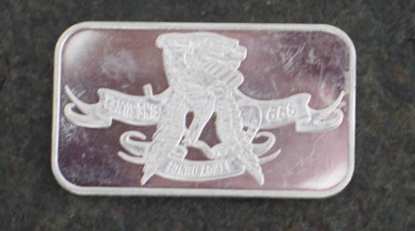
Silver Ingot Donated Anonymously at Field Day

~

Accessory Odyssey
By Artie, WBØJMG

Several years ago, I purchased a Yaesu FT-817 QRP HF, VHF, UHF transceiver from a friend of mine. It is a simple little rig that was (supposedly) small and portable. In the cardboard box was the transceiver, microphone, its’ rubber antenna, an LDG Z-11 autotuner, a 1:4 BALUN and some cables, and manuals.
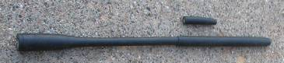
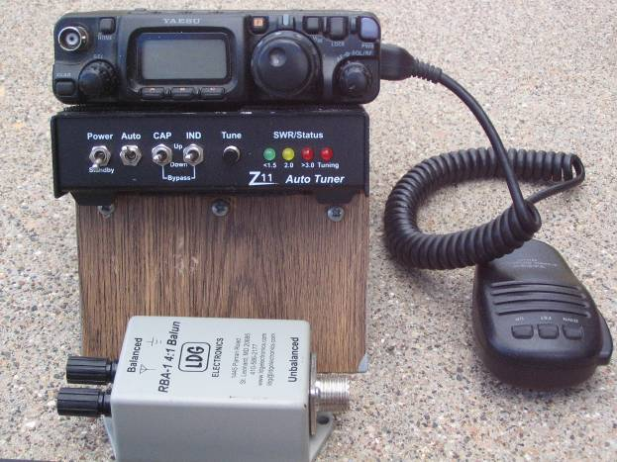

I bought a Gel-Cell battery with wall charger. This meant that I had to connect the spade terminals of the battery to the power cables going to the radio and tuner. This was just sort of lashed together and had bare pigtails and was somewhat temporary. I was always very careful to keep the wires separated and under control. This worked OK, until I was camping and a “friend” wanted to take a picture of the rig. Moving the rig to get the best shot, he shorted the wires and they burned up. A fuse would have been a good idea. Black electrical tape also could have helped too. I rebuilt the cables with fuses and tape.
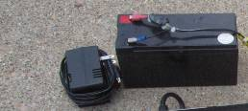

I bought a little portable battery in a yellow plastic case that had 2 cigarette lighter outputs, with a rechargeable battery and charger. I then made a plug for cigarette lighter power. Then I made a lamp with 8 yellow LEDs connected to a cigarette lighter plug. This was to be used while camping as a bug light so I could see the logbook without attracting bugs. Then, I made another one in white, and yet another one in a sort of bluish white, for general purpose (indoor) illumination.
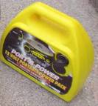
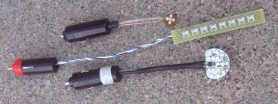

I found a 115-volt to 12 V/ 5A switching power supply to run the rig with AC. Great bargain and did not radiate RF interference.
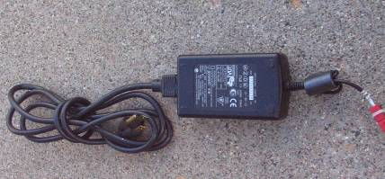

I got the whim to get on PSK 31 and, because of my typing rate, I bought a “nomic” interface for the computer, and a bunch of cables to connect to it. Then I bought a computer interface cable to work with a logging program.
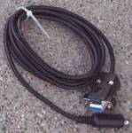

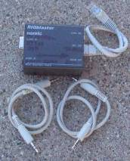

To make impromptu antennas, I had several bunches of antenna wire; lots of coax adapters; 25 feet of RG58U; and even more adapters. I also have a 33-foot fiberglass mast to hold up a full-sized 40m vertical ground plane antenna. I found a cast iron base for a patio umbrella would fit the mast base perfectly. I made four 33-foot radials for it, that would connect to the base.
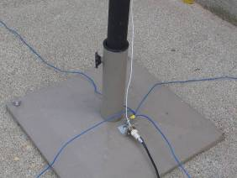

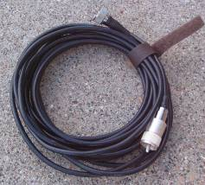

I added more adapters. You can always use more adapters. It would be a shame not to have the one you need. With enough adapters connected together, one can connect almost anything to anything else.

Then I decided to modify all power cables with Anderson Power Pole connectors. Also heat shrink insulation, fuses, etc.

I bought an MFJ portable antenna (with manual) that was specifically designed for the FT-817. Suddenly I got the urge to revisit CW, so I bought a Bencher paddle.
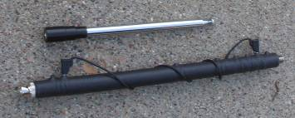

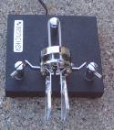

As the collection grew larger and larger, it was obviously time to find some sort of container to put it all in.

Box number 1 was an instrument case from Menards, with metal (colored plastic) walls and chromed metal corners that would just hold all of the above stuff except for the battery. It had foam that could be cut out in the shape of each item.

This would keep the items apart with some protection. I made a lot of cutouts in the foam, but I soon found that there was almost no foam left between the pieces. Then, to make matters worse, the sides burst out of the box after forcing it shut. Time for another solution.
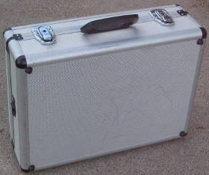

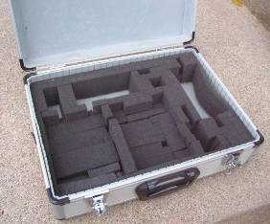

Box number 2 was a bit stronger, and would hold all the stuff. This was a pistol case from Fleet Farm that had camouflage sides but stronger, it seems. Cutouts were made in the foam to accommodate various items.
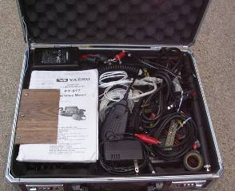
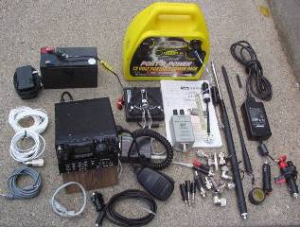

I put all the stuff (except the battery) in there, but the paddle might have been damaged from all the items crushing down on it. So, I found another small box that would hold the paddle, BALUN, and some of the adapters.
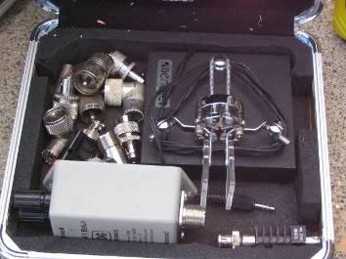

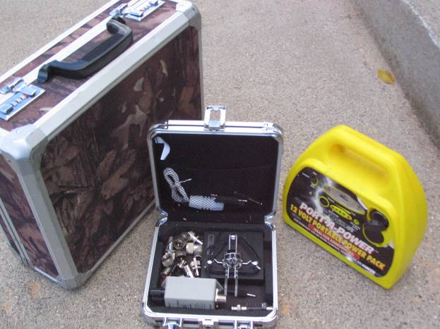

Including the thirty three-foot tall fiberglass antenna, cast iron base, all the coax and ground plane radials, I have about 100 pounds of accessories for a 2.5-pound radio!

It would be the perfect system if only I had a…

How to Terminate Tinned Braid Ground Cable
by Artie, WBØJMG

Cut off the end of 1 inch braided cable squarely with a scissors or tin snips. Do not let it unravel. Do not use an axe, adz, or knife, or sword. Try to not trim it because the short trimmed pieces of wire can get into fingers and toes, and will not vacuum up out of carpet.
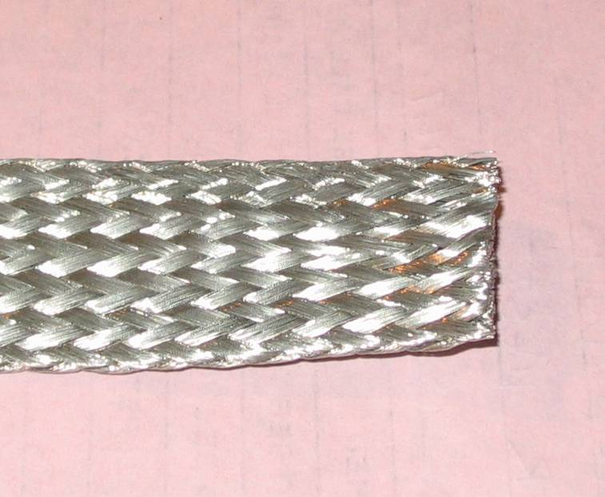  Figure 1: Square cut one inch tinned copper braid | 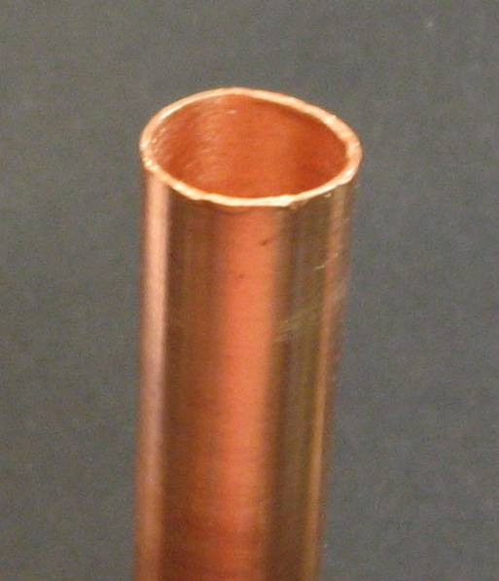  Figure 2: 1/2-inch water pipe with the cut end cleaned up

Go to your copper pipe collection and find some ½ inch copper water pipe that isn’t too corroded. Clean it back from one end with a piece of steel wool, emery cloth, or wire brush. Clean the inside with a brush intended for this purpose, or if you’re like me, an old car battery terminal cleaning brush. You might try a piece of emery cloth wrapped “scratchy side out” on a pencil or dowel, or the aforementioned steel wool jabbed in the end and twisted around. (Remove it for future steps.)

Find your pipe cutters and place the cutter wheel about one inch from the end. Rotate this pipe cutter a few times to make a mark and then tighten it and repeat until the 1 inch piece falls on the floor.
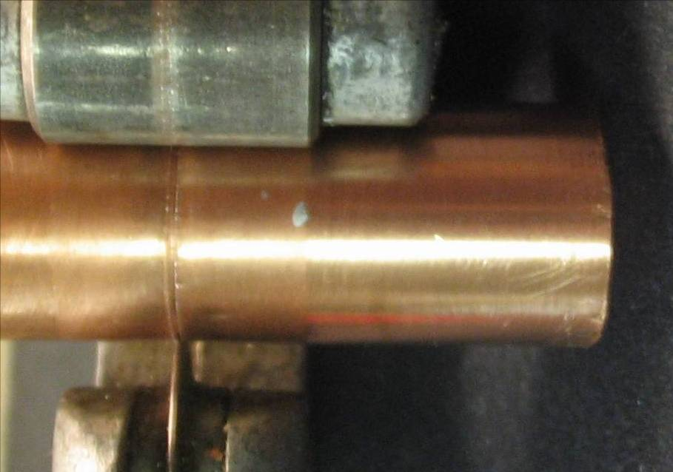
Figure 3: Cutting off 1-inch piece of water pipe

Pick it up off the floor, and clean it up again, removing whatever got inside while it was rolling under the workbench.

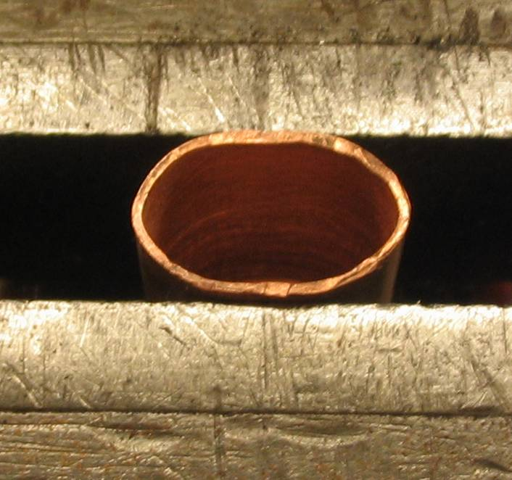  Figure 4: Starting to crush the pipe piece | 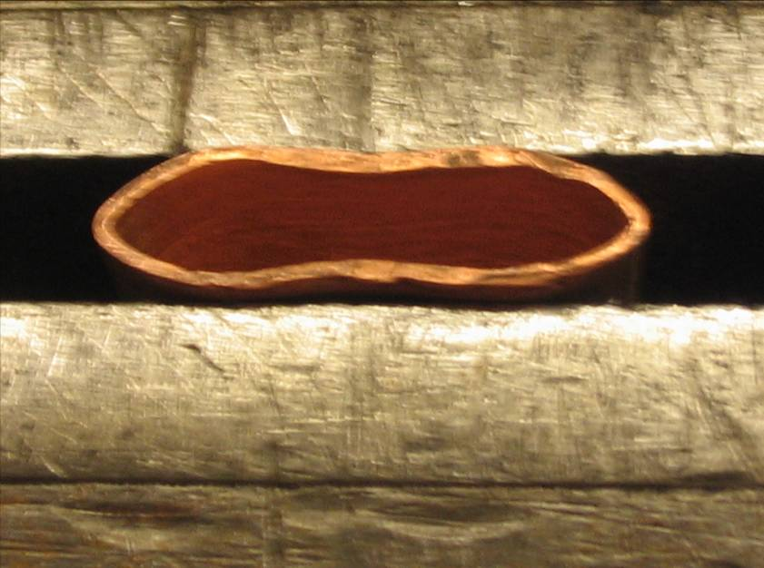  Figure 5: Crushed to about 1/8 inch opening

Put it into your vise as shown and start to crush the little devil flat. STOP at about 1/8 inch wide opening. If you crushed it too far, you can drive a screwdriver into it, and spread it out a bit, but this may mar the surface and may cause frustration in removing the piece from the screwdriver. It’s best to start over with a new, 1-inch piece of copper pipe. At about $0.08 per inch even I can afford it.

Insert the braid carefully so you do not leave stray wires sticking out. Insert it all the way into the partially crushed water pipe piece. Now for the fun part; Position the braid in the center and tighten the vise really hard until it screams in agony. (Actually, if you hear screaming, back off on the vise handle and remove whatever part of you that had gotten itself between the vise jaws.) Then, you should finish it by pounding it flatter with a hammer, against something harder than your hand or head.
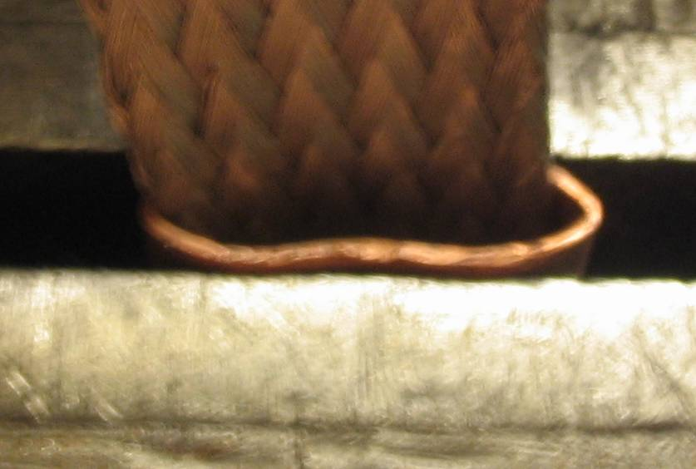
Figure 6: Insert braid all the way in

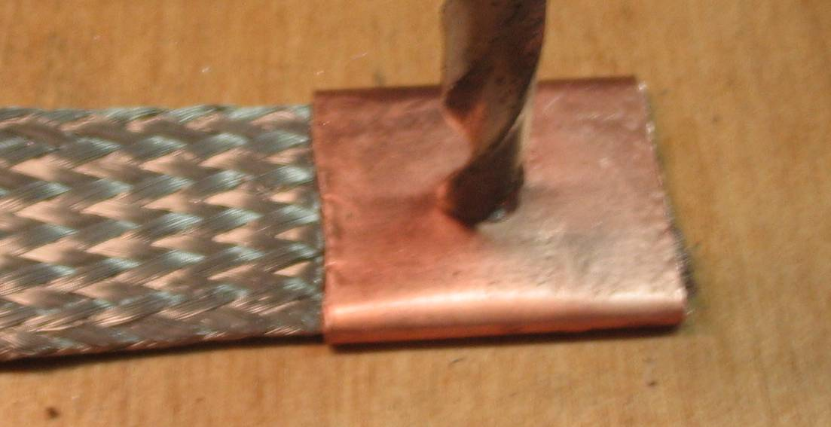
Figure 7: Drill hole in terminal

At this point, you have a wonderful copper tab on the end of your shiny braid. You will want to drill a hole into it to bolt it to something. Find the exact center of the tab and then drill a hole somewhere near there. Drilling copper can be tricky. I used a ¼ inch drill bit, a drill press at high speed, a wood block underneath, and very little pressure on the drill. (Editor note: use a sharp drill bit) If you have crushed the copper sufficiently, when you slowly drill trough it you will not grab individual strands, but drill through them smoothly. At this point, if you are holding the tab with your hand, you will remember the fact that there is friction between the drill and the copper, friction produces heat, and that copper is an excellent conductor of heat as well as electricity. Oh, and holding the tab with a pliers is also an excellent idea especially at the end of the drilling when the tab will want to climb up the bit and then swing the braid around madly like a Weed Eater on steroids.
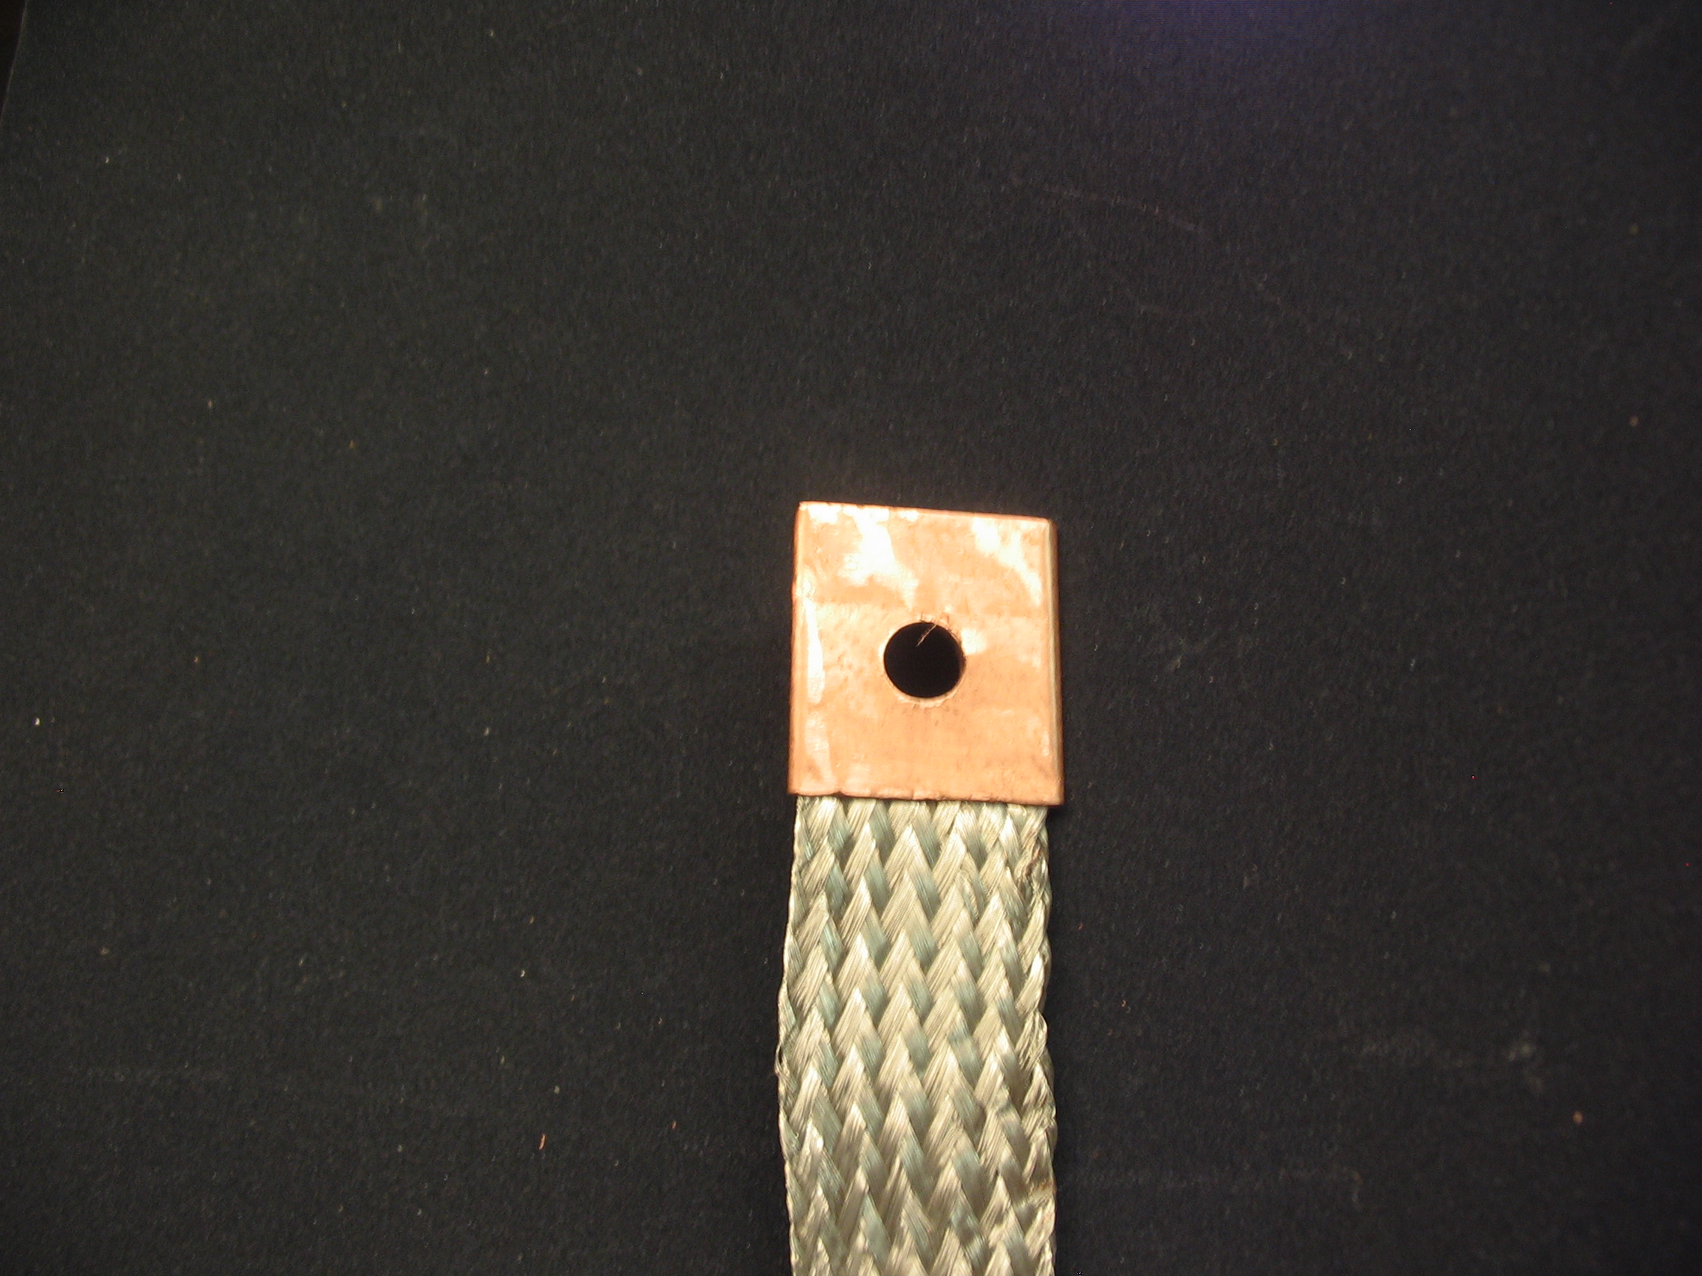
Figure 8: Completed terminal

At this point you could be done, but if you really want a good connection, you can solder this new tab but it’s hard to keep the solder from going up the braid and not into the tab. If you decide to solder this you will find you will need a lot of heat, like you will find over your wife’s kitchen stove burner, and you will recall, copper is a good heat conductor so do not hold it anywhere near the end you are soldering. (Oh and it will retain heat for a long, long, long time too.)

So, here is a neat, cheap, and practical way to assemble and attach grounding braid to just about anything. Figure 9 shows a typical application.

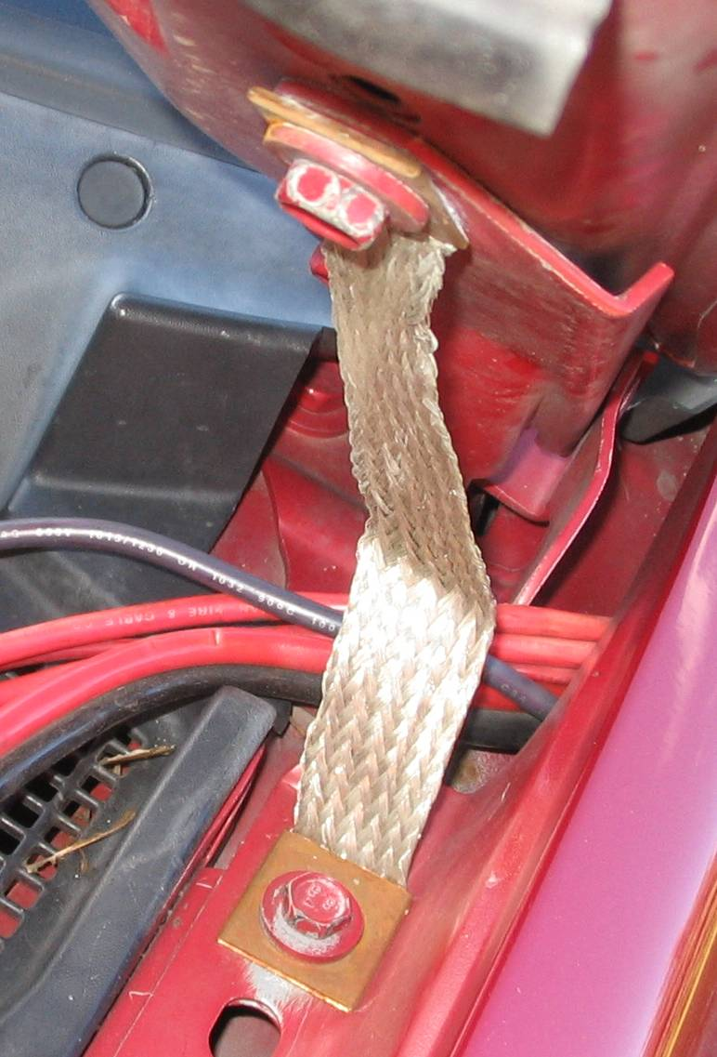
Figure 9: Braid installed to ground the hood to the body on a car.

 | Twin Cities Repeater Club, Inc.  P.O. Box 11534  St. Paul, MN 55111-0534 |  | Place  Stamp  Here

Your Membership Dues Have Expired.
Please Renew your Membership Today!

Join the Twin Cities Repeater Club!
P.O. Box 11534, St. Paul, MN 55111-0534
http://www.tcrc.org
There are two ways to register:
- Return this completed application form (to the mailing address indicated above) along with your $25 check payable to: Twin Cities Repeater Club
OR
- You can fill out this form electronically (at the web address indicated above) and pay online using PayPal.

(Please check one) This is ___New Application ___Renewal ___ Change Date _____________________
Name Callsign
Address License Class
City State Zip
Home Phone Work Phone Cell Phone
E-mail Address
Please note: For your privacy, an e-mail alias will be set up using yourcallsign@tcrc.org. E-mails sent to this alias will be redirected to the e-mail address you indicated above.
May we list your address in club publications? ___Yes ___No
May we list your phone in club publications? ___Yes ___No
Are you available for Emergency Service? ___Yes ___No
Are you a member of the ARRL? ___Yes ___No
Are you a member of Metro Skywarn? ___Yes ___No; (if Yes) spotter ID:
Are you a member of ARES? ___Yes ___No
Would you like a club ID badge? ___Yes ___No (free to new members, otherwise $5.00)

