The Repeater | 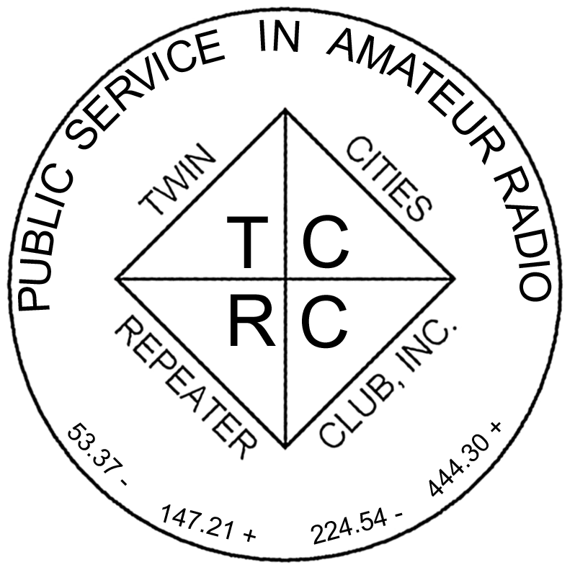
The Official Publication of the Twin Cities Repeater Club, Inc.

Mission Statement of the Twin Cities Repeater Club, as Adopted on September 20, 1993
The purpose of the TCRC is to facilitate the local communication needs of its members by owning and operating a state of the art wide area coverage two meter repeater system. The club will further involve itself in secondary activities intended to (1) promote the exchange of ideas and information related to amateur radio, (2) strengthen the fellowship and camaraderie among the members, (3) serve the local amateur radio community, and (4) increase local public safety.

Winter, 2009
Volume 32, Number 1

Inside this issue

Mission Statement 1
Dr. Ivan D. Frantz Jr., WØBU, SK 1
Repeater News 2
Wash Day CW Key 3
Troubleshooting the Noise in 147.21 4
The Decline of Ham Radio? 5
TCRC Skywarn Classes 6
Welcome, New Members 6
CQ Field Day, CQ Field Day 6
Membership Application 8

Please Join Us
for the
Quarterly Membership Meeting

03/17/09 7:30 PM Burnsville City Hall
Meeting Room

Talk-In on the 147.21 Repeater

Abbreviated Net Starts at 7:00 PM
Dr. Ivan D. Frantz, Jr.,
1916 – 2009 (WØBU, SK)
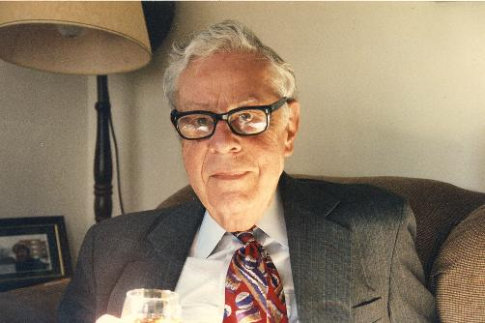
Ivan D. Frantz Jr., MD, whose WØBU Amateur Radio callsign graced all four of the Twin Cities Repeater Club’s VHF and UHF Repeaters, passed away on Friday January 23, 2009, at the age of 93. Born on January 16, 1916 in Smithville, WVa, Dr. Frantz was a long-time member of the faculty of the University of Minnesota Medical School. He studied at Duke University and Harvard Medical School. In the Navy, he was Flight Surgeon on the aircraft carriers Ranger and Essex, rose to the rank of Lieutenant Commander and was awarded a Bronze Star for Valor. After the conclusion of WWII, his professional positions included the Cardiovascular Research Laboratory at Massachusetts General Hospital and Harvard Medical School, and Chief of Cardiovascular Research at the University of Minnesota, where he was principal investigator of the NIH-funded Minnesota Heart Study that linked diet, cholesterol and heart disease. He served in many local and national professional organizations, including as president of the Minnesota Chapter of the American Heart Association. Dr. Frantz was an outstanding musician who played solo clarinet with the Duke University concert orchestra, and after graduation from Duke was forced to choose between accepting a position in the famous Les Brown Band and attending medical school. In addition to his professional activities Dr. Frantz was very active in amateur radio. He obtained his first Ham license, W8AKG, as an eighth grader. His subsequent call signs, W1PXY, WØWHM and WØBU, mark his moves across the country. He took particular joy in teaching youngsters including his sons and grandchildren about amateur radio and in helping them obtain their licenses. He also helped teach classes sponsored by the TCRC that led to the licensing of numerous additional Hams. He is survived by his wife Veronica of nearly 67 years, and five sons and their spouses, Ivan III (KØOSZ), Charles, Donald, Karl, and Robert (WBØFKK); also 10 grandchildren and 9 great-grandchildren. He will be sorely missed by those of us who knew him.
The Repeater is published quarterly by the Twin Cities Repeater Club, Inc. (the TCRC). The TCRC is organized as a nonprofit corporation in the State of Minnesota, with Articles of Incorporation and Bylaws. The club elects officers annually. These officers are simultaneously elected for a two-year term on the Board of Directors. The Repeater Trustee is a permanent member of the Board of Directors. Unlike the other Officers and Board Members, the Trustee may select a proxy to serve in his place at meetings of the Board. Membership in the TCRC is $25 per year. The TCRC is an official ARRL affiliated society.
TCRC Officers:
President: Artie Johnson, WBØJMG
Vice President: Phil Lefever, KBØNES
Secretary: Tanna Morse, KCØURO
Treasurer: Craig Larsen, KCØDMF
Board Members:
All of the above Officers, plus…
Chris Buck, WØHO, Club Callsign Trustee
Appointed: Mark Neumann, KCØITP
Appointed: Dale Morgan, KCØTAP
Appointed: Jeff Goodnuff, WØKF
Appointed: Kevin Uhlir, NØBEL
Technical Committee (a/k/a Tech Team):
Kevin Uhlir, NØBEL, Chair
Phil Lefever, KBØNES, Vice Chair
Doug LaBore, NØBIS
Rich Kenney, WØRFK
John Toscano, WØJT
Jeff Goodnuff, WØKF
Art Johinson, WBØJMG
Field Day Committee:
Tanna Morse, KCØURO, Chair
Open, Vice-Chair
Kevin Uhlir, NØBEL, Site Setup Manager
Open, FØOD Station Manager
Information Services Committee:
Kevin Uhlir, NØBEL, Chair and Head Webmaster
Phil Lefever, KBØNES, Assistant Webmaster
John Toscano, WØJT, Assistant Webmaster
Jeff Goodnuff, WØKF, Web Calendar Maintainer
Membership Committee:
Open, Chair
Craig Larsen, KCØDMF, Acting Chair
Tanna Morse, KCØURO
Newsletter Committee:
John Toscano, WØJT, Editor

Net Control Operators:
Chair: Larry Jenkins, KØLEJ
1st Tuesday: Jeff Goodnuff, WØKF
2nd Tuesday Mark Newman, KCØITP
3rd Tuesday: Open
4th Tuesday: Phil Lefever, KBØNES
5th Tuesday John Toscano, WØJT

Metro Skywarn Liaison:
Jeff Goodnuff, WØKF

Minnesota Repeater Council Liaison:
Jeff Goodnuff, WØKF

Emergency Services Coordinator:
Janet Skovran, KBØZFB
Repeater News

Of course, the biggest news about the club’s four repeaters is that the repeater ID’s have all been changed, temporarily, to the callsign of the new trustee, Chris Buck, WØHO, with the passing of Ivan, WØBU. True to his extremely generous nature, and his love of Amateur Radio, Ivan made it known to his family and to the TCRC club, that he would support the transfer of his callsign to the club for posterity, in his own humorous words, “…once I’m finished using it, but not before then…” Paperwork has been filed with the FCC for the cancellation of Ivan’s license effective on the date of his passing, and then the TCRC will petition the FCC to trade in our current club callsign (KCØDRZ) for Ivan’s WØBU call. Once that is accomplished, we will be able to restore the repeaters’ ID messages to their former state.

There is also a lot of work going on among the Tech Team to replace the very aged Kendecom Mark 4 CR repeater equipment at the heart of our flagship repeater on the 2 meter Ham band, the 147.2/147.8 system. The Mark 4 CR, affectionately known as “Swen” by the Tech Team, is showing signs of his age. Unfortunately, he isn’t aging as gracefully as Ivan did, and is not likely to be on the air at the age of 93. Led by the Tech Team Chair, Kevin, NØBEL, an all-new replacement for both Swen and the Linux-based PC, dubbed “Ole”, which provides additional functionality to the 147.21 repeater, is being designed and built. Some of the parts that would be needed to keep Swen in operational status are already bordering on “Pure Unobtanium” status, and that will only get worse over time.
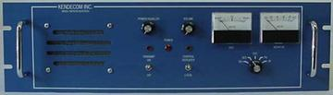

Rather than continuing to slap “Band-Aid” fixes on Swen, or spending the extremely high price of new commercial equipment, the Tech Team is designing and building a new system from the ground up, with an emphasis on maintaining existing features, having the ability to add new features, and most importantly, being easier to maintain and keep on the air. Discussions about the progress on the new repeater design and build are often held at the Tuesday Night Coffee Gathering. Drop by some time and meet with some of the folks that are making it all happen.
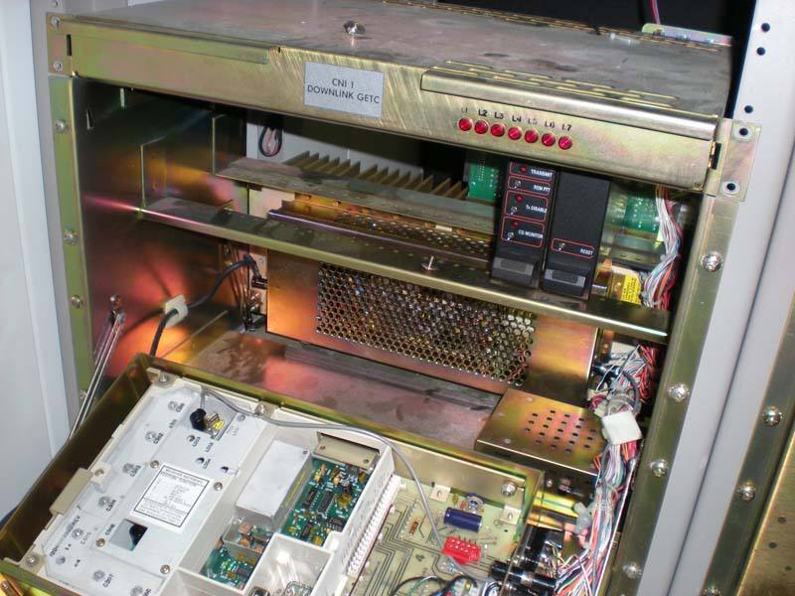

Field Day is coming!!
By Mark Neuman (KCØITP)

Wash Day CW Key
by Artie Johnson, WBØJMG
It came to pass that I had some time on my hands in December and got the idea to build a fully automatic key.
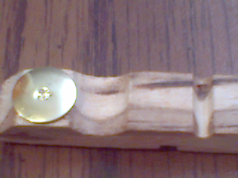I dug around in my collection of metal parts and found a nice piece of aluminum plate about a half inch thick and about 3 inches on a side. I picked it because it had a really smooth and shiny surface (it was pretty) and there were some holes in it that seemed to be in a convenient location. (I was lazy).
I needed to find something to use as paddles. After looking in my scrap bin and looking for plastic with just the right color and texture, I was disappointed. Then I looked into my collection of rare and exotic wood pieces and still did not come up with the right color and texture. Then while doing the laundry I had a revelation. A clothespin has nicely shaped wood pieces and in the collection was a specimen with really nice grain and texture. This one had a spring that was really too strong for the application, so I took it apart and started to examine its idiosyncrasies. Grooves, notches, bevels and flats. The possibilities boggle the imagination. I decided to use them back to back with the beveled sides on the outside.
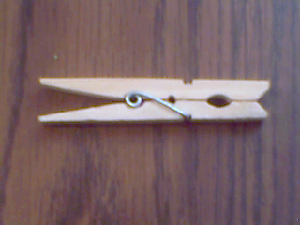Here was a concept that was both elegant and simplistic. Techno and rustic. High tech and low tech.
I would use the groove cut for the spring ends as a pivot point. I needed some sort of pin for the wooden clips to pivot on, and a way to hold them securely but allow them to move. I settled on a long screw with some small diameter sleeve and some washers to capture the clips.
I then figured that holding them in place was the job of the springs that provide the tension of the keys. I would figure that out later...
I needed contacts because, last time I looked, wood was not a very good conductor. I found some thumb tacks and pushed them into the cord end of the clothespin halves. These formed the contacts and had a nice golden color. One problem was that the pin end of the thumbtack was too short, and cold not be soldered to. . I took the thumbtack out and, using a twist drill, back drilled the clothespin to expose the end of the pin to soldering activities.
So it was decided to bring the juice from the input contacts to the thumbtacks by the use of very flexible wires. These I happened to find while taking apart an old circuit breaker from the junk box. (Part of the search for contacts for the keyer. It did not have usable contacts for my earlier search)
So each of the terminals will connect to the thumbtacks using the ultra flexible wire.
I drilled 3 holes for the common and dit and dah outputs. The two outer ones I drilled to clear some screws I had so that I could use some heat shrink tubing to insulate them from the base.
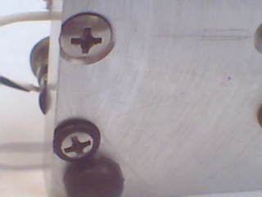I figured a way to hold the clothespin halves up against a pin. I was making the connections from stand offs and sleeves. Drilling and tapping the holes and drilling and tapping some of the standoffs produced the contacts and limiters that control the gaps. I found some ultra-flexible wire to make the connection between the thumb tacks and the terminals on the base.
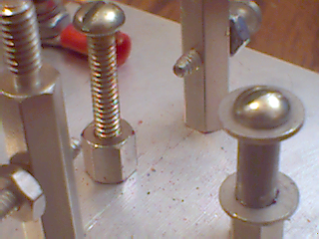I needed some spring action to hold the contacts open....AHA, rubber bands. I searched high and low (junk drawer upstairs, and the radio shack downstairs) and found a suitable rubber band that had just the right length and tension to make the key work well.
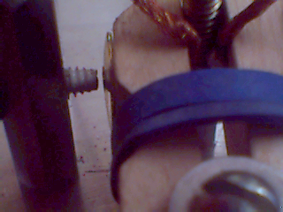Connecting the key to the keyer in the rig in the code practice mode, I started to send some code and made some adjustments and wow, it worked!
73 and happy keying,
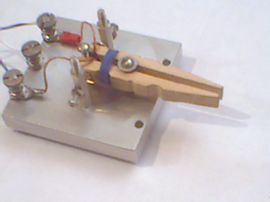
Artie, WBØJMG
~
Troubleshooting the Noise in the
147.21 MHz repeater
by Artie Johnson, WBØJMG

During the holidays at the end of December 2007, and the beginning of January 2008, the 147.21 repeater started to experience a form of interference that was keying the repeater periodically. Bursts of paging tones and weak distorted audio seemed to trigger it at different times. It would key up and then shut down. It almost seemed that someone who was very far away was trying to get into the 147.21 repeater. Several times the audio was finally good enough to be understandable. Much to our surprise, there were ambulance dispatches for various towns in Dakota County.

This was a day after Christmas, and I had to work because my office could not survive without my services. On my way home from work, rolling down the freeway, I was hearing the interference on my main mobile radio again. I thought it could be from some public service band transmitters so I decided to do a little experimenting. I bring the hand-held radio (Yaesu VX-5R) with me nearly all the time. I figured that the public service band was in the 150 MHz area, so I set the hand-held to 150.000 MHz and 5 KHz steps, and started twisting the frequency knob. I could not look down often due to traffic concerns. Suddenly, I heard the same kind of interference from the hand-held radio that I had heard coming through the 147.2 repeater. Glancing down at the display, I found the readout was showing 151.295 MHz. I postulated that there was some type of unintended emissions from one of these transmitters. The full scale of the problem was not apparent at the time.

A little Internet search of the frequency and county revealed the locations of 9 transmitters that could cause the problem. I called the County and left messages because, unlike my place of work, they were closed except for a couple of automatic phone answering 'bots' that finally took a voice message.

After the Holidays, I received a call from the County radio guy who listened to my complaint and said he would check it out. Then I received a call from the Motorola guy who told me of a special system that the county was checking out over the Holiday week(end). Apparently, there are 9 radio sites around Dakota County that have a special simulcast system, each of which has two transmitters on the same antenna. He speculated that the culprit was a system on Buck Hill, a mile away from our main repeater site. Could be, but I heard the interference in Saint Paul.

The frequencies of these transmitters are such that they produce what is called a second-order mix. Two times the low frequency of 151.295, minus the high frequency of 154.785, produces 147.805 MHz. This is just 5 KHz off from our input frequency of 147.810 MHz, which close enough to sneak through even our very highly selective input filters, but far enough from the input frequency that it does not give a crystal-clear signal to the repeater.

Meanwhile, I got a call from the consultant who designed the system. He was quite concerned about the interference. No doubt there was quite a bit of behind-the-scenes communications among all of the parties concerned, that I was not part of.

This is a simulcast system. The simulcast system works like this. Each of the transmitters has a very high stability frequency control system. Each transmitter is transmitting with the same deviation in the same polarity. With 9 sites and 18 transmitters, this system will give a mobile radio a strong local signal, with the other transmitter causing small signal level variance at low frequencies. The signal strength variation will only be at about 16 Hz at 65 MPH, and usually much lower than that. If there were not the ultra high frequency stability, there would be a tone heard and a lot more drop outs as a mobile drives through the county.

See Figure 1 for the locations of the WQHY522 and 521 sites.

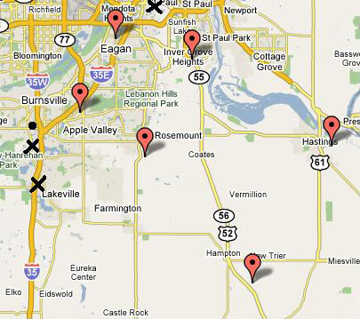
Figure 1: The WQHY522 transmitters are marked by the Balloons; The WQHY521 transmitters are marked by the X’s; and the 147.21 repeater is indicated by the Dot.

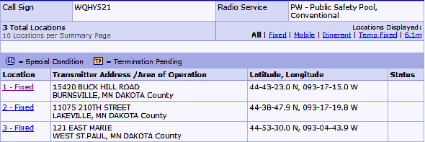

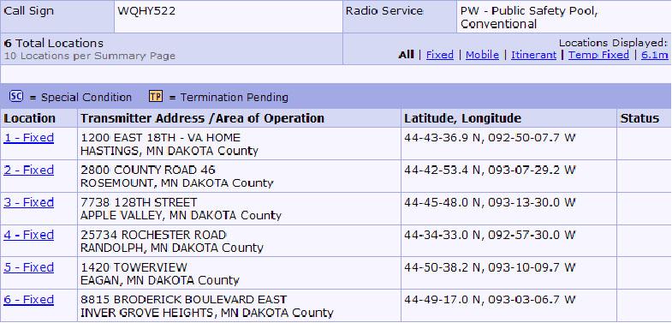

The Tech Committee has added a 100 Hz PL™ (Private Line, a Motorola trademark) or CTCSS (Continuous Tone-Coded Squelch System) squelch to the Main receiver and later, the North receiver as well. There was a lot of anguished discussion about this. As a wide-area coverage repeater system, we should have the capability of receiving any weak signal, even if it does not have the CTCSS tone. Hams are used to using weak and marginal signal quality, but adding the tone meant that the signal had to be clean and strong enough for the filters to detect the tone. The West site does not have the CTCSS tone at this time. The rationale behind this move is that the interfering signals from the County radio system will not be transmitting the 100 Hz “sub-audible” tone, and so should not open the squelch on the input of the repeater system.

The County now has both transmitters having the same modulation and transmitting at the same time. In the near future, the transmitters will have different audio and may RARELY be on at the same time. If/when that happens, this problem should disappear, because the adverse mixing and production of an interfering signal should mostly stop.
Artie, WBØJMG
~
Editor’s Note: In the previous issue of The Repeater, I wrote a fictional article entitled “The End of Amateur Radio!” which was intended to stimulate discussion about the perceptions in the media about the supposed ill health of the Amateur Radio Service. Fortunately, that rather pessimistic article was only a fantasy (nightmare), and as Ken points out in the following article, to paraphrase Mark Twain after reading his own obituary on June 2, 1897, “The reports of (the demise of Ham Radio) are greatly exaggerated.”. (jpt)

The Decline of Ham Radio?
by T. Kenneth Lewis, K3FMK
Some of the conversations around the table(s), or QSO’s on the air, have discussed the issue of “The Decline of Ham Radio.” Not having any hard information on that, I recently discovered some evidence on a parallel issue. While “surfing the web” one evening, researching a different issue, I came across a website with data on the number of licensed hams in the entire country, which includes all fifty states, the District of Columbia, Guam, Puerto Rico, the Virgin Islands, and other territories and possessions, as well as the APO’s and FPO’s. The article included a database, entitled “FCC actions through Tuesday, 03-Feb-2009.” As Sgt. Schultz used to repeatedly tell Colonel Hogan, “Interesting... very interesting.”
So, I copied the data into an Excel spreadsheet, and after running several mean, median, range, maximum and minimum statistical functions, it was impressive to see that California has the highest number of Hams in each of the license classes, ergo the highest number of all license classes per state, which includes the no longer issued classes of Novice, Tech Plus, and Advanced class licenses.
On the opposite end of the spectrum, no single state has the lowest number for all the classes, but Guam comes in with the lowest number of Novice and General, with absolutely no Tech Plus licenses, followed by D.C. with only one Tech Plus licensee. The Territory of the U.S. Virgin Islands has the lowest number of Technician, Advanced, and Amateur Extra licenses, as well as the lowest number of total licenses.
Another curiosity is the fact that while the highest number of licenses in the U.S. is the Technician class, the lowest number of licenses is the Technician Plus class. It would almost seem as if the least number ought to be the no longer issued Novice, especially since back in 1963/1964, when I got my Novice ticket, Novice was “one year, up or out.” Since then, that requirement seems to have changed.

However, as of February 3rd, 2009, when I did the research for this article the license classes ranked as follows:
- Technician: 318,573 licensees
- General: 145,044 licensees
- Amateur Extra: 115,795 licensees
- Advanced: 61,880 licensees
- Novice: 18,148 licensees
- Technician Plus: 4,491 licensees
The population of the United States, as of 18:51 GMT, on February 6, 2009, was 305,762,071. The total number of Amateur Radio Service licensees, as of February 3, 2009, was 663,931. It seems that Ham Radio is not really dying out. While we are a relatively small percentage of the population (0.217%), we are alive and active.
T. Kenneth Lewis, K3FMK
~
TCRC Skywarn Classes
Jeff Goodnuff, WØKF, TCRC Skywarn Liaison

Here it is, almost Spring again, and tornado season will soon be upon us. Remember, in order to maintain your active status as a Metro Skywarn Spotter, you must retrain every other year. As in the past, the TCRC will sponsor two spotter training classes this year. The first class was held on March 7, 2009, but the second will occur on May 30, 2009. Both classes will run from 9:00 AM until 1:00 PM, and will be held at the same location as last year: Open Circle Church, 2400 Highland Drive, Burnsville, Minnesota, 55337. Details, including driving directions, are on www.tcrc.org. Look on the calendar under the appropriate date.

The classes are open to everyone. You need not be a Ham to take the training and become certified. However, you will of course need an Amateur Radio license to be able to report your observations in real time. The classes are free. Bring a pencil.

If you have any further questions, do not hesitate to contact me: Jeff Goodnuff, WØKF, 952-927-0201.
~

Welcome, New Members!

The following folks have recently joined the ranks of the Twin Cities Repeater Club, or have re-joined after a period of elapsed membership. Please welcome them the next time you hear them on one of our repeaters! The club thanks them for their willingness to participate in the club.

Callsign | Name
KF9EW | Neal Zimmermann
WNØV | Kim Rawlinson
KC8AJY | Dylan Palmer

CQ Field Day, CQ Field Day, WØBU, 2A, MN
– or –
What were you doing on the 4th full weekend of June?
by John P. Toscano, WØJT
Well, another Field Day weekend has come and gone. As usual, the Twin Cities Repeater Club put forth an outstanding effort to get folks involved in this annual Amateur Radio event. For those of you who may be new to Ham Radio or for some other reason are unfamiliar with the concept, Field Day is an event sponsored by the American Radio Relay League (ARRL) every year, partly as a contest, partly as an emergency communications preparedness exercise, and partly as an excuse for Hams all over the country and beyond to get together for a weekend of fun and radio time.
For 2008, the TCRC played in the 2A category. This allowed us to have two transmitters on the air at all times on the HF bands of our choice, plus a “free” VHF/UHF/Satellite station, plus a “Get On The Air” station for inactive or inexperienced users. Unlike most years since I was first licensed, I was not able to participate for the full weekend this year, although I did bring out a VHF/UHF station for a short while to try to help out with some additional points for the few hours that I was available. It appears from the ARRL scores database that we did not have a GOTA station this year, and unfortunately, my time in the VHF/UHF station was too short to nab even a single satellite contact for the 100-point bonus that would have brought us. Nevertheless, we put in a very respectable showing this year, and more importantly, we had a lot of people having a good time. In fact, our Field Day event is more of a social gathering than a hard-core contesting effort. We’d rather take the time to show some new folks a mode or band of operation that they’ve never tried before, or even put them in the “hot seat” for a while and let them call CQ, than worry about how to get the maximum number of points by shutting out all the inexperienced folks who typically stop by the Field Day site to gawk. In the case of the TCRC Field Day operation, gawkers are always welcome.
Here’s how we did in our 2A class in the state of Minnesota:
Place | Callsign | Club | Score
1 | WØGKP | Arrowhead RAC | 4,692
2 | WØBU | Twin Cities Repeater Club | 4,118
3 | WØALX | Runestone ARC | 2,034
4 | WØNE | Winona ARC | 1,934
5 | NØDH | Hiawatha Valley ARC | 1,506
6 | WØWCR | Wright County ARS | 1,258
7 | WCØAAA | ARA of Bloomington | 1,244
Second place out of seven contenders, and more than twice as many points as the next place behind us – not so shabby, I’d say. In fact, in the entire state of Minnesota, there were 45 entries in all operating classes, and the scores ranged from first place (WØAA, class 3A, scoring 9,316 points, the Minnesota Wireless Association), to 7th place (us), to 45th place (N9DVT, class 1B1C, scoring 30 points). Once again, this represents a fine showing for a club that wasn’t particularly burning up the airwaves for maximum points instead of maximum fun.
To really give you some perspective, there were a total of 2,409 clubs that participated in Field Day in 2008, of which we scored in place 341. The top club of all, W3AO, the Potomac Valley Radio Club, which operated in class 23A (yes, 23 HF transmitters on the air at the same time), earned 33,664 points. But hang onto your seats: they had 60 participants at their Field Day event, and we had 54 participants. How’s that for a telling statistic?

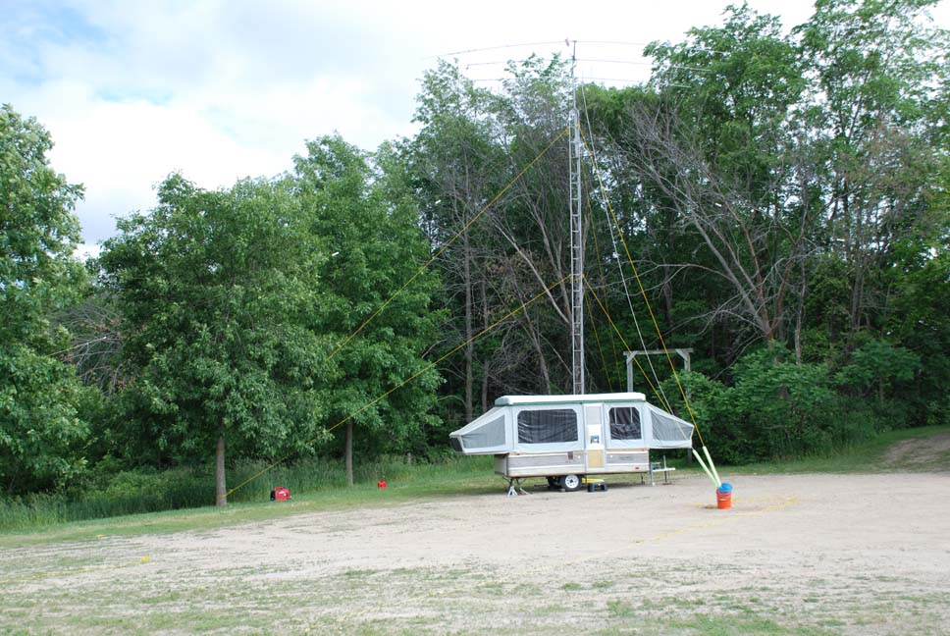 | One of our HF stations, situated in a pop-up camping trailer. There is a three element HF beam antenna at the top of the tower, which is rotated manually using the “Armstrong rotation” method (a rope dangling to the ground, which someone pulls in the direction they want the antenna to point.)
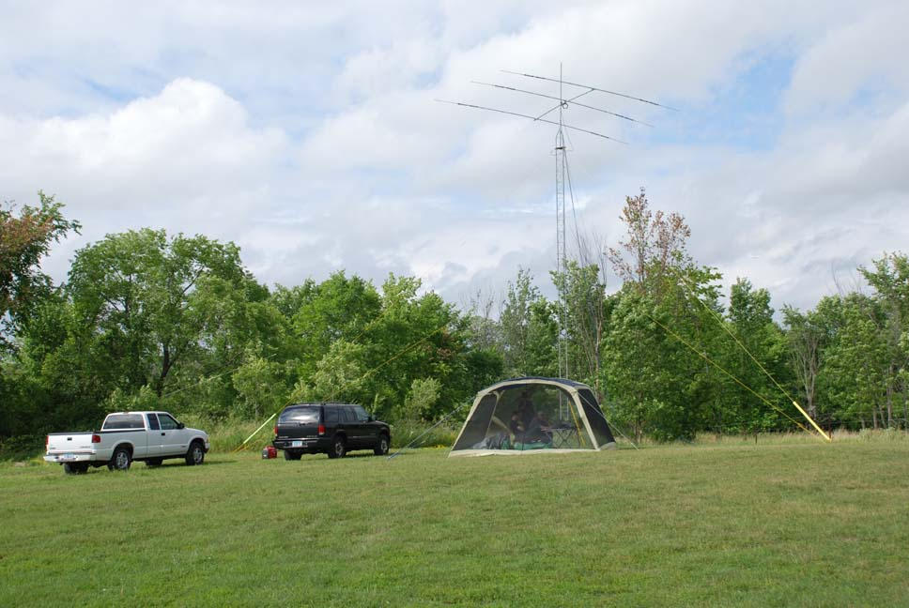 | Another HF station, this one housed inside an ordinary camping tent. One again, there is a three element beam antenna atop the tower, and again a simple “Armstrong Rotator” to point the antenna in the proper direction.

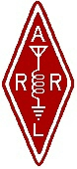 | Twin Cities Repeater Club, Inc.  P.O. Box 11534  St. Paul, MN 55111-0534 |  | Place  Stamp  Here

Your Membership Dues Have Expired.
Please Renew your Membership Today!

Join the Twin Cities Repeater Club!
P.O. Box 11534, St. Paul, MN 55111-0534
http://www.tcrc.org
Fill out this Membership Application Form, and mail it with your check for $25.00 payable to the Twin Cities Repeater Club, to the mailing address listed above. You can also fill out this form electronically at the web address listed above, and either send us a check, or pay online using the PayPal system.
Name Callsign License Class
Address City State Zip
Home Phone Work Phone Computer Phone
Ok to list your address in club publications? ___No ___Yes
Ok to list your phone in club publications? ___No ___Yes
Are you available for Emergency Service? ___No ___Yes
Are you a member of the ARRL? ___No ___Yes
Are you a member of Metro Skywarn? ___No ___Yes, spotter ID:___________________________________
Are you a member of ARES? ___No ___Yes
Would you like an autodial speed dial number? ___No ___Yes, to phone #___________________________________
Would you like a club ID badge? ___No ___Yes (free to new members, otherwise $5.00)
What is your internet e-mail address, if any? ___None
Would you like an e-mail alias set up, so that mail sent to yourcallsign@tcrc.org gets redirected to the e-mail address you listed above? This can be handy on the air! ___No ___Yes
Do you want a copy of the TCRC Handbook? ___No ___Yes (add $9.50, which includes postage)
Do you want a TCRC binder to hold it? ___No ___Yes (Add $5.50 to the above)
This is ___New Application ___Renewal ___Other Change __Callsign update, old call was ________________________ ________________________

