The Repeater | 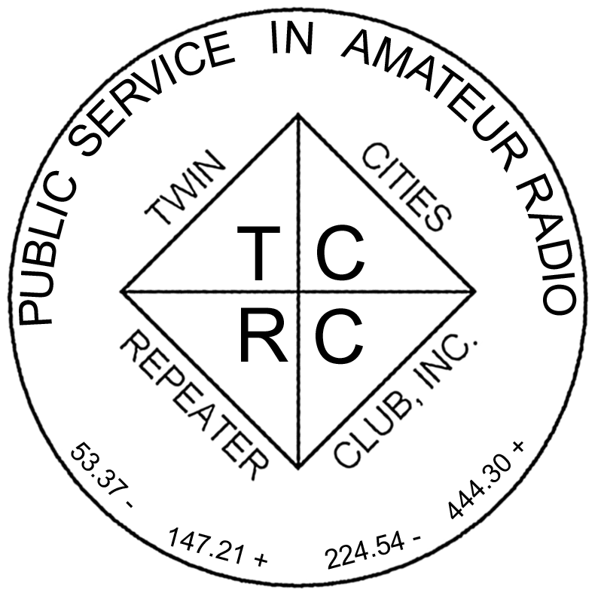
The Official Publication of the Twin Cities Repeater Club, Inc.

Mission Statement of the Twin Cities Repeater Club, as Adopted on September 20, 1993
The purpose of the TCRC is to facilitate the local communication needs of its members by owning and operating a state of the art wide area coverage two meter repeater system. The club will further involve itself in secondary activities intended to (1) promote the exchange of ideas and information related to amateur radio, (2) strengthen the fellowship and camaraderie among the members, (3) serve the local amateur radio community, and (4) increase local public safety.

Early Autumn, 2007
Volume 30, Number 2

Inside this issue

Mission Statement 1
TCRC Membership Meeting 1
Field Day 2007: See what’s Inside! 1
Welcome, New Members 2
First Electronic-Only Newsletter Issue 2
Getting Myself Back Onto HF, Part 2 3
Field Day 2007 with the TCRC 3
Amateur Radio Missionary Service 10
Membership Application 12

Please Join Us
for the TCRC
Annual Membership Meeting,
with Election of Club Officers,
and Selection of the Recipient of the Arnie Pung Award

Burnsville City Hall
7:30 PM
November 27, 2007

TCRC Membership Meeting
the 2007 Annual Meeting
is coming soon!

The final quarterly meeting of the year will also be the annual membership meeting. Elections for club officers will be held, and the members who are present will vote for the recipient of the Arnie Pung Award for outstanding service to Amateur Radio. This meeting will be held at 7:30 PM on November 27th, 2007, in the large basement meeting room of Burnsville City Hall. Because of the elections, it is particularly important that all members attend. Come early to the meeting; socialize, and have some coffee and cookies.
~

Field Day 2007
with the TCRC
Pictures and Stories Inside!
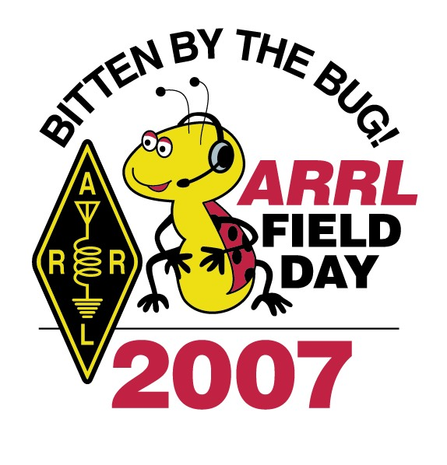 | 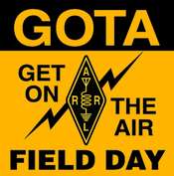

The Repeater is published quarterly by the Twin Cities Repeater Club, Inc. (the TCRC). The TCRC is organized as a nonprofit corporation in the State of Minnesota, with Articles of Incorporation and Bylaws. The club elects officers annually. These officers are simultaneously elected for a two-year term on the Board of Directors. The Repeater Trustee is a permanent member of the Board of Directors. Unlike the other Officers and Board Members, the Trustee may select a proxy to serve in his place at meetings of the Board. Membership in the TCRC is $25 per year. The TCRC is an official ARRL affiliated society.
TCRC Officers:
President: Phil Lefever, KBØNES
Vice President: Mark Neuman, KCØITP
Secretary: Tanna Morse, KCØURO
Treasurer: Craig Larsen, KCØDMF
Board Members:
All of the above Officers, plus…
Ivan Frantz, WØBU, Repeater Trustee
Ivan has currently appointed Mogens Dantoft, OZ9MD, as his proxy for Board Meetings.
Jim Rice, NØOA, Past Secretary
Jeff Goodnuff, WØKF
Larry Jenkins, KØLEJ
Artie Johnson, WBØJMG
Technical Committee (a/k/a Tech Team):
Kevin Uhlir, NØBEL, Chair
Phil Lefever, KBØNES, Vice Chair
Doug LaBore, NØBIS
Rich Kenney, WØRFK
Dave Kleindl, NØKP
John Toscano, WØJT
John Phelps, KFØZM
Steve Filek, NØOWL
Kent Peterson, KCØDGY
Field Day Committee:
Mark Neuman, KCØITP, Chair
Jim Rice, NØOA, Vice-Chair
Kevin Uhlir, NØBEL, Site Setup Manager
Open, FØOD Station Manager
Information Services Committee:
Kevin Uhlir, NØBEL, Chair and Head Webmaster
Phil Lefever, KBØNES, Assistant Webmaster
John Toscano, WØJT, Assistant Webmaster
Jeff Goodnuff, WØKF, Web Calendar Maintainer
Membership Committee:
Doug Ayers, NAØVY, Chair
Craig Larsen, KCØDMF
Tanna Morse, KCØURO
Newsletter Committee:
John Toscano, WØJT, Editor

Net Control Operators:
Chair: Larry Jenkins, KØLEJ
1st Tuesday: Jeff Goodnuff, WØKF
2nd Tuesday Doug Ayers, NAØVY
3rd Tuesday: Open
4th Tuesday: Phil Lefever, KBØNES
5th Tuesday John Toscano, WØJT
Alternate: Mark Newman, KCØITP

Metro Skywarn Liaison:
Jeff Goodnuff, WØKF

Minnesota Repeater Council Liaison:
Jeff Goodnuff, WØKF
Welcome, New Members!

The following folks have recently joined the ranks of the Twin Cities Repeater Club, or have re-joined after a period of elapsed membership. Please welcome them the next time you hear them on one of our repeaters! The club thanks them for their willingness to participate in the club.

Callsign | Name
KDØCBY | Jeremy Olson
W9RJS | Robert Scanlon
KE6CLF | Christopher Powell
KØUC | Brady Palmquist
NØFBM | Lucia Johnson
KAØICL | Myron Papiz
KDØBCL | Peter Paulson
KD5TRU | John Watson
NØMGQ | Gale Allen
KDØBEK | Josh Thorstad
KCØZQI | David Wagner

~
First Issue of The Repeater
in Electronic-Only Format

As previously announced, we have decided to try publishing about half of the issues of The Repeater (one or two per year) in electronic-only format, on the club’s web site. This is the first such issue of this new experiment. We still expect to publish the other half of the issues (one or two per year) in the traditional printed and mailed format. There are several motivations for going in this direction. One is the considerable savings in printing costs and postage, since electronic distribution is basically free. Another is the ability to include lots of pictures or large amounts of other content without worrying about the cost of mailing out a heavy, multi-page newsletter.

Club members in good standing will get an email notice that the next electronic issue is available on the TCRC web site, and they can download it or view it on line at their leisure.

Because the annual membership meeting is happening so soon, and because the club bylaws require mailed notice of that meeting, you can expect to get the next issue (Volume 30, Number 3) in the mail very shortly, and it will be pretty small.

Field Day is coming!!
By Mark Neuman (KCØITP)

Getting Myself Back Onto HF
Part 2, Preparing for a New Wire Antenna
by Kevin Uhlir, NØBEL

(Editor’s Note: In Part One, Kevin described his first steps in getting back onto the HF bands, including the repairs of his DX-77 multiband vertical antenna. In Part Two, he discusses his next steps in adding an additional HF antenna for more versatility.)

After success with the DX-77, I decided I needed to put up a wire antenna in order to cover 80M, and to use on 40M or 20M when conditions were more favorable to a high angle of radiation. I spent about a week yapping on the repeater about what antenna to use and reading lots of web articles. After a lot of vacillation, I finally decided what antenna to put up.

After I started to realize that the "Windom" antennas that are advertised and sold are not really Windoms, I decided to put up an off center fed dipole. The popular "Windoms" that are out there all have about 1/3 - 2/3 ratio off-center feeds, and radiating vertical sections (á lá the G5RV). Some radiating sections are open wire and some are even coax. Then, on top of that, they call out specific lengths of coax to the shack.

Then I finally started getting some real information. An off-center fed (OCF) dipole fed at the 1/3-2/3 point is resonant based on total length, and instead of a 75 ohm feed point, they have a feed point impedance of anywhere from 200 to 600 ohms. The interesting thing is that it is multi banded with no traps. An 80 meter length of wire will do 80, 40, 20, 10, and even 6M (not 15M), all with nearly the same feed point impedance.

So, I started modeling one using antenna modeling software. Initially, nothing worked. Then, I remembered how important segmentation was to the modeling programs. Once I did that, things started working. Further research showed that people were putting in a 100 pF cap in series with the longer leg at the feed point, to make 80M have a better SWR. I put that in, and things worked in the model even better. Doing even more research, I found that people were putting another OCF dipole for 15M in parallel with the main one. Now all of a sudden, you can have 15 as well, with minimal interference with the other bands.

I spent about 24 hours playing with the models, modeling where my antenna would be, and trying to fit it all in place. One leg is 90 feet long, and the other is 45 feet long. I couldn't find my 100 foot tape reel, so I couldn't measure all the points in the lot that I needed to, so I made some guesses.

What I end up with is an OCF going down and away to the North from the tower. The apex angles are about 30 degrees down, but in addition, the inside angle between the wires (as one goes Northeast and one goes Northwest) is about 90 degrees. What I thought should happen did: whenever you bend a dipole at the apex, you lower the impedance. So instead of the impedance being in the neighborhood of 400-600 ohms, it’s around 100-200 ohms, with 80M having the lowest impedance.

Most OCF's are fed with a 4:1 balun. Transforming 50Ω to 200Ω with a 4:1 balun seemed about right for me after the modeling. I also found some OCF's are fed with 6:1 and even 9:1 baluns, but my modeling showed 200 Ω with a 4:1 balun should be good for me. So, "somewhere" in the house or garage was a 4:1 balun that I bought years ago. I also haven't seen my 2M and 70cm Mirage amps, nor my 1296 MHz transverter in a couple years. My initial search turned up none of these items.

Since I couldn't find a 4:1 balun, and it was Sunday, I figured I'd see what it takes to make one. During my research, I saw that there are two kinds of 4:1 baluns (and I guess all others too). I knew that the traditional 1:1 balun with ferrite cores or the coiled up coax was a current balun. The other kind of balun which used a toroid core was a voltage balun. In the 4:1 type voltage balun, there are two windings, which are connected appropriately. A 4:1 current balun can be on a single core with 4 windings (two windings in one direction on one half, and two windings the other direction on the other half), or it can also be made on two cores, with 2 windings on each. For me, the current balun seemed better. Most reports talked about the current version having more isolation and a larger impedance handling range. Within that choice, the two core model seemed to me to be better, in power handling and heat dissipation, at least. So I dug up some cores of unknown properties (probably from an old Tripplite Isobar), decided on some wire to use, and wound up my 4:1 current balun. After all that research, why would I use unknown cores? Because it’s what I had, and remember, It was Sunday.

Now… how do I test the properties of a balun made of questionable materials? Enter the antenna analyzer. Ok, but I always questioned the absolute readings given by this meter, because it always seemed worse than other measurements showed. However, with my experience with the DX77, after using it with the radio, it seems that the analyzer was now showing better results than other measurements showed. I wasn’t too worried at the time because all I was interested in were the SWR nulls. But now, I need accurate readings of impedance and SWR, to determine if I just made a collection of wires wound on some cores, or if I had succeeded in actually creating a balun. Somewhere in my research of the previous few days, I ran across an article where someone recalibrated (and in one case, upgraded parts) of their MFJ-259 Antenna Analyzer. I found the article again, but realized that it was referring to an MFJ-259B, which is really a different animal. I then went to MFJ’s site, and found, of all things, a calibration procedure for the 259! I went looking for schematics, but I could only find stuff on the 259B. The procedure I found was obviously for MFJ’s inside tech people, because it even pointed out problems with the high end of the impedance meter being inaccurate, such as the statement, “make it work at 50 ohms, since most hams use this, and won’t notice problems in other areas”. So, of course, they use the old standard 50 ohm and 100 ohm resistor for testing. 100 ohm is of course 2:1 SWR, and they use 50 ohm to set the impedance meter. The two items I was looking for in a calibration procedure was simply what pots do I turn? They were there. R17 adjusts the SWR meter, and R31 adjusts the impedance meter. After messing around with the 50 ohm resistor, 100 ohm resistor, (and for good measure, I also used a 25 ohm and a 200 ohm resistor, to see how well the meter worked) I ended up with a reasonable result. 100 ohm measured 110 or 120, and 200 measured 250, basically just like the calibration document stated. The 25 ohm reading was probably 23. The SWR was quite accurate, even with the 25 ohm which of course read 4:1. Most of my testing of the meter was done at 3 and 7 MHz. I did find more inaccuracies came into play above 26MHz, mostly in the impedance measurement, but the SWR seemed to work well all over.

Ok. So now I have a meter I can trust, so did I make a balun? I needed a jumper from the meter to the balun. Of course I couldn’t find one around the bench area. I couldn’t find one around the radios. I did find the jumper whose ends had been removed to make my run out to the DX-77 antenna (see previous article in the series). Out to the garage again, looking for a jumper. One box… nope… another box, found a jumper with one end a PL259 one end an N connector. Ok, all my adapters are up at the repeater site in my adapter box. Oh, what is this box over here, under some other stuff? There’s a jumper sticking out, and as I dig inside the box to see what else is here for future reference, I find... 2 Mirage amps, a 1296 MHz transverter, a piece of coax coiled up ready for a dipole, and what do you know, a 4:1 balun, of course!

The balun is a spiro-something “Pro-balun” 4:1, something I had picked up at the candy store 15 years ago. While I was doing my research on baluns, I had seen this brand and model, and found that this was a voltage balun. So let’s test it to see if it works! So how would one use an antennal analyzer to test a 4:1 balun? The 4:1 part is easy. The balanced to unbalanced part I have to leave as faith. I hooked up my homebrew balun, and connect my trusty 200 ohm resistor. I get an SWR reading of 1:1 on 7 MHz, with the impedance reading 50 ohms. So, sometimes theory actually does match up to practice. I then tune around and find that the SWR and the impedance start moving around below 5 MHz to the point where the balun is really not working, and above 25 MHz it’s poor as well. Based on my research on baluns, I have some ideas as to why it didn’t work so well.

Well, let’s see how a “commercial” “PRO” balun works. I connect that up in the same way and sweep it. Interestingly, it’s poor until about 2.5MHz, and above 30 MHz it’s poor as well. So, obviously, the design criterion for this commercial balun is 80M – 10M. Why is a “broadband” impedance transformer not as broad-banded as one would like? When I was reading about baluns, I found one person’s description of balun design included a formula specifying that the minimum inductance of the windings the balun should relate to the maximum impedance that the balun would be seeing. Basically, the inductive reactance, plus some safety factor, should be the impedance which the balun sees. Another article I read reminded the reader to consider stray capacitance when dealing with higher frequencies. Putting this all together, my home brew balun, wound on unknown cores which were small and therefore had only 7 turns for each pair of wires, probably didn’t have enough inductance to work at the lower frequencies. In addition, the small cores meant that the windings were close, (packed, in fact), which would cause more stray capacitance between windings.

However, when sweeping the commercial product, it became apparent to me that you need to be sure to check the operating range of a balun, to be sure that it would work on the frequencies you want to use. If I wanted to use this commercial balun, on 160M, for example, based on my sweep and its poor performance below 2.5 MHz, it would not have worked.

So, I have a balun that will work (the commercial one), even though I’ll probably replace it with another one when I get the chance.

(… to be continued…)

Field Day 2007 with the TCRC

This year, the Twin Cities Repeater Club operated the Field Day event from a new location, Murphy-Hanrehan Park Reserve, because our old site was sold to a housing developer. It seems like a lot of members didn’t find the new site, because the attendance at this year’s event was noticeably lower than in past years.

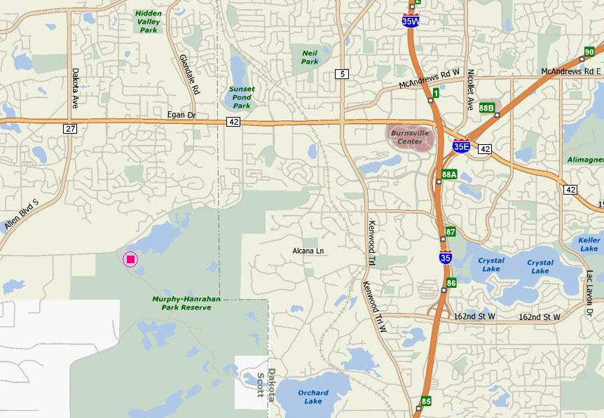

This year, we also operated in a different class, namely 2A, instead of our traditional 3A entry class. This limited us to a maximum of 2 transmitters on the HF bands for the main station, plus a separate VHF/UHF/Satellite station, plus our GOTA (Get On The Air) station. We switched classes due to a perception (proven to be correct) that participation was going to be lower this year than in the past, and that we would have difficulty finding enough operators to keep 3 HF stations busy for a large percentage of the available 24 hours of operating time.

So how did we do? Well, turn to page 5 to get the answer to that question!

For 2007, the Twin Cities Repeater Club scored a total of 5,654 points, from 1,245 QSO’s. This put us in 59th place out of 477 clubs in the 2A class, or in 200th place out of 2,334 clubs in all classes combined. Here is a table showing how the TCRC has fared in the last few years. As you can see, our score this year is down significantly from the two prior years. Part of this is the participation level by club members, and part of this is low sunspot activity. | Year | Operating  Class | Number of  QSO’s | Total  Points | Place in Class | Place Overall
 | 2007 | 2A | 1,245 | 5,654 | 59/477 | 200/2334
 | 2006 | 3A | 1,705 | 6,582 | 18/279 | 143/2184
 | 2005 | 3A | 2,427 | 8,444 | 10/262 | 70/2202
 | 2004 | 3A | 1,462 | 5,262 | 38/308 | 246/2250
 | 2003 | 2A | 1,156 | 4,086 | 97/429 | 324/2085
 | 2002 | 3A | 2,109 | 6,024 | 40/306 | 212/2100

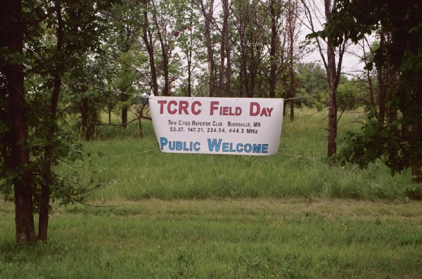  This is the banner that greeted visitors to this year’s Field Day operating site. |  | 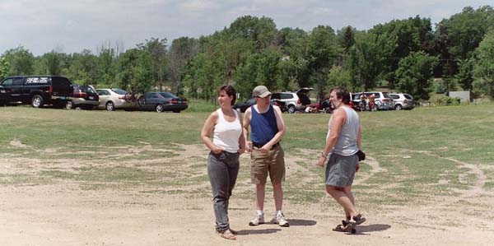  As the vehicles and participants started arriving, the site is “surveyed” by Phil (KBØNES), the previous Field Day Chairman, and Kevin (NØBEL), the previous and current Field Day Site Setup Coordinator.
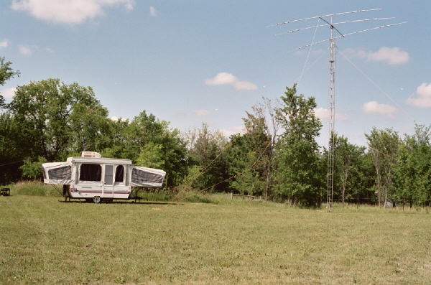  Here is one of our two HF stations, housed in a pop-up trailer, with its associated tower and 3-element HF beam. |  | 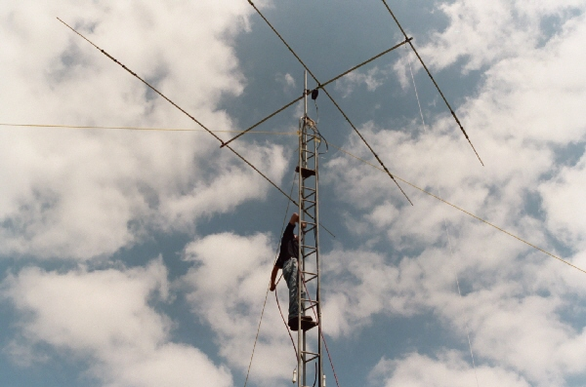  Here we have a brave soul who has climbed the tower to make some last-minute adjustments.
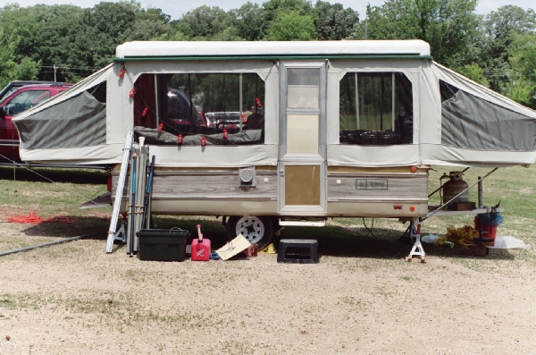  The GOTA station from the outside… | 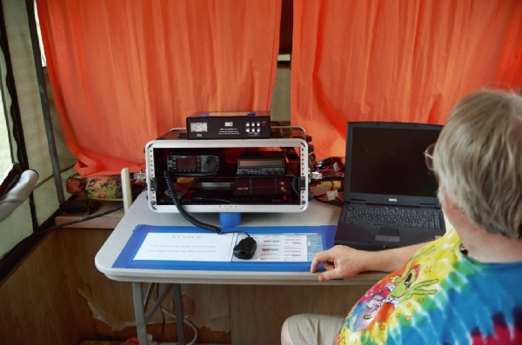  … and from the inside… |  | 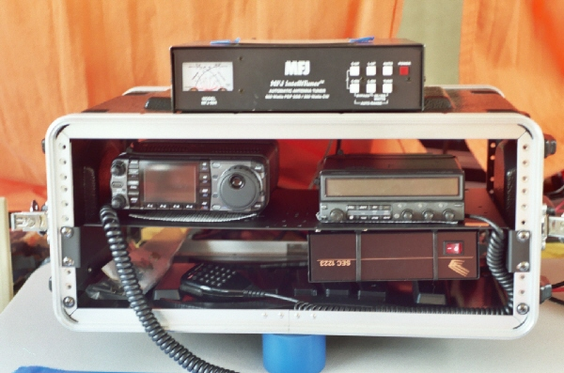  … with a close-up view of the radio gear.

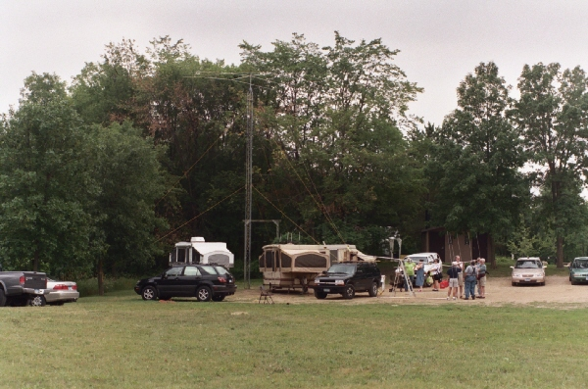  The crew prepares the VHF/UHF and Satellite antennas for erection. | 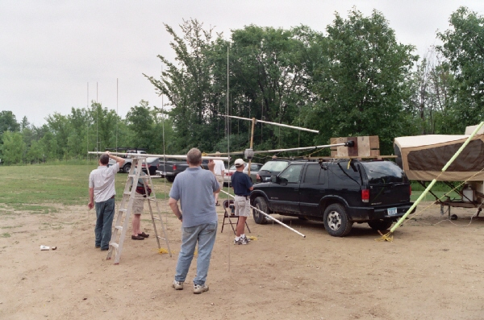  Almost ready to swing them up onto the roof of the black SUV. |  |  |  |  | 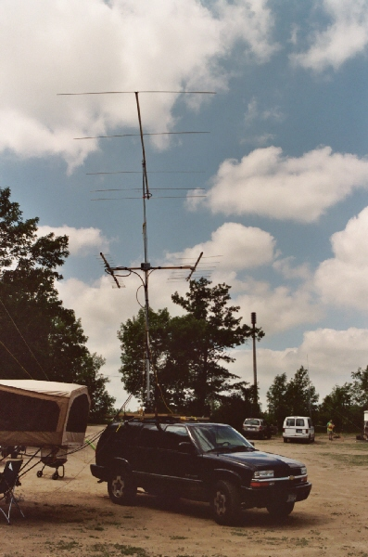  Antennas are now in place.
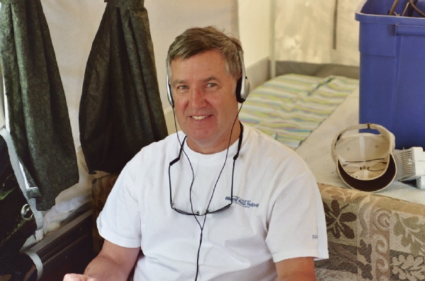  Operator NAØVY on the job… |  |  | 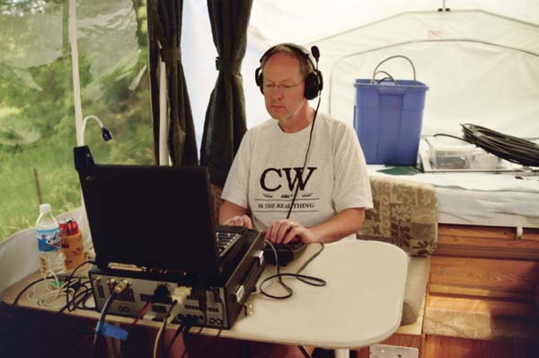  Operator KØPC showing us how CW is done…
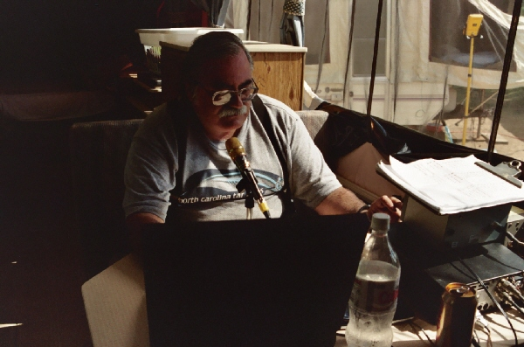  Operator WØJT in the VHF/UHF station, trying to work some of the Amateur Radio Satellites. This year, we made contacts on AO-7, a very old satellite that was launched in 1974, but went out of service in 1981 due to battery failure. It “miraculously” sprang back to life in 2002, and is now operational only when it is in daylight and can run off its solar panels without battery assistance. We also made contacts on VO-52, one of the newest linear transponder Ham satellites in orbit, launched by AMSAT-India in 2005. Now all we need is something borrowed and something blue… |  |  |  |  | 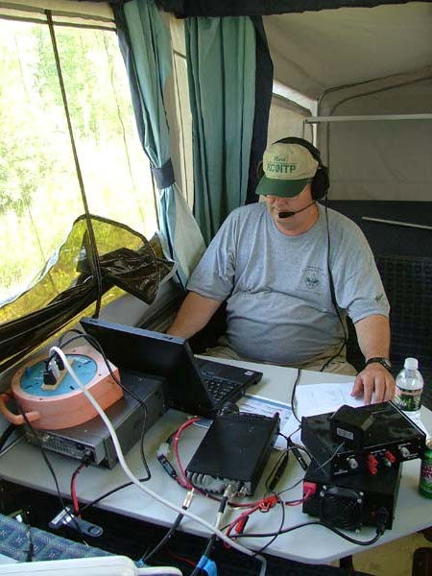  Operator and 2007 Field Day Chairman KCØITP at work in the HF Phone station…
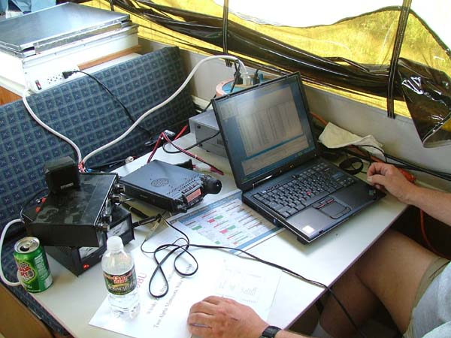  Another view of KCØITP’s operating position. |  |  |  | 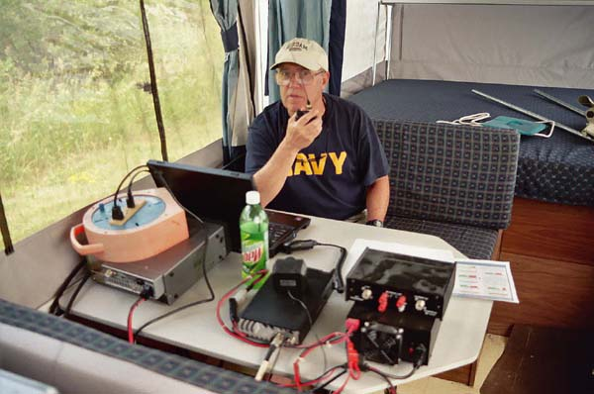  NAØVY takes a turn in this station, and ponders where his next QSO will come from. Or is he using his handheld radio to check on the status of lunch preparations at the FØOD station?
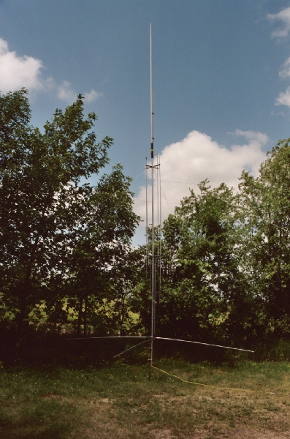  Multi-band HF vertical antenna used by the GOTA (Get On The Air) station. |  | 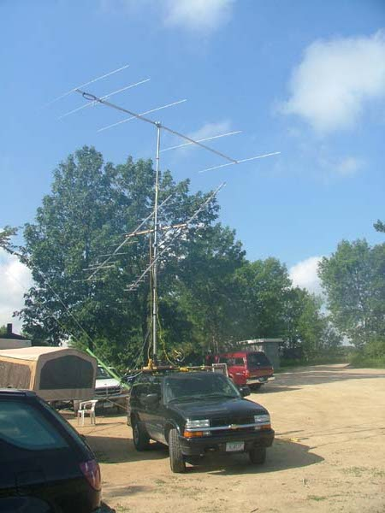  6 Meter VHF beam at the top, and elevatable 2 M and 70 cm beams below that, tipped up for a satellite pass. |  |  |  |  | 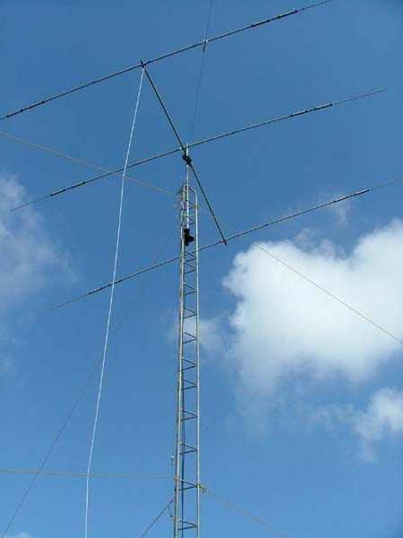  The classic tri-band HF beam with a rope for a rotator (also known as Armstrong rotation).
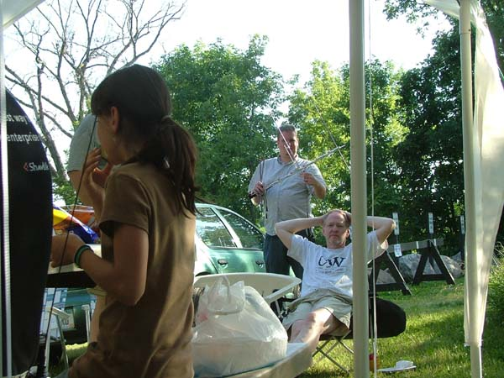  Taking a break from the radio operations at the FØOD station. |  |  |  | 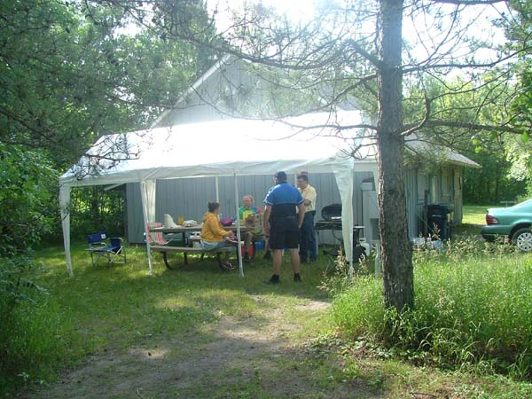  More ragchewing (but without using RF) at the FØOD station.

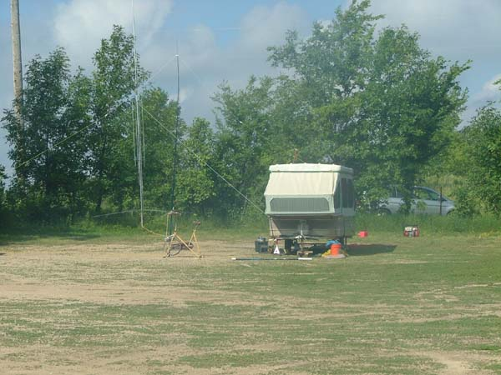  Another look at the GOTA (Get On The Air) station with its HF vertical antennas. And what’s the yellow exercise cycle doing out there? Hint: it’s an alternative to fossil fuels, wind power, and solar power… |  | 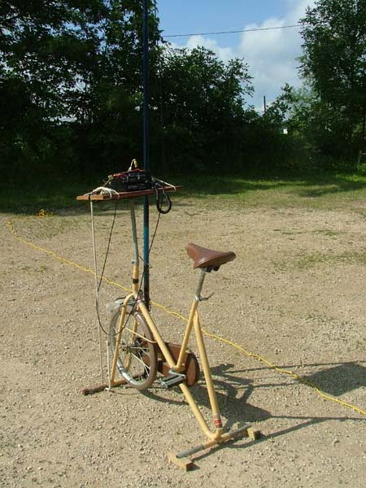  For additional ARRL bonus points, we needed some QSO’s made with totally natural power. So we have a generator on the exercise bike connected to a QRP radio. How many watts can you pedal today?
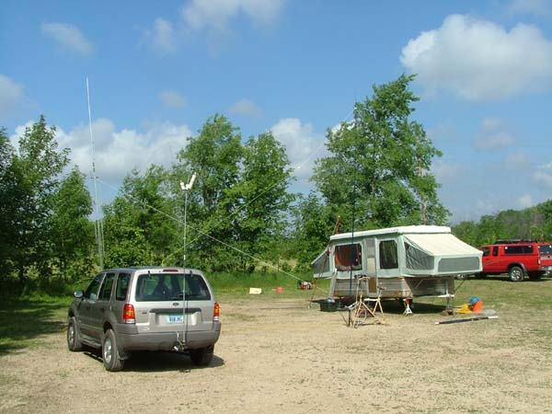  Many vehicles at the Field Day site sport an exotic antenna or two… | 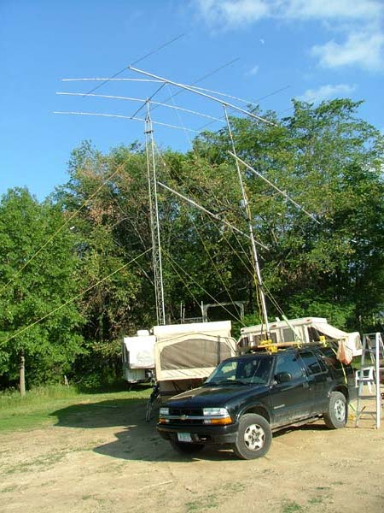  But trust me, this is a special case. Those antennas don’t stay strapped to the roof of the SUV while it’s in motion! We’re just using the SUV instead of a support tower!

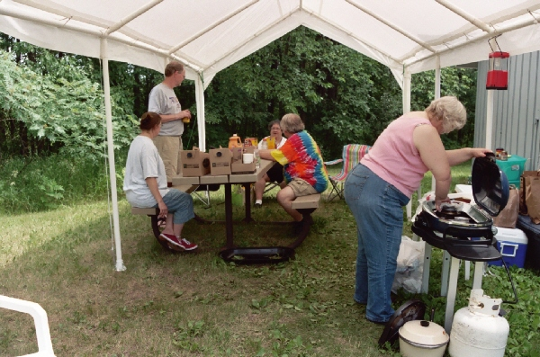  Meeting and eating at the FØOD station. | 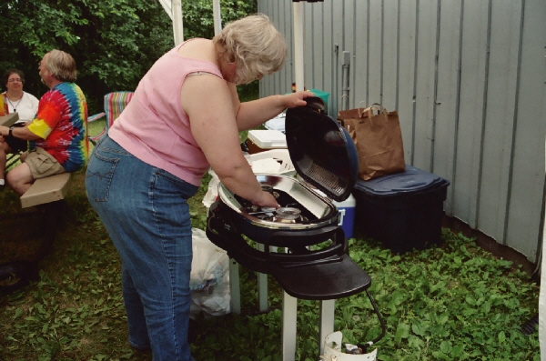  Tanna, KCØURO, fires up the gas grill.
What is Field Day?  It’s not just a chance to get onto the radios for a weekend, although that is a valid goal for many of us who seem to be too busy with the demands of daily life to get on the air as often as we’d like.  It’s not just a contest, although we strive to earn a good score and have fun doing it.  It’s an opportunity for TCRC members, and potential future members, to get together for a weekend of companionship and relaxation.  It’s not just an “Emergency Preparedness Exercise”, but you all know that when major disasters strike, ordinary telephone and cell phone service will be knocked out of operation, and the ability to start with an empty field devoid of commercial electrical power, and turn it into a fully-functional, self-sustained emergency communications post requires practice. It doesn’t just happen automagically. Naturally, we hope to never have the need to apply these skills in a real emergency. But, I guarantee you, it has happened in the past, and will happen again. And we will be more nearly prepared for the next disaster as a result of having participated in Field Day. | 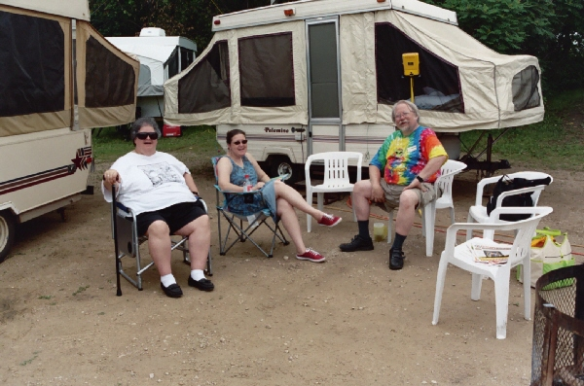  Taking a moment or two to relax.
So, what’s your excuse
for not coming this year?

Will you be joining us
for Field Day next year?

ARMS
Amateur Radio Missionary Service
by T. Kenneth Lewis, K3FMK

On May 14, while browsing in the May issue of QST, I turned to the SPECIAL EVENTS page. Out of curiosity, I scanned the page to see if there were any local events. Sure enough, on May 25-27, a national convention of ARMS Christian Fellowship was being held. The location was given as Farmington so my interest was piqued. The website for more detailed information was given as www.armsfellowship.org. So an investigation was definitely in order.
Going to the webpage, it showed that the National Convention and 50th anniversary celebration would be held at the Mount Olivet Conference and Retreat Center. My XYL had attended a weekend retreat there with some of the ladies from our church, so I was familiar with the center.
The website also revealed that ARMS stands for Amateur Radio Missionary Service. This really had my attention because part of the reason I had gotten my license back was to help our church to communicate with a missionary that our church supports in Ahuas (pronounced ah-WASS), in the state of Gracias A Dios, in Honduras. Just before our trip to the mission hospital about six years ago, the team members communicated with him via a land line between Eagan and Winston-Salem, NC, where our contact, who was also a ham with an autopatch that was the final link with the missionary, Dr. Gerard Rudy-Goff, who together with his wife who also is a doctor, have ham licenses.
I had been previously licensed as KN3FMK in SE Pennsylvania, so the ham radio bug was “itching” again. Add to that the fact that we had to make that long distance call when phone rates were highest, it wasn’t just a nudge to get the license back; it was an outright shove! And here was an organization dedicated to supporting missionaries in the field. I had to check this out. So, sending an email message to the Secretary/Treasurer, Ora Gifford, KE7BF, I indicated my desire to attend. He was already on his way to Minnesota, so the President, Gerry Brunk, K4RBZ, responded, indicating that I should meet them on site at the Conference and Retreat Center.
So, arriving Friday afternoon, May 25^{th,} at about 3:45 I met President Brunk. After introducing myself, he directed me inside to where my registration could be completed. In the conference room, after registration, the Midwest Section Director, Arnie Kopischke, WAØDFT, from Mankato had set up his mobile 40 meter rig in preparation for the net. The transceiver, antenna tuner, dipole antenna and power supply had been packed into a brief case, but was now fully operational.
That evening, we had a good dinner and a meeting that went over the history of ARMS I was surprised that the group had formed back in Philadelphia in 1957, when several hams who were Christians met on the 75 meter net. The first president was also a professor, William (Doc) Mierop, K2JEI. Doc was also the president of the Philadelphia College of the Bible, and lived in nearby Collingswood, New Jersey.
The sole surviving founding member was introduced and spoke at that meeting, and among the members were pastors and missionaries, including some who worked with Wycliffe Bible Translators in different parts of the world and even had different call signs at those times. When the meeting had adjourned, we were entertained by and participated in singing, accompanied by a piano, two guitars and a fiddle. As the evening drew to a close, we broke up for some well-earned sleep, especially for the senior members and those who had come from as far away as the states of Pennsylvania, Montana and Washington.
Saturday morning after breakfast, the organization had a check in on the ARMS nets. Then the group conducted a business meeting, discussing among other things a proposal of a name change. That was the only motion that did not pass, although the vote was almost dead even. As the meeting adjourned, there was a group photo prior to lunch for a commemoration of 50 years of service.
After lunch we all had free time to take advantage of nature, meeting friends with whom some never had an eyeball QSO. There was also some on the air time.
Following the evening meal, we heard from several members during the “Stories of ARMS in Action” presentation, telling exciting stories of amateur radio in the mission field. Recruiting new members was a serious discussion as many of the members are seniors and the organization needs new members to survive. Again, there was singing and camaraderie amongst the members and XYL’s many of whom were also licensed.
Sunday morning was a little quieter, as some members had already departed, and others were preparing for flights that were leaving later that morning. After breakfast some of us had bid our farewells while the rest of us headed for the chapel, where one of the members, who was also pastor in Northfield, MN, conducted the service. At the close of the service, the rest of us departed; some for the airport, some for a several hour drive to points such as Mankato, or North Dakota, or Iowa.
Overall, this was a weekend to remember and a group where Christians with a ham radio license can communicate with each other on 20M, 40M and 75M nets, as well as supporting our missionaries. While the point had been made during the convention that with cell phone and satellite radios, short wave communications with missionaries might be dying, some of them in the field still rely on short wave, one of them being the missionary doctor our church supports in Honduras. I have joined ARMS and am looking for an HF rig to get on the nets and communicate with our missionary team in Honduras.

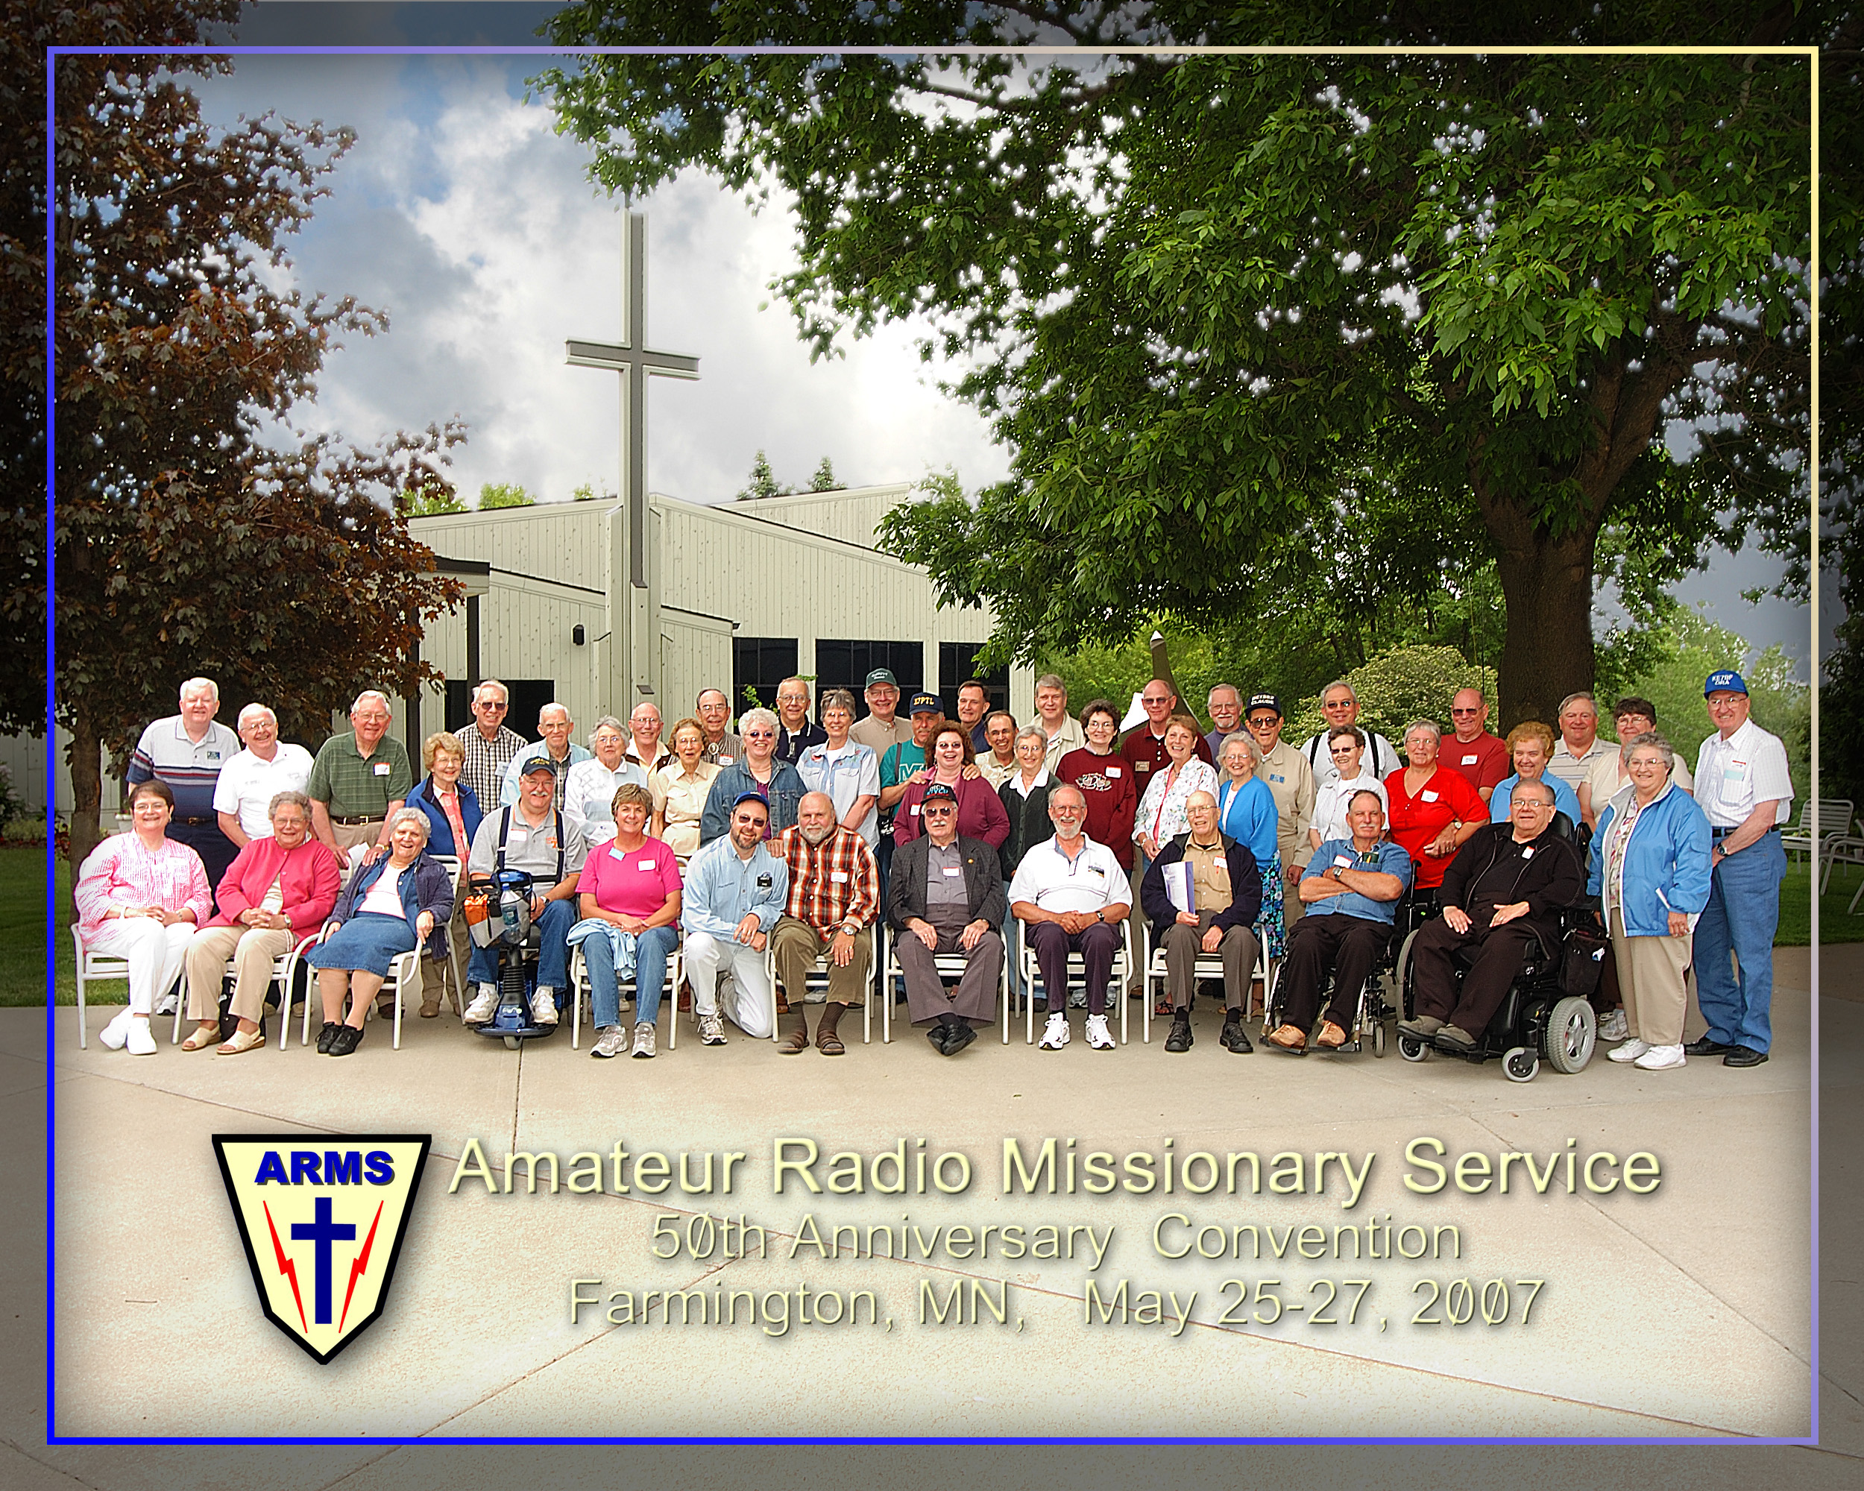

~

This space reserved
for your contribution
to the club newsletter. . .

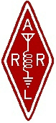 | Twin Cities Repeater Club, Inc.  P.O. Box 11534  St. Paul, MN 55111-0534 |  | Place  Stamp  Here

If Your Membership Dues Have Expired,
Please Renew your Membership Today!

Join the Twin Cities Repeater Club!
P.O. Box 11534, St. Paul, MN 55111-0534
http://www.tcrc.org
Fill out this Membership Application Form, and mail it with your check for $25.00 payable to the Twin Cities Repeater Club, to the mailing address listed above. You can also fill out this form electronically at the web address listed above, and either send us a check, or pay online using the PayPal system.
Name Callsign License Class
Address City State Zip
Home Phone Work Phone Computer Phone
Ok to list your address in club publications? ___No ___Yes
Ok to list your phone in club publications? ___No ___Yes
Are you available for Emergency Service? ___No ___Yes
Are you a member of the ARRL? ___No ___Yes
Are you a member of Metro Skywarn? ___No ___Yes, spotter ID:___________________________________
Are you a member of ARES? ___No ___Yes
Would you like an autodial speed dial number? ___No ___Yes, to phone #___________________________________
Would you like a club ID badge? ___No ___Yes (free to new members, otherwise $5.00)
What is your internet e-mail address, if any? ___None
Would you like an e-mail alias set up, so that mail sent to yourcallsign@tcrc.org gets redirected to the e-mail address you listed above? This can be handy on the air! ___No ___Yes
Do you want a copy of the TCRC Handbook? ___No ___Yes (add $9.50, which includes postage)
Do you want a TCRC binder to hold it? ___No ___Yes (Add $5.50 to the above)
This is ___New Application ___Renewal ___Other Change __Callsign update, old call was ________________________ ________________________

