The Repeater | 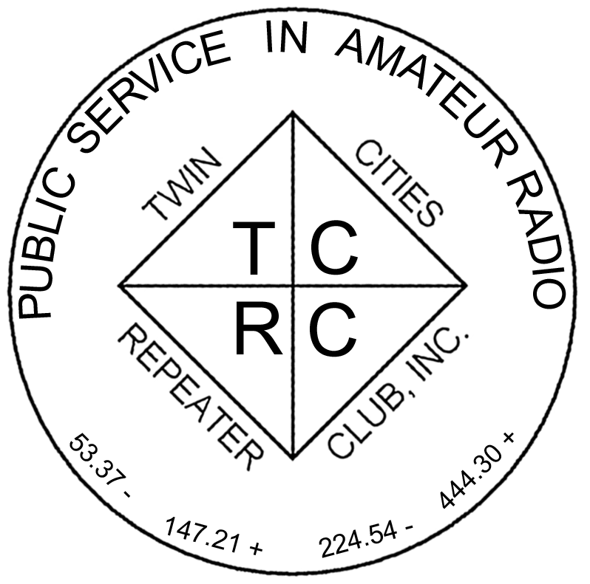
The Official Publication of the Twin Cities Repeater Club, Inc.

Mission Statement of the Twin Cities Repeater Club, as Adopted on September 20, 1993
The purpose of the TCRC is to facilitate the local communication needs of its members by owning and operating a state of the art wide area coverage two meter repeater system. The club will further involve itself in secondary activities intended to (1) promote the exchange of ideas and information related to amateur radio, (2) strengthen the fellowship and camaraderie among the members, (3) serve the local amateur radio community, and (4) increase local public safety.

Late Spring, 2006
Volume 29, Number 2

Inside this issue

Mission Statement 1
Quarterly Membership Meeting 1
Field Day 2006 1
Welcome, New Members 2
TCRC Plans for Field Day 2006 2
Field Day is HERE 3
Field Day – the GOTA Experience 3
Powerpole Connectors 4
Coleman Power Inverters 5
2006 Skywarn Classes End 7
My Dayton Trip Highlights 7
Morse Code by Flashing Light 8
CSVHFS Annual Conference 9
DX Basics 9
DX Glossary 10
Membership Application 12

Please Join Us:

TCRC Quarterly Membership Meeting
Tuesday,
June 13th, at the Burnsville City Hall!

Field Day 2006
Setup Begins 06/23/06
Operate 06/24 to 06/25
Teardown 06/25/06
TCRC Quarterly Membership Meeting
Tuesday, June 13, 2006
7:30 PM until 10:00 PM

The next Quarterly membership meeting of the Twin Cities Repeater Club will be held on Tuesday, June 13th, at Burnsville City Hall, in one of the basement rooms. As we usually do on the Tuesday evenings of the quarterly membership meeting, we will have an abbreviated version of the TCRC Information Exchange net, from 7:00 PM to about 7:30 PM, so the meeting can get started at that time. You are welcome to show up at Burnsville City Hall before 7:30 PM (as early as 6:45 PM is okay), so you can chat with the other folks who have come to the meeting, and enjoy the coffee and cookies that will be provided. We hope to see you there!
~
Field Day 2006
Friday June 23 – Sunday June 25, 2006

- Eligibility: Field Day is open to all amateurs in the areas covered by the ARRL/RAC Field Organizations and countries within IARU Region 2. DX stations residing in other regions may be contacted for credit, but are not eligible to submit entries.

- Object: To work as many stations as possible on any and all amateur bands (excluding the 60, 30, 17, and 12-meter bands) and in doing so to learn to operate in abnormal situations in less than optimal conditions. A premium is placed on developing skills to meet the challenges of emergency preparedness as well as to acquaint the general public with the capabilities of Amateur Radio.

- Date and Time Period: Field Day is always the fourth full weekend of June, beginning at 1800 UTC Saturday and ending at 2100 UTC Sunday. Field Day 2006 will be held June 24-25, 2006.

For full details, you can find all the rules on the ARRL web site:
http://www.arrl.org/contests/rules/2006/rules-fd-2006.html

See inside this issue for more information about TCRC’s plans for Field Day this year!
The Repeater is published quarterly by the Twin Cities Repeater Club, Inc. (the TCRC). The TCRC is organized as a nonprofit corporation in the State of Minnesota, with Articles of Incorporation and Bylaws. The club elects officers annually. These officers are simultaneously elected for a two-year term on the Board of Directors. The Repeater Trustee is a permanent member of the Board of Directors. Unlike the other Officers and Board Members, the Trustee may select a proxy to serve in his place at meetings of the Board. Membership in the TCRC is $25 per year. The TCRC is an official ARRL affiliated society.
TCRC Officers:
President: Phil Lefever, KBØNES
Vice President: Mark Neuman, KCØITP
Secretary: Tanna Morse, KCØURO
Treasurer: Craig Larsen, KCØDMF
Board Members:
All of the above Officers, plus…
Ivan Frantz, WØBU, Repeater Trustee
Ivan has currently appointed Mogens Dantoft, OZ9MD, as his proxy for Board Meetings.
Jim Rice, NØOA, Past Secretary
Jeff Goodnuff, WØKF
Larry Jenkins, KØLEJ
Artie Johnson, WBØJMG
Technical Committee (a/k/a Tech Team):
Kevin Uhlir, NØBEL, Chair
Phil Lefever, KBØNES, Vice Chair
Doug LaBore, NØBIS
Mike Ferguson, NØDGG
Rich Kenney, WØRFK
John Toscano, WØJT
John Phelps, KFØZM
Steve Filek, NØOWL
Kent Peterson, KCØDGY
John Laxson, KCØPZN
Field Day Committee:
Mark Neuman, KCØITP, Chair
Jim Rice, NØOA, Vice-Chair
Kevin Uhlir, NØBEL, Site Setup Manager
Monica Filek, KBØUWZ, FØOD Station Manager
Information Services Committee:
Kevin Uhlir, NØBEL, Chair and Head Webmaster
Phil Lefever, KBØNES, Assistant Webmaster
John Toscano, WØJT, Assistant Webmaster
Jeff Goodnuff, WØKF, Web Calendar Maintainer
Membership Committee:
Doug Ayers, NAØVY, Chair
Craig Larsen, KCØDMF
Tanna Morse, KCØURO
Newsletter Committee:
John Toscano, WØJT, Editor

Net Control Operators:
1st Tuesday: Open
2nd Tuesday & Chair: Larry Jenkins, KØLEJ
3rd Tuesday: Open
4th Tuesday: Phil Lefever, KBØNES
5th Tuesday John Toscano, WØJT
Alternate #1: Jeff Goodnuff, WØKF
Alternate #2: Mark Newman, KCØITP

Metro Skywarn Liaison:
Jeff Goodnuff, WØKF

Minnesota Repeater Council Liaison:
Jeff Goodnuff, WØKF
Welcome, New Members!

The following folks have recently joined the ranks of the Twin Cities Repeater Club, or have re-joined after a period of elapsed membership. Please welcome them the next time you hear them on one of our repeaters! The club thanks them for their willingness to participate in the club.

KCØVME | Stephen Pickett
KCØURP | Jerry Keohen
KCØIVL | Russell Jones
W9FZ | Bruce Richardson
KCØVXB | Jerry St. Clair
N9PCG | Douglas Kilian
~
TCRC Plans for Field Day 2006  by John P. Toscano, WØJT  VHF/UHF/Satellite Station Manager, 2006 | 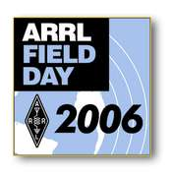

While the official description of Field Day provided by the ARRL (see page one of this issue of The Repeater) talks about Field Day as a contest and an emergency communications preparedness exercise, the TCRC considers it to be something even more than that. We also see it as the premier social event of the Amateur Radio calendar each year. Many of us, with busy schedules, who hardly ever seem to get out and see one another, congregate at the Field Day site each year, trade stories, re-live old times, eat, drink, be merry, and, oh yeah, even operate radios. ☺ And if you are new to Amateur Radio, this is an excellent opportunity to meet new folks, and operate in ways that you may not have done before. Maybe you don’t have a license with HF privileges? No problem, we will have multiple HF stations with control operators so that you can operate HF to your heart’s content. Maybe you’ve never experienced a 6 meter band opening to the East Coast, Florida, Texas, or Colorado? Well, we can’t guarantee that you’ll get the chance, since that’s dependant on the whims of the propagation gods, but if they smile on us, we will at least be prepared with an operational station to take advantage of it. Maybe you’ve heard about amateur radio satellites, but have no idea what it’s like to operate one. We plan to have a satellite-capable VHF/UHF station set up this year, as we have in most of the past years. Maybe you want to see why some folks get excited about contesting – the bug has bitten some unsuspecting hams who tried it for the first time at Field Day (and I’m not talking about the Minnesota State Bird, I mean the Contesting Bug!). We even plan to have some non-traditional modes of communication going at the site. Come on out and have a blast! The map below gives you an idea of where this year’s TCRC Field Day site is located. Sadly, this will be the last year at this site, because the property has been sold for housing development, but we hope our “last fling” at this site will be a great one. I hope to see you there!

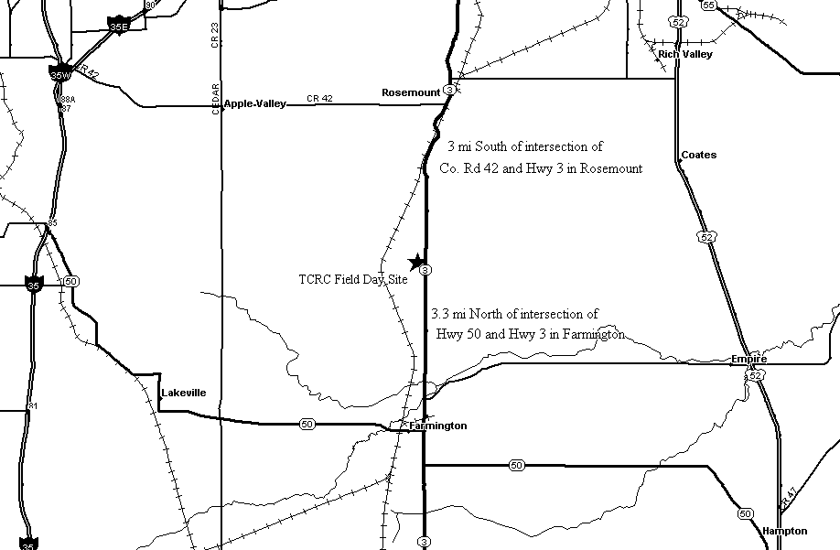

Field Day is coming!!
By Mark Neuman (KCØITP)

Field Day is HERE
by Mark Neuman (KCØITP)

That is right, Field Day is now on top of us: June 24th to June 25th this year, and the TCRC is getting ready to party, contest, and have a good time.

Field Day was originally started in the name of training amateur operators to operate using temporary stations, in less than ideal conditions. The lessons learned by those that operate Field Day are invaluable, in the event that any large-scale disaster ever occurs. Within hours, we could have several stations on the air using temporary equipment to provide wide range communications. All this is accomplished without using any permanent equipment, and using only emergency power. Field Day helps us to keep our skills sharp, and teaches us how to pull together and work as a team. It was noted in the government reports that the only reliable and interoperable communications operating in the aftermath of hurricane Katrina last year was that provided by hams, and Field Day is a chance to brush up on those skills not only in being able to pass messages in potentially difficult conditions, but also in being able to set up a station under less than ideal conditions.

For us to pull off a successful effort, we need the help of as many people as possible! So far this year, enthusiasm for the event has seemed to be down compared to years past. We do normally see interest build as the event approaches. While the world events of the past years have changed people’s lives, the need for emergency Amateur Radio communications has only increased. It is my hope that as many TCRC members and their friends can come out to join us for the event this year.

The Field Day location will be the same as in past years (about one mile south of County Road 46, on County Road 3, in Rosemount); however we have been told by the land owners that next year there will be houses there. So, we are now looking for a different spot for next year and beyond. If you are aware of a location with the following parameters that you think would make a good Field Day spot please speak up. The following is a list of desires/requirements:

- Open space, for tower placements. All Field Day activities by a single group must be within a 1000 foot circle, but we would like to place the antennas as far apart as possible while staying inside that limit.
- Public accessibility, so many people can get there.
- Camping is available. We can yield a little on this one, although we will be a 24-hour operation for Field Day, and many folks like to camp out for the duration of the event on the site.
- Adult beverages are allowed.
- Picnicking allowed / encouraged.
- We would prefer to be away from power lines to have the site radio quiet.
- Reasonable terrain – higher is generally better, down in a hole is not as conducive to radio propagation.

Also, as in past years the TCRC is looking for a number of hardy souls to help put up the antennas on Friday evening June 23rd. If you are available, please stop by the Field Day site and help pull the towers into the sky. As in past years, we will be operating in the Class 3A category, which means that we are allowed up to 3 HF transmitters to be on the air at the same time. We generally run 1 HF radio strictly on CW, 1 HF radio primarily on 20M SSB voice, and 1 HF radio on general voice (bands other than 20M). In this category, we are also allowed to have a “GOTA (Get On The Air) station”, for inactive and new hams) and also a VHF/UHF/Satellite station. All except GOTA will operate under the callsign of WØBU. As always, the TCRC hosts a picnic on the Field Day site on Saturday starting at about 5:00PM, so bring your family and friends on by (along with a dish to share) to meet and greet and put a face to those voices you have heard on the best repeaters in the Twin Cities area. As always, visitors are very welcome.

Remember, Field Day is an event that happens only once a year. Be sure to mark the fourth weekend in June (June 24th – June 25th this year) on your calendars, so you are sure to have the weekend free. If you miss it, you will have to endure hearing others talk about how great it was, for an entire year afterwards. Come out and join in the fun, and try your hand at some of the bands or modes you don’t normally operate. I guarantee you will have a great time.

All Field Day questions, comments, and offers to help should be directed at Jim Rice NØOA, the Field Day Co-Chair. We hope we will see you all at Field Day.
~

Field Day - The GOTA Experience
by Craig, KCØDMF

Last year, I wrote about my experiences at the GOTA ("Get On The Air") station for Field Day. I had such a great time last year, that this year I will be in charge of the station. I want to encourage everyone to come to Field Day this year, but especially to the GOTA station to experience the GOTA experience.

Here's some background. As you may know, Field Day is a contest that is held each year on the fourth full weekend in June. The goal is to earn points by making as many radio contacts as possible in 24 hours – using minimal setup and preparation in a remote area. The idea is to simulate the response to a communications emergency, for example, providing effective communications after a major disaster that has disrupted normal communication channels and many of the basic services that we have grown so dependent upon, such as commercial electrical power.

One of the five radio stations that we plan to have active at Field Day this year will be devoted to giving folks a chance to experience HF radio communications, without needing to own expensive radio equipment, and even if they are not licensed at all, or have a Technician class license that lacks HF privileges. This station is called the “Get On The Air” station, or GOTA for short.

The focus of the GOTA station is to get non-licensed operators, novice-class hams, technician-class hams, and relatively inactive hams of all license classes, the opportunity to experience amateur radio by getting on the air. The GOTA station is less focused on getting the maximum possible points (which, during Field Day, are earned by making more radio contacts). Instead, it is designed to entice hams and prospective hams to experience amateur radio firsthand, and to get excited about getting licensed, advancing their license privileges, or simply getting active once again.

Although this is also my focus as Station Manager, I do want to see how many points this station can earn. The first five youth (18 and younger) who make one contact will earn the station bonus points. Moreover, anyone making a whopping 50 contacts will also earn the station bonus points. So, the more operators we get and the more contacts we make, the more points we will earn.

Our GOTA Station goals for 2006:
- five youth making at least 1 contact each, for bonus points
- at least one operator making 50 contacts, for bonus points
- a total of at least 200 contacts (vs. 187 contacts last year)
- at least one non-traditional mode demonstration (APRS, WinDRM, etc.)

I encourage everyone to come out to Field Day and visit the GOTA station. Experience the GOTA experience.

"Bring me your poor, your youth, your novice and technician, your huddled inactive and non-licensed masses ...."
~
Powerpole Connectors
by Mark Neuman, KC0ITP
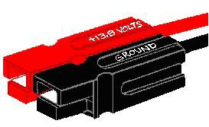
The 30 amp Anderson Powerpole® is quickly becoming the standard power connector of preference within emergency communications organizations around the country. First becoming popular in the Pacific Northwest, the Powerpole® allows for quick field installation and interchange of power supplies and radio equipment without having to resort to adapter cables, clip leads and other jury–rigged arrangements.

Powerpoles® are both polarized and genderless, so you never have to worry about male vs. female or positive vs. negative. Connections can be quickly made and remade in the dark without any hassles and the 30-amp connector can easily handle 100-watt radios.

Housings should be mated according to the diagram above, viewing from the contact side (opposite the wire side), tongue down, hood up, RED on the LEFT, BLACK on the RIGHT. Use a 3/32-inch-diameter roll pin, 1/4 inch long, to keep the housings from sliding apart.

Highly conductive silver-plated copper contacts allow minimal contact resistance at high currents. Self-wiping action on make and break keeps conducting surfaces clean. Contact detents keep connectors mated in high-vibration applications and provide quick-break, snap action upon disconnect.

Non-corrosive stainless-steel leaf springs maintain constant contact pressure, which is ideal for frequent connections and disconnections and for intermittent overloading. Durable, impact-resistant, polycarbonate housings with UL94V-2 flammability ratings come in many colors for circuit trace ability and coding.

Identical connector halves are genderless—making assembly quick and easy and reducing the number of parts stocked. Molded-in dovetails allow for customized harness in a variety of configurations.

The 15-ampere contacts are designed for 16-20 AWG wire and the 30-ampere contacts are designed for 12-16 AWG wire. The contacts can be soldered or crimped to wires. A very inexpensive crimping tool is available from Gardner-Bender (crimp tool #GS-88). After a contact has been attached to a wire, it should be installed into the housing so that the housing spring mates with the underside of the contact.

To remove a contact from the housing, you may use a very small bladed jeweler’s screwdriver or an “X-Acto” knife to depress the spring, allowing the contact to be removed.

I have been using Anderson Powerpole connectors not only for my radios, but for all of my power connections for quite a while, and I am thrilled by their performance. You can get the connector shells in colors other than red and black, so I use the different color combinations for various voltages. For example, I have a car that has a 6 volt system, so I use white and black on any power connections I build for that voltage. In addition to the 15, 30 and 45 amp connectors (which share the same form factor) Anderson Powerpoles come in higher current models. I use some 75 amp connector sets to provide a disconnectable power distribution set that I can move between the house, car and field. Once I get the new car wired, I will be glad to show anyone the layout at one of the gatherings at Caribou Coffee after the Tuesday net when I am there.

Coleman Power Inverters
by Larry, KØLEJ

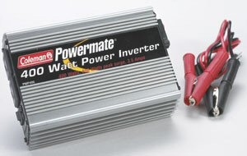

Last year, I completed the three ARRL Amateur Radio Emergency Communication (AREC) classes. For those who are not aware, these classes deal with all aspects of Amateur Radio emergency communications, such as ARES, RACES, American Red Cross, ARRL Sections, message handling, preparation, equipment, safety, etc. One of the underlying themes of all three classes is being prepared to deal with emergencies.

In the Level I class, the subject of equipment is addressed, and part of the equipment is power sources. When most people think of power sources, they immediately think of backup power for their radios, with battery being the most common. Fortunately, most amateur radios operate from 13.8 VDC, and will run very well from a deep cycle battery or even a car battery. There are other devices, such as a computer, that don’t often run from a 13.8 VDC source, however. While most notebook computers do run off internal batteries, the batteries will eventually need to be charged, and many modern laptops use batteries with significantly higher voltages than the 13.8 VDC available from a vehicle’s electrical system, so their DC power supplies require 120 VAC to power them.

For long-term power generation (assuming the power grid is not available), gas-powered generators are often used. But what about the short-term power needs that occur immediately after the communications team is deployed? One low cost and lightweight answer is a “modified sine” wave DC–to–AC inverter. An inverter converts the voltage from a (nominal) 12VDC battery to standard AC voltage (about 110 - 120 VAC). These devices can be purchased in a variety of sizes, with most of them costing less that $100.

In this article, I will discuss two Coleman inverters that I recently purchased. One inverter is a 400 Watt unit and the second is an 800 Watt unit. Before looking at the Coleman inverters, let’s explain what a modified sine wave inverter is. Drawing A shows a standard 60 Hz sine wave. In this drawing you will notice that there is a smooth continuous sine wave that swings positive and negative 60 times per second. This is the type of signal you have at your AC power outlets in your home.

Drawing B shows a “modified sine” wave. Here, you will notice distinctive square wave steps in the waveform as the voltage swings positive and negative. This type of signal is produced by switching DC power on and off to “simulate” or approximate 60 Hz sine wave power. This is the type of power output you will find in low cost inverters (and many computer Uninterruptible Power Supply, or UPS systems).

Drawing A

Drawing B

Which is better? Naturally, the pure sine wave is the best, but it’s also a lot more expensive to generate. Modified sine wave inverters can be purchased for as little as $20. Pure sine wave inverters, on the other hand, cost a lot more money. For example, a 400 Watt modified sine wave inverter is available for $25, while a 300 Watt true sine wave inverter will set you back around $150. (Samlex, the popular supplier of Amateur Radio power supplies, makes a nice series of reasonably priced sine wave inverters.)

What can you power with a modified sine wave inverter? Modified sine wave inverters will run most resistive loads (heaters, incandescent lights, toasters, coffee pots, etc.) easily. They will also run a lot of consumer electronics such as computers, ink-jet printers (but not laser printers), a small television, or radios, to name a few. Most switching power supplies used in a lot of consumer electronics will work with modified sine wave inverters, providing you don’t exceed the power rating of the inverter. Modified sine wave inverters likely won’t run cell phone chargers, rechargeable flash lights, and most frequency–sensitive electronics.

There is one very important thing to remember when using an inverter, and that is the power rating of the inverter and the powered device. For example, many small heating appliances such as coffee pots and toasters are rated at 1000–1500 Watts. You must make sure that your inverter can handle the load. Note that most low–cost inverters, including the ones mentioned here, will not run a coffee maker. It is possible to purchase high power inverters, but the cost is higher, the weight of the unit is greater, and the battery drain is much higher.

Let’s take a look at the Coleman 400 Watt and 800 Watt inverters. I purchased both from Checker Auto after seeing them advertised in the newspaper. The funny thing about Checker Auto is that the prices they charge in the stores are often different than the prices you pay if you purchase on their Web site. To make things even stranger, you can purchase items from their Web site and pick them up in the store. I was able to save over $20 on each inverter by purchasing it on-line and picking it up at my local Checker Auto.

The 400 Watt and 800 Watt inverters look pretty much the same, except for size. Both are enclosed in an aluminum case that acts as a big heatsink. There is a built–in cooling fan that operates continuously whenever the unit is turned on. Both models have dual three-prong AC outlets and a power switch. Safety features include overload protection, under–voltage protection, thermal protection, and polarity protection.

The 400 Watt model provides 400 Watts of continuous power and will provide up to an 800 Watt surge. The package includes a 12V power cord with battery terminal clamps, a second power cord with a cigarette lighter plug and spare fuses. When using the cigarette lighter plug, you must be careful not to exceed the power rating of the jack or plug.

The 800 Watt inverter provides 800 Watts of continuous power and has a 1600 Watt surge capacity. The inverter is a lot larger than the 400 Watt version, and only comes with one heavy duty 12V power cord that has substantial terminal clamps. Clearly the 800 Watt version is designed to be connected directly to the battery. The 800 Watt inverter also has mounting holes in the case if you want to permanently mount the inverter in an appropriate location.

Other than the current capacity, the performance of these two inverters is the same, so the following comments apply to both of them. Setup was very easy. All I had to do was connect the 12V power cord to the five-way binding posts. The AC jacks have rubber covers to protect them when not in use. All that is needed is to properly connect the cable to a 12V battery. If you happen to connect the battery up backward, the inverter beeps to let you know that the polarity is wrong. Once connected to a battery, you turn on the switch and you have AC power.

The first thing I did was check the output with a meter to make sure the voltage was correct. Note that with a modified sine wave inverter you need to use a true RMS volt meter. Non-RMS meters will show an incorrect voltage. Next, I put the inverters on the scope to see what the modified sine wave looked like, and to again verify the voltage. The signal I saw on both was a very clean stair step square-sign wave that had very clean edges.

After verifying that the supplies were working, I plugged in a table lamp and it lit as normal. I figured it was better to burn out a light bulb rather than a computer in case the inverter was not working properly. Next I tried a fan, and it, too, worked. So far, so good. I tried a second variable speed fan, and it did work, but it had a pretty nasty hum coming from the motor. Modified sine wave inverters have problems powering variable speed motors.

I decided to try out the under–voltage protection circuit. I plugged in a fan and ran it until the battery discharged to the point where the inverter turned on its protection circuit. The inverter properly shut down the AC, turned on the fault LED and beeped to let me know there was a problem. This is important, because you don’t want to completely exhaust a lead acid battery. Lead acid batteries are designed to be discharged to a certain point and then recharged. Deeper discharges can damage the battery. Besides, if the battery is discharged too low, how do you plan to re-start the engine if this happens to not be a separate battery from the one that runs your vehicle’s starter?

One of the drawbacks of early inverters, particularly the original square wave models, was the RF hash they produced. Inverters are actually a switching power supply, much like what you find in a lot of Ham shacks. I tested both inverters by placing them next to my Grundig Satellit 800 receiver and running them with and without a load. The 400 Watt version caused virtually no interference, even with the antenna within an inch or two of the inverter. The 800 Watt version caused a slight amount of interference when the Grundig’s antenna was within 15 inches of the inverter, but only when the inverter was under load. I repeated the experiment with my Kenwood HT next to the inverters and there was no interference in either the VHF or UHF band. Frankly, I was surprised to see these low cost inverters not generate boat loads of RF hash.

A couple of caution points: First of all, the inverters are not sealed – make sure that you keep them away from moisture, especially if you plan to mount the inverter permanently or semi-permanently into a vehicle. Like the power outlets in your home, the inverters have lethal voltages at the outlets – make sure to observe the same safety precautions you would with your household power. Don’t exceed the constant or surge power rating of the inverter – pay particular attention to the surge rating of devices with motors.

Small inverters can provide household AC power for short periods of time. For long term power you’re likely better off using a gas powered generator. Overall, I found the Coleman inverters very simple to use, and they seem to be pretty well designed. I have them in my radio jump kit just in case I need AC power some day.

73
Larry, KØLEJ

Some information sources:
majorpower.com, teamproducts.com (Coleman), xantrex.com

Editor (WØJT)’s inverter comments:
- Be sure to test your inverter under conditions that are as close as possible to those you expect to be present when use it. My first inverter use for ham radio was to power an antenna rotator affixed to the roof of my vehicle as a “rover station” in a UHF contest (222 MHz and up). I had no problems with the cheap, “Brand X” inverter on that occasion, but when I tried to use the same setup in a VHF contest rover station (50 MHz and up), I discovered (too late) that the RF hash was unbearable on 50 MHz, and whenever I would transmit on the 2 meter band, the inverter would stop producing AC current! Not the kind of problems you want to discover after driving 170 miles from home to start the contest in a remote grid location!
- A more expensive inverter made by Astron worked much better, both in terms of lower RF hash and immunity to RF fields generated by my transmitter. But it still raises the noise floor perceptibly on 50 MHz.
- In the UHF contest where I was roving with the cheap inverter, I was using a 1296 MHz transverter system that was used, but new to me. The previous owner had installed an 18VDC relay to do T/R (Transmit/Receive) antenna switching, powered by a step-down transformer and simple rectifier from the 120 VAC power supply. The T/R relay worked fine with commercial AC (true sine wave) power, but buzzed and rattled horribly with the “modified sine wave” power from the inverter. I eventually re-built the T/R switching circuit to run on 13.8 VDC power instead, to get around this problem. It is possible that adding a filter capacitor to the original ultra-cheap 18 VDC power supply would also have worked, but I wanted the transverter to be usable even if no AC power was available.
~
2006 Skywarn Classes End
by Jeff, WØKF
TCRC Skywarn Liaison

The last Metro Skywarn Training Class of the 2006 season is being sponsored by the Twin Cities Repeater Club (TCRC), and is scheduled for Saturday, June 10, 2006 in the Council Chambers of Burnsville City Hall at 9:00AM. Interest has been quite heavy, and I predict that we will have a large attendance. Remember, Skywarn training is required every two years, so if you didn’t train last year, this is your last chance to get re-certified for this year!

Our first Metro Skywarn Class, which was held on March 4th, 2006, was well attended (about 35) and the new material was interesting. If you haven’t discovered it yet, the Skywarn Newsletter is located at:

www.skywarn.ampr.org/images/06sprgswnl.pdf

I would encourage everyone to download and read it.

The TCRC is happy to sponsor two Skywarn classes each season and to offer the services of the 147.21 repeater as the primary Skywarn repeater for the South Metro area.
~

My Dayton Trip Highlights
by Craig, KCØDMF

Just about every year, I travel to the Dayton Hamvention® in Dayton, OH. This year, my group consisted of three from Minneapolis and three from Des Moines. Here are some of the highlights of my trip.

This was the first time I took my own vehicle to Dayton. It was the most driving I have ever done in one trip (13 hours one way). I felt that my car and I were up to the challenge.

My vehicle was transmitting my location on APRS on the way to Dayton. Suddenly, someone called for me on the national calling frequency 146.52. What a surprise! They could tell I was nearby because they had been monitoring the APRS packets. It was an unexpected contact that added to the fun of going to Dayton.

This was my first year where I attended some of the seminars. I usually do not do this since it takes away from the "deals" out in the flea market. But it would be a different way to spend the time. I focused on seminars involving digital communication. The most interesting was on WinDRM (a digital voice communication mode), which I will attempt to do at this years Field Day.

I think the biggest event, however, was that two from my group won prizes. My friend's dad, Leroy Baldwin WØOFY, won a book from the ARRL at one of the hourly prize drawings. And at the final drawing, TCRC's very own Artie Johnson WBØJMG won a 2-meter mobile radio. Congrats, Artie!

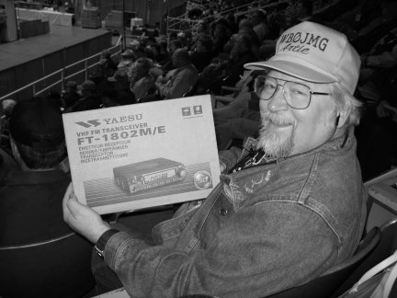

Overall, it was an enjoyable trip with fairly decent weather and good company.

Morse Code by Flashing Light,
An Inexpensive Experiment
by Doug, NAØVY

Have you mastered Morse code yet? Are you ready for another challenge? Being a ham while I was in the Navy, I asked to use the ship’s flashing light for code practice a few times while the ship I was on was underway and within visual range of another ship in our formation. Basically the shipboard device is a spot light that is always on with shutters in front of the light to either let the light through or block it off. In practice, you just point the light towards the receiving ship and send by operating a handle on the side of the light, which operates the shutters. Navy Signalmen have been doing this for years, as you probably have all seen by watching old Navy movies on TV. It works quite nicely at low code speeds.

I wanted to perform an inexpensive experiment using my HF radio to receive Morse code by flashing light. There are various ways to accomplish this, but most are more complicated than what I had in mind. I talked with Artie, WBØJMG, about using an LED on the headphone output and he thought it would be possible.

I measured the voltage across the headphone jack of my rig and found that it read about 2 volts AC. I considered that an LED would only be on during half of the sine wave cycle due to that fact that an LED works like a diode. Artie suggested using two LED’s in parallel so that one would turn on during the positive half of the sine wave and the other would turn on during the negative half. I had performed some experiments some time ago while in school that showed that although the eye and brain combination can actually see higher rates of flashing LED’s, by the time the brain processes the information, a rapidly flashing LED looks like a steady light. Unfortunately, my brain has forgotten what the highest frequency was, but I know it was low. So, I concluded that for a signal in the audio range I would not be able to perceive anything but a steady light.

Next, I considered the voltage drops required for different colors of LED’s and decided to go with red, which has one of the lowest voltage requirements.

I spent a couple of dollars for a pair of 1.8V, 20ma, red LED’s. I plugged in a headphone jack into the rig and put the LED across the jack connectors. While tuned into a Morse code signal, I turned up the volume until the LED lit and I was visually able to see the Morse code by flashing light. I tried two bulbs back to back as I described earlier and other than having more light, there did not seem to be a difference.

A note on looking at the LED: you need to look at it from the top. Looking from the side gives you a light at the base of the LED and a reflection at the top. Looking down at the top of the LED gives much more light and is more uniform in color.

In crowded band conditions, with overlapping CW signals, there would be a problem with receiving more than one signal. The LED would not differentiate between the tone frequencies like your ear can. You can turn on the CW filter on your rig, if you have one, to help solve that problem.

I read a web article written by a deaf person who said he was able to copy 18 WPM by flashing light. Maybe with practice that would be possible, but I have a hard enough time doing that with audio sound. One problem I have is that I handwrite my code copy. It is very hard to do that and watch the light from an LED at the same time. As Artie suggested, maybe I could use it as a heads-up display by some method that would light up a greater area and I would not have to stare at the LED. Also, I found myself humming the dits and dahs when trying to copy the code from the LED, so I guess I was really going from flashing light to audio and then to hand writing the letters. That slows down the speeds you can copy.

I tried to copy 5 words per minute on the W1AW code practice on 40 meters and I would have failed the code test miserably. But I do have an excuse. My excuse is that there was some QRN on the frequency and it was often hard to tell what was a letter and what was not. However, I did copy some words correctly and I am sure with better conditions and more practice I could pass a 5 word per minute code test.

I proved my point that I could easily create a means to see Morse code by flashing light. My only expense was for the LED, since I had an old ¼ inch phone jack in my junk box.
~
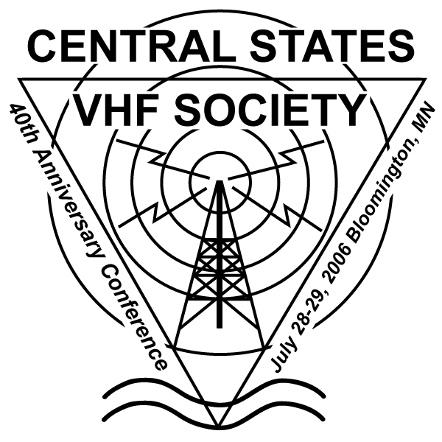 | 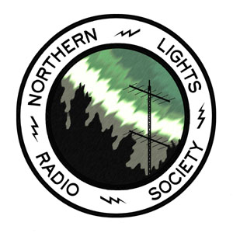

Central States VHF Society
2006 Annual Meeting Draws Closer
by John P. Toscano, WØJT

As I mentioned in the last issue of this newsletter, the Central States VHF Society (CSVHFS) holds a Technical Conference once a year, and this year, for the first time in 10 years, it is being held “in our own backyard” (in Bloomington, Minnesota) rather than somewhere distant like Colorado, Texas, Louisiana, Illinois, Manitoba, etc. The conference provides a forum for Amateurs to present technical papers relating to VHF, UHF, and Microwave operating practices, equipment and station construction, contesting, etc. There are also talks focusing on radio modes such as EME, MS, FAI, E-skip, and other topics that promote operation on Amateur bands above 50 MHz. So if any of these aspects of Amateur Radio sound interesting to you, then this is the year that you have no excuse for missing the conference!

This year’s 40th Anniversary Central States VHF Society Conference is being hosted this year by the Northern Lights Radio Society (NLRS), and will be held on July 28-29, 2006 at the Ramada Mall of America (formerly the Thunderbird Hotel) in Bloomington, MN.

If you did not receive the CSVHFS second mailing with the registration form and other materials of interest, you can find them, and a whole lot more, at the CSVHFS web page, and in particular, at the following URL:
http://www.csvhfs.org/CSVHFS2006.html

You can also learn more about the host club, the Northern Lights Radio Society at their web page:
http://www.nlrs.org

Just some of the activities planned for this year’s conference include:
- Antenna Range: bring one or more antennas (144 MHz and up) and find out what their gain really is.
- Preamp Testing: find out the true specs (gaine, noise figure) on that commercial or homebrew preamplifier you have used or plan to use on your system.
- Rover Row: some hams who engage in VHF & Up contesting in rover mode will show off their vehicles all decked out with radios, transverters, and antennas.
- Dish Pound: get a close-up look at 10 GHz and up microwave systems set up for portable use on tripods, and see different approaches to their construction.
- Poster Sessions: technical talks without the talk – presenters set up a poster describing their topic, and in some cases, “hang out” at the table to answer questions about it.
- Technical presentations: stand-up talks on a variety of topics. Tentative schedule includes:
  - Solar Cycle 24 - What can we expect for 6M Propagation - Carl Luetzelschwab, K9LA
  - Building 24 & 47 GHz LNA's - Paul Drexler, W2PED
  - Upper Midwest Roving Experiences - Tim & Pat Sullivan, KØPG & K9ILT
  - AMSAT: Software Defined Transponders - Tom Clark, K3IO and Bob McGwier, N4HY
  - 10/24 GHz Beacon Project & Brief VHF+ SDR (Software Defined Radio) Update - Mike King, KMØT
  - EN52 Beacons, design and history - Gary Hess, K3SIW
  - Recent Experiences with WSJT - Bill Davis, KØAWU
  - SETI League 1296 MHz EME Beacon - Paul Shuck, N6TX
  - Highly Efficient Feedhorns for Low f/D Dishes & Notes for 13cm EME - Tommy Henderson, WD5AGO
  - SDR Update - New Software Architecture (Open Source) - Gerald Young, K5SDR
  - 3YØX Dxpedition & EME - Gordon Hardman, WØRUN
  - Microwave Equipment Ideas For P3E - Andy Flowers, KØSM
  - A Look Into The Auroral Zone After Ten Years of Study - Jeff Leer, KGØVL
  - Design of a 30" Dual Band Dish & Elevation System - Barry Malowanchuk, VE4MA
  - Technology: From Entry to Extreme Roving - Jim Froemke, K0MHC
  - 40 years of CSVHFS History - Bruce Richardson, W9FZ
  - Twin Cities Microwave Beacons - Dave Kleindl, NØKP
- Flea Market and Dealer/Disrtibutor Tables: better than your typical hamfest, good deals on all kinds of radio-related things.
- Banquet: more than just good food, you are also likely to go home with an outstanding prize!
- Hospitality Suites: several local VHF & Above clubs host opportunities to munch and sip while chatting informally with other hams sharing interest in the bands above 50 MHz.
- Family Programs:
  - Jonathan Padelford boat trip and banquet
  - Mall of America guided tour and self-directed exploration
  - Scrapbooking introduction
  - Trolley ride of historic St. Paul
  - Fort Snelling historical tour

I hope to see you there!
~
DX Basics
by Gary Hosler, WØAW

1) An amplifier is NOT necessary. Put your money into a better antenna!
2) Listen, listen, listen! Don't jump into the middle of a pile up until you have figured out how the DX is working the deserving. Most of the time, they are not working simplex but rather are working split. Calling simplex when the DX is working split will not make you popular with those in the chase.

3) If the DX is saying UP 2 or UP 5, listen to them work several stations to determine any pattern. Many times you can be very effective with modest antennas and power by figuring out how the DX OP is working the pile up. Very often they will take a station UP 1, then UP 2, UP 3, then return to the original UP 1. Learn to stay one step ahead of them.
4) If the DX is working split and announcing UP 5, listen to the pile up. If you hear nothing but chaos and the DX is struggling to maintain control (due to people continuing to call regardless of who the DX comes back to), move up 6 or 7 KHz and call. Many times the DX station can't pick out anything from the pile up so they continue to tune higher until they can pull out a call. Many times I have worked a tough one by moving a good deal higher than the multitude of stations that are calling.
5) Don't depend on the DX Packet Cluster for all of your DX. Many times you can find the DX before they appear on the Cluster and they are far easier to work.
6) NEVER spot the DX to the Packet Cluster until AFTER you have them in the log. If you want to test this, work a DX station that has not been spotted, then spot them to the Cluster and listen to the hoards that show up within 60 - 120 seconds. You don't need to add to your degree of difficulty, work ‘em before you spot ‘em.
7) If the DX is working SPLIT and someone comes on the DX calling frequency and repeats "Who's the DX", or "Where is he listening", or "What’s the QSL Route" … do not respond! Sooner or later they will figure it out. Trying to inform the LID who the DX is will only result in additional QRM for everyone else that is trying to hear them. Never transmit on the DX calling frequency!
8) If the DX comes back to "Who's the W2 Alpha?", if you're not a W2A?? - DON'T CALL! It is common to hear many other call district stations calling regardless of who the DX has just requested, but don't join the hoards of poor operators in this practice. Many of the DX stations have begun the practice of working the K4 or W6 that calls repeatedly when the DX is trying to work a KC0. What the K4 doesn't realize is that his call is in the log, with a note after it saying NO QSL or NIL (Not In Log). Occasionally we will all find ourselves in a situation where the DX is very tough copy and we think we hear our call. Calling out of turn happens every now and then due to poor conditions, but not time after time! Don't fall prey to this bad habit.
9) You want to be a DXer? Avoid DX Nets. They are a poor representation of what working DX is all about. Some will refer to it as spoon fed DXing. The Net Control OP will say "you got the report wrong", (to the DX station) "give it to them again". The DX repeats the report five times and says "Over, Over". The station guesses at the report again and the guess is still incorrect. This cycle repeats until the report is guessed correctly at which point the Net Control OP announces "Dats a Good One" and proceeds to the next station on the list. This is not only instills poor DXing skills but is frustrating to those on the list. They may have good copy on the DX, however by the time this nonsense is repeated over and over again and it finally becomes their turn on the list, the propagation has shifted and the DX is no longer audible. Avoid the Nets and List operations. Hone your operating skills to learn to take advantage of propagation, pile up management, etc.

10) Learn everything you can about propagation, greyline, etc. There are several good (free) tools that will allow you to enter Solar Flux numbers, your location, the DX location, and the program will identify the best times and frequencies to work that particular part of the world. These software programs are a good starting point, however they are not the bible. The gods of propagation work in strange and wonderful ways, allowing a band to open when you would simply not expect it to. Listen, listen, listen!
11) Once you begin to understand propagation, you will learn that there are times of day, and times of the year when "the long path" is active. This is a situation where both stations will beam 180 degrees from the normal (short path) beam heading. Many times you will be amazed at the strength of the received signal when there appears to be no short path propagation.
12) Get to know your friendly neighborhood DXer. Those that have been in the chase for years have picked up many tips that will make your DXing experience more enjoyable in the long run. Share your "needed" list. Many times this will result in a phone call that alerts you to the DX frequency and allows you to work them before others show up.
In short, you don't need a world class station with multiple towers and monoband yagis swinging in the wind to work DX. Keep in mind that DX is different things to different people. If you are limited to VHF/UHF, DX could be the next state away. If you are an HF operator that is antenna challenged, Worked All States could be a reasonable challenge. Don't let others dictate what constitutes DX. I will never work 300 countries on 160 Meters, but that’s OK. It doesn't diminish my fun because I can't have a 4 element monoband yagi on 80 Meters. It's all about the challenge of working a rare one and having fun doing it.
Reprinted with the permission of Gary Hosler (WØAW), and the Stillwater Amateur Radio Association.

DX GLOSSARY

1) DX - DX is a common term for a distant or rare station.
2) If the DX is saying UP 2 or UP 5 - In other words, the DX station is instructing those trying to contact them to transmit UP 2 KHz or 5 KHz from their frequency.
3) the pile up - A large gathering of stations that are all trying to work the DX station.
4) working the pile up - This describes the DX station working or contacting the many stations that are calling.
5) working split - Describes not working simplex, or on the same frequency that the DX is transmitting on, but rather transmitting a few KHz up from the frequency that the DX station is using to transmit on. In short, the DX station has so many stations calling them on their frequency that people can't hear who the DX station is calling. Working split frequency keeps the DX transmitting frequency clear so everyone can hear who the DX is calling.
6) the DX Packet Cluster - A packet radio (or Internet) network that is used to inform people what DX stations are active, and on which frequency.
7) spot the DX to the Packet Cluster - Send notification to the network what frequency a particular DX station is operating on.
8) you have them in the log - A log is document (either paper or computer) which is used to record your station activity. The above statement would indicate that you have made a QSO or contact with the station (and exchanged signal reports) and have recorded that information in the log (callsign, date, time, signal report send and received).
9) a DX station that has not been spotted - The DX station has not been announced to the DX Packet Cluster (network).
10) then spot them to the Cluster - Send the DX station’s call and operating frequency to the DX Packet Cluster.
11) “Who's the DX?” - What is the callsign of the DX station?
12) “the QSL Route” - Who do you send a QSL card to for confirmation of the contact or QSO. In the case of a station in a remote location that does not get mail on a regular basis, the DX station may make arrangements in advance to have another station (the route) handle the QSL card activity for them. Thus, you would mail your QSL card to a station that differs from the station that you made the contact with.
13) the LID - LID in Ham Radio speak defines a poor operator, or one with inconsiderate operating habits.
14) If the DX comes back with “Who's the W2 Alpha?”, don’t reply if you're not a W2A - If W2ABC is calling the DX station (along with many other stations), and the DX station can only hear part of the callsign and the DX station responds “Who is the W2 Alpha?”, he is looking for a station whose callsign begins with W2A to respond (in this example W2ABC). If the DX responds “Who is the W2 Alpha?”, he does not expect to hear KCØSNV calling him.
15) K4 or W6 - K4 is the prefix of a call sign generally associated with the southeastern part of the United States. W6 is the prefix of a call sign generally associated with the state of California.
16) work a KCØ - Make a contact with a station whose call sign begins with KCØ.

17) in the log - You have made a contact or QSO with a station, exchanged signal reports, and have recorded that information in your station log (either paper or computer variety).
18) DX Nets - A group that meets on a specified frequency with the intent to work DX. A “Net Control” operator takes a list of DX stations that wish to join the group. The “Net Control” station then announces to all stations listening on the frequency, which DX stations have joined the Net. At that point, the Net Control station will take a long list of stations that have an interest in making a contact with one of the DX stations on the list.

19) Net Control – “Net Control” is the self-appointed Big Dawg that controls who works the DX, and how the signal report exchange is managed.
20) List operations - Very similar to a DX Net. There are several variations on the “List” operation. The first is where a station will take a list of callsigns of stations that want to have a contact with a DX station. Very often the DX station will show up at some specified date and time, and call the station that is managing the list for them. The station managing the list will then go down the list one by one and tell the stations to call the DX and exchange signal reports. While this creates less chaos for the DX station, it generally results in very poor results. When the list was taken, there were many stations that wanted to work the DX station. Unfortunately, the stations on the list have no idea whether or not they will have favorable propagation (conditions) to the DX station by the time that the DX station finally shows up on frequency. It becomes a mess when the DX station shows up and half of the people on the list can't hear the DX. If that’s not bad enough, there may also be many stations that are not on the list who can hear the rare DX, but can't get on the list. The second scenario is when the DX station will take a list of stations that they can pick up from the many that are calling until they have gathered a list of 20 or 30 stations. They will then work each station until the list is complete and then take another list.
21) greyline - This describes a period of time, either side of sunrise/sunset when signal propagation is enhanced. The time will vary (although generally an hour either side of sunrise/sunset) and the effect is more pronounced on the lower frequencies.
22) Solar Flux numbers - In addition to broadcasting the correct time, the National Bureau of Standards (ex. stations such as WWV) broadcast the SFI or Solar Flux Index. The Solar Flux is a measure of the amount of solar activity which can adversely impact or enhance radio propagation. A detailed description of the Solar Flux and “A” and “K” index is outside the bounds of this article.
23) “the long path” - If you live in the state of Maine and want to have a contact with a station in France, you would normally point a directional antenna (beam, yagi, quad, etc.) directly at France (about 45 degree heading). When long path propagation is in effect, stronger signals would be heard when pointed the opposite direction (or roughly 225 degrees). In other words, you are communicating by sending your signals the long way around the earth. At certain times of year, this path is much stronger than by using the short path. This only works when both stations (you and the DX) are pointing your antennas on a long path heading.
24) your “needed” list - If you are down to needing a few countries, the ones that you still need defines your “needed” list. If you are in need of a few countries that are expected to become active in the next few months, share the needed list with some friends. If they should hear the DX stations on the air, they can give you a phone call (a/k/a landline) to inform you where to find the station.

Reprinted with the permission of Gary Hosler (WØAW), and the Stillwater Amateur Radio Association.

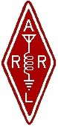 | Twin Cities Repeater Club, Inc.  P.O. Box 11534  St. Paul, MN 55111-0534 |  | Place  Stamp  Here

Your Membership Dues Have Expired.
Please Renew your Membership Today!

Join the Twin Cities Repeater Club!
P.O. Box 11534, St. Paul, MN 55111-0534
http://www.tcrc.org
Fill out this Membership Application Form, and mail it with your check for $25.00 payable to the Twin Cities Repeater Club, to the mailing address listed above. You can also fill out this form electronically at the web address listed above, and either send us a check, or pay online using the PayPal system.
Name Callsign License Class
Address City State Zip
Home Phone Work Phone Computer Phone
Ok to list your address in club publications? ___No ___Yes
Ok to list your phone in club publications? ___No ___Yes
Are you available for Emergency Service? ___No ___Yes
Are you a member of the ARRL? ___No ___Yes
Are you a member of Metro Skywarn? ___No ___Yes, spotter ID:___________________________________
Are you a member of ARES? ___No ___Yes
Would you like an autodial speed dial number? ___No ___Yes, to phone #___________________________________
Would you like a club ID badge? ___No ___Yes (free to new members, otherwise $5.00)
What is your internet e-mail address, if any? ___None
Would you like an e-mail alias set up, so that mail sent to yourcallsign@tcrc.org gets redirected to the e-mail address you listed above? This can be handy on the air! ___No ___Yes
Do you want a copy of the TCRC Handbook? ___No ___Yes (add $9.50, which includes postage)
Do you want a TCRC binder to hold it? ___No ___Yes (Add $5.50 to the above)
This is ___New Application ___Renewal ___Other Change __Callsign update, old call was ________________________ ________________________

