The Repeater | 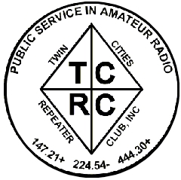
The Official Publication of the Twin Cities Repeater Club, Inc.

Mission Statement of the Twin Cities Repeater Club, as Adopted on September 20, 1993
The purpose of the TCRC is to facilitate the local communication needs of its members by owning and operating a state of the art wide area coverage two meter repeater system. The club will further involve itself in secondary activities intended to (1) Promote the exchange of ideas and information related to amateur radio, (2) strengthen the fellowship and camaraderie among the members, (3) serve the local amateur radio community, and (4) increase local public safety.

Spring, 2004
Volume 27, Number 1

Inside this issue

Mission Statement 1
President Haralson Resigns 1
Quarterly Membership Meeting 1
Repeater Etiquette Reminder 1
President’s Report 2
AERO Class 3
Minnesota VOAD Seminar 3
Tornado Season Approaches 4
Fire Extinguisher ABC’s 4
Emergency Services Net 5
Welcome New Members 5
Emergency Equipment List 6
Burnsville CERT Class 6
HF Mobile, First Installations 7
Portable Ham Radio Operation 8
MFJ-259B Antenna Analyzer 9
Membership Application 10

Remember!

TCRC Quarterly Membership Meeting

Tuesday, March 23rd
Burnsville City Hall
6:30 PM Coffee & Cookies
7:30 PM Meeting begins

Talk-in available during the TCRC Info Exchange Net, 147.21 MHz
Please Join Us!

President Shanon Haralson (KCØEIG) Resigns
Board of Directors Selects Replacement

Shanon Haralson, KCØEIG, who has served as TCRC president for the last few years, submitted his resignation to the Board of Directors, citing his lack of time to devote to club issues, due to the stresses of owning and running his business. Vice-President Phil Lefever (KBØNES) immediately stepped in as acting President, and on Monday, March 15, 2004, he was selected by Board to take Shanon’s place as president for the remainder of the term. Since that move also created a vacancy on the Board of Directors, the Board selected Steve Filek (NØOWL) to fill that vacancy.

The Board wishes to express its gratitude to Shanon for all his hard work in the past as President and as a club member in general, and they wish him the best of luck in all his future endeavors.

~

Quarterly Membership Meeting

The regular quarterly TCRC membership meeting will occur on March 23 at 7:30 PM (right after the net). All members (current and prospective) are encouraged to attend. Come early (6:30 PM) for coffee and cookies. The official meeting begins at 7:30 PM. The location is Burnsville City Hall, in the Basement Meeting Room. Please join us for this meeting.

~
Repeater Etiquette Reminder

All four of the TCRC repeaters, but particularly our flagship system on 147.21 MHz, have many user functions that can be accessed with a DTMF keypad on your radio. Although the FCC identification requirements only mandate that you give your callsign at the end of your block of transmissions, or every 10 minutes, the Control Operators of the WØBU repeaters respectfully insist that you identify at the beginning of every repeater function, so that they know that a legitimate access attempt is underway, rather than malicious interference. Simply say, for example, “KCØXYZ to access” before hitting those DTMF keys. (Use your own callsign, of course!) If the Control Operators hear repeated attempts to access repeater functions without identification, they will usually ask you to identify yourself, but if they feel that a hacking attempt is underway, they may simply shut off the repeater to foil the attack. Thanks for your cooperation, and please enjoy the repeaters.
The Repeater is published quarterly by the Twin Cities Repeater Club, Inc. (the TCRC). The TCRC is organized as a nonprofit corporation in the State of Minnesota, with Articles of Incorporation and Bylaws. The club elects officers annually. These officers are simultaneously elected for a two-year term on the Board of Directors. The Repeater Trustee is a permanent member of the Board of Directors. Unlike the other Officers and Board Members, the Trustee may select a proxy to serve in his place at meetings of the Board. Membership in the TCRC is $25 per year. The TCRC is an official ARRL affiliated society.
TCRC Officers:
President: Phil Lefever, KBØNES
Vice President: Steve Filek, NØOWL
Secretary: Jim Rice, NØOA
Treasurer: Pat Cain, KØPC
Board Members:
All of the above Officers, plus…
Ivan Frantz, WØBU, Repeater Trustee
Ivan has currently appointed Mogens Dantoft, OZ9MD, as his proxy for Board Meetings.
Kevin Uhlir, NØBEL
John Toscano, WØJT
Janet Skovran, KBØZFB
Mark Neuman, KCØITP
Technical Committee (a/k/a Tech Team):
Kevin Uhlir, NØBEL, Chair
Phil Lefever, KBØNES, Vice Chair
Doug LaBore, NØBIS
Mike Ferguson, NØDGG
Rich Kenney, WØRFK
John Toscano, WØJT
John Phelps, KFØZM
Steve Filek, NØOWL
Field Day Committee:
Phil Lefever, KBØNES, Chair
Kevin Uhlir, NØBEL, Site Setup Manager
Monica Filek, KBØUWZ, FØOD Station Manager
Information Services Committee:
Kevin Uhlir, NØBEL, Chair and Head Webmaster
Phil Lefever, KBØNES, Assistant Webmaster
John Toscano, WØJT, Assistant Webmaster
Jeff Goodnuff, WØKF, Web Calendar Maintainer
Membership Committee:
Mark Neuman, KCØITP, Co-Chair
Pat Cain, KØPC, Co-Chair
Newsletter Committee:
John Toscano, WØJT, Editor

Net Control Operators:
Kevin Plummer, KBØUEU, Chair, 1st Tuesday
Ian Boje, KCØITQ, 2nd Tuesday
Thomas Gagnon, KBØDCO, 3rd Tuesday
Phil Lefever, KBØNES, 4th Tuesday
John Toscano, WØJT, 5th Tuesday

Metro Skywarn Liaison:
Jeff Goodnuff, WØKF

Minnesota Repeater Council Liaison:
Jeff Goodnuff, WØKF
President’s Report
by Phil Lefever, KBØNES

Hello all, and welcome to 2004! It’s early in the year, and things are already busy. The TCRC has some interesting irons in the fire for this year.

First of all, I regret to inform you that Shanon, KCØEIG, the elected TCRC president for 2004, has resigned from his position as president and board member. His personal business commitments have increased to the point where he felt he could no longer give the club enough time. He will still be around to help out, though. Filling the vacant position will be a board of director’s decision at the March 15th meeting board meeting. Until that point I will be acting as the interim president. (Editor’s note: Phil was selected by the board to fill Shanon’s position as president for the remainder of the term, and Steve Filek, NØOWL was selected to fill the vacant board position at the Board Meeting of March 15th.)

With the return of spring-like weather, the road up the hill to the repeater site is now passable again. The Tech Team has been doing a few upgrades to several of the repeater systems. The multiple receive site levels of the 147.21 repeater are now much more closely balanced and the voter action is much improved also. The new 6 meter repeater had a hiccough and developed a noisy audio signal. The problem was traced to a failed receiver preamplifier on the link receiver that wasn’t needed anyhow. It was removed from the circuit, and now the repeater has the same excellent audio as when it was first installed.

The club has also started a changeover process for our web hosting. Kevin, NØBEL’s company Flochart Software, will provide the new hosting. The main advantage of the change is better system access for administration. Look for new content and functionality from www.tcrc.org

Also we have started to seriously look into the possibility of forming a club station! This would give us all a common meeting place along with the ability for new or antenna restricted Hams to get on the air. It is also an opportunity to become better involved with the City of Burnsville, by using the facility to offer license classes and possibly VE testing sessions. Also, the location could serve as an emergency operations center (EOC) if the need would ever arise. As we move farther down the path, we will likely form a club station committee. Stay tuned for more!

Finally, a subject that has been a concern of mine for some time is the declining activity level in the club and amateur radio in general. Everybody (the FCC, ARRL etc.) seems to have a proposal for a solution for the general activity levels. Only time will tell if they are right. On a more local level, involvement with the TCRC is in all of our hands. It can be as simple as just turning on the radio more often or checking into the Tuesday night Information Exchange net. When the repeaters are quiet, fewer and fewer people tune in to them looking for a conversation. Another possibility is simply attending club functions like breakfast, coffee or membership meetings. For those that have more time to volunteer, we can always use help with a number of different club tasks. What we all get out of a club is the sum of what we all put into it. Just imagine what could be done if every member just participated a small amount — the outcome would probably surprise us all! It’s the membership that drives the direction and involvement of any club. What would you like to see the TCRC do to make amateur radio in the area more fun, more useful and more educational? The TCRC organization is like a lump of clay… We are looking for a few hands to help sculpt ;)

73, Phil KBØNES
Association of
Emergency Radio Organizations
(AERO) Class on 02/28/2004

by Janet Skovran, KBØZFB

The AERO (Association of Emergency Radio Organizations) class was run by Dan Pietso on February 28th, 2004 in Blaine MN. The basic function of the AERO class is for all attendees to receive training on running or being part of an emergency net.

The morning portion of the class included information on what the basic equipment to bring to a 3 day “go bag”. The minimum basic equipment for any disaster is as follows: You, your radio, extra batteries or power supply, your antenna(s) (different heights), microphone and/or earphones, radio manual, money and always identification. The 24-hour go bag would contain the above plus the following: Water, food/snacks, any medication you need, small personal first aid kit, flashlight with extra batteries, weather–appropriate clothing, TP, paper, pens/pencils, a small alarm clock and personal toiletry items. The three-day go bag is as follows: Minimum requirement, extend the contents of the 24-hour bag out for 3 days, add in a week’s worth of medication, electrical and duct tape, components to create and/or repair coax. Any TCRC member who has taken the CERT training can add the disaster supply kit to this. Always remember that what seems to be a minor situation can become a major disaster with no warning. Keep your 3-day bag handy.

The morning training included a presentation of MIMS (Minnesota Incident Management System) by Tim Butler, the Emergency Communications Center for the St. Paul Police Department. Tim gave us a short overview including the command structure in the form of a flow chart. The basic command structure can use the acronym CFLOP: Command, Finances, Logistics, Operations, and Planning. Under Command is the FLOP portion, with their own little boxes and lines to Command. Each FLOP portion will have boxes under them with a line to each box. Tim believes that for each box representing a function on the flow chart there should be an amateur radio operator for communication purposes. Any TCRC member who has taken the CERT training is familiar with CFLOP and the flow chart.

The class was informed that anyone who wants can take the 16 hour MIMS class given by the State of Minnesota, Department of Homeland Security and Emergency Management, can do so. You can get further information from the web page of www.hsem.state.mn.us or you can contact Suzanne Donnell the State Training Officer at:

State Training Officer
Homeland Security and Emergency Management
444 Cedar Street, Suite 223, St. Paul MN 55101
Telephone: 651-296-0472 or 651-296-2233
email: suzanne.donnell@state.mn.us

The afternoon portion was taken up with a disaster net. Each net controller was ideally a 3 person team; net control, secretary and runner. All message traffic was passed using common language. For example, “City Manager to Net Control, I have a message for Public Works Director”, give the message, (break it up in one or two sentence bursts if it is long or say it again if it is short) and then your call sign.

The radio operators are interchangeable during the time span of the disaster. You are not going to be working the radios for 24 to 72 hours straight without relief. So as to not confuse anyone, use the person’s job title or common language as opposed to your call sign. We are just the message facilitators. Say the message as given, if a professional wants to use acronyms, use them, do not change the message. We don't need to understand the message traffic we pass along, we just need to accurately pass the message traffic along.

During the disaster net everyone was given a “person” to shadow. There were separate nets, one for the portions of CFLOP that we were using. Message traffic was passed from your “person” to another “person”. After all participants were given their assignment, we were told to disperse around the building (inside or out). Each “script” gave a time frame for you to contact net control with a message to pass on to another “person”. During this time, you also received messages that you had to respond to.

One of the skills that is required during a disaster net is the ability to talk slowly and clearly when relaying message traffic. Another is remembering that unless you have a message to pass, stay off the radio. You always have to go through the net control before you get a message and before you give a message. Unless directed by net control you don't talk "person to person".
~
Minnesota Voluntary Organizations
Active in Disaster (VOAD)

Joint Agency Seminar
by Janet Skovran, KBØZFB

On Saturday, February 21st, 2004, the Minnesota Voluntary Organizations Active in Disaster (VOAD) held their 2004 Joint Agency Seminar, entitled “Facing The Threat of Terrorism Together”. This event was held at the Salvation Army's Lakewood Temple Corps, in Maplewood, MN.

The topics discussed included “What Volunteer Agencies Learned After 9-11” and “Minnesota Threats - From Within and From Without”. These two programs were for all attendees. There were three breakout sessions during the day, with a choice of three different topics for each session. The topics ranged from “55th Civil Support Team - Minnesota Prepares for Terrorism” to “Animals in Terrorist Disasters”.

All of the discussions I attended had similar threads running through them. Most government agencies do not have enough resources (mostly people) to manage an emergency. In disaster situations, all have relied upon volunteers to assist – whether it is a formal volunteer agency like the Salvation Army or Red Cross, or ordinary individuals who simply show up to help. Most agencies train their volunteers so that they have the skills, knowledge and abilities to achieve the goal of the agency. Most volunteers who show up do not have any skills, knowledge or abilities, and must be trained prior to helping the existing volunteers.

One of the big topics was credentialing the volunteers from local groups. It was recommended that you keep a laminated list (or more than one copy) to be given to whoever is in charge of providing IDs for the disaster site. The local groups should also have a picture ID with the minimum following information: clear picture, full name and organization name. This is necessary, as it will streamline the process for a disaster ID. As in the case of 9-11, some disasters will require more than one ID card to get you into specific areas at the disaster site. Another important thing to remember is that not all people who show up to volunteer will get credentialed for access to the disaster site. Some volunteers will be turned away, because they, for any number of reasons, are not suitable to be there.

The other issue was communication. Most volunteer groups lack the equipment to communicate with each other or with the professionals. Which leads to the suggestion to get your local EMS/Firefighter/Law Enforcement officials to become amateur radio operators.

The MN VOAD conducts these seminars on a yearly basis and encourages anyone who belongs to an organizational member group to attend. A number of TCRC members are VOAD members if you belong to any of the following organizations: ARRL, Skywarn, Citizen Corps (CERT) and of course Red Cross and Salvation Army. For more information on MN VOAD, you can go to: www.mnvoad.org.

~

Tornado Season Approaches
by Jeff Goodnuff, WØKF, TCRC Skywarn Liaison

Spring is coming, and with spring comes tornado season. That reminds us of the need for all Metro Skywarn Weather Spotters to recertify every two years. So, if you didn't take a Skywarn class last year, you need to take one this year. The TCRC sponsored Skywarn class was held on Saturday, March 6, 2004, and was very well-attended. But don’t worry if you missed that one. There are many more classes still available. Most of them are free and open to all interested persons. The complete class schedule can be found at: www.skywarn.ampr.net.

The Skywarn class is four hours long and consists of lots of photos of storm conditions and interesting videos of past events. There is a short, multiple-choice quiz at the end. Topics covered include the recognition of reportable conditions, how to observe storms safely, how to communicate your observations to the Skywarn net, net procedures, and all sorts of neat stuff.

73 and have a safe summer
Fire Extinguisher ABC’s
by John Toscano, WØJT
As mentioned in another article in this issue, a fire extinguisher is an important item to have on hand for emergency preparedness. Do you know the ABC’s of fire extinguishers? Typical fire extinguishers are rated according to their ability to fight Type A fires (ordinary combustibles, such as wood, paper, cloth, rubber, and plastics); their ability to fight Type B fires (flammable liquids, such as oils and gasoline; and combustible liquids, such as charcoal lighter fluid and kerosene); and finally, their ability to be used safely in the presence of energized electrical circuits (Type C rating). There are also highly specialized extinguishers that the ordinary consumer would not need to be concerned with, such as a Type D extinguisher for combating a fire consisting of combustible metals like magnesium.
The Type A and Type B ratings are given a numerical value. The larger the value, the larger the fire of that type that the extinguisher can fight. The numerical scales for the Type A and Type B capabilities are not comparable, so an extinguisher rated as 2A10B is not necessarily capable of fighting a Type B fire that is 5 times as large as a Type A fire. This rating actually means that the extinguisher has the same firefighting capacity on a Type A fire as a 2.5-gallon water extinguisher, and that it is able to extinguish approximately a 10 square-foot Type B fire. “A” ratings typically range from 1 to 40, and “B” ratings typically range from 1 to 640.
The Type C rating is an all-or-none affair. The device is either safe to use on an electrical fire (has a Type C rating), or it is unsafe to use on an electrical fire (does not have a Type C rating). Typically, the issue of Type C capability is related to whether or not the extinguishing agent conducts electricity (and could cause the firefighter to be electrocuted).
A water-containing extinguisher is unsafe on flammable liquids and conducts electricity, making it unsafe on electrical fires, hence it will have only an A rating.
Dry chemical extinguishers typically have either a BC rating (usually containing sodium or potassium bicarbonate), or an ABC rating (typically monoammonium phosphate).
For fires in sensitive electrical equipment, Halon used to be the agent of choice due to lack of residue on the equipment, but due to ozone depletion concerns, it is no longer readily available, and alternatives such as Halotron are available. Carbon dioxide extinguishers are popular because they leave no residue, but they are poor at fighting Type A fires.
To use a fire extinguisher, remember the acronym: “P A S S” – Pull the safety pin, Aim at the base of the fire, Squeeze the trigger or handle, and Sweep across the fire until it is out.
For maximum personal safety, be sure you have two exits before starting to fight a fire, don’t get too close, don’t enter a smoke-filled area, and work with a buddy!

Proposed
Amateur Radio Emergency Services Net
for Burnsville, Minnesota
by Artie Johnson, WBØJMG

- Purpose: To set up a flexible structure that is easy to implement and modify as needed for backup communications.
- Structure: How the Amateur Radio Service will be set up when needed.
  - Directed Net: The first implementation will be a directed net with a net control operator.
    - Calling List: The Emergency Manager for Burnsville will make the decision to call out the Amateur Radio Operators. They will maintain a calling list of people who are trained as Net Control Operators. They will call persons on the list until one is reached who can operate as net control.
    - Net Control Stations: The Net Control Operator will start a directed net on the 147.21 MHz repeater system. The Net Control operator will make a call for volunteers as needed by the requirements of the EOC, who will be deployed as needed to facilitate communications.
    - Location of Net Control Station: The Net control station may be located anywhere, initially. Since they are setting up the communications network, they can be anywhere. It is desirable to move the location of the Net Control to physical location of the EOC, but the EOC station may not be Net Control.
    - Location of other stations. The EOC and Net Control will direct Amateur Stations to various locations as needed.
    - Communications control: All stations must call Net Control to be checked in and out. All communications must go through Net Control. Net Control can direct stations to pass messages on frequency or to go to another frequency to converse. When Stations are finished with off frequency operation, they must re-check in with Net Control to show they are ready for more communications.
    - Net Control: The Net Control operator can change the structure of the net to Peer-to-Peer, if the traffic load is light. Or the Net Control operator can shut down the net as needed.
  - Peer-to-Peer Net: All stations are equal and can call each other.
    - Communications Control: First come, first served. Each station can call another station and transact communications quickly, then leave the frequency open for the next call.
- Callsigns: Use of location names is desirable, as long as the FCC call signs are transmitted in accordance with the FCC requirements (a minimum of once every 10 minutes of ongoing activity, or at the end of a conversation). Say “Firehouse One calling Police Station” or similar, as required. Use common language for all message traffic.
- Frequencies:
  - Primary: 147.210 MHz (repeater with input of 147.810 MHz) will be the primary frequency.
  - Secondary: If the 147.210 MHz repeater is not in service, use 147.210 MHz Simplex (both transmit and receive) as the secondary frequency. Net Control will announce, “All stations use 147.210 MHz Simplex” several times.
  - General Frequency: Use 146.520 MHz as a general simplex frequency. Since this is the National 2 meter FM calling frequency, most Amateurs with 2 meter FM capability will have this frequency installed already.
  - Other Frequencies: Other simplex frequencies may be used during the Emergency Net. The Net Control will announce to all what frequencies will be used, and for what purposes.

~

Welcome, New Members!
The Twin Cities Repeater Club would like to welcome the following fine folks who have joined our organization since the last newsletter. Listen for them on the air, and give them a friendly TCRC Hello!

Callsign | Name | Residence
WØCRT | Joe Kadlec | Farmington
KCØREO | Kris Christenson | Owatonna
KCØRGD | Eric Moe | Woodbury
KCØCAP | Dan Gelle | Litchfield
KØSEY | Shane Young | Minneapolis

Emergency Equipment List
Compiled by
Artie Johnson, WBØJMG and
Janet Skovran, KBØZFB

Radio Equipment

Collection of materials needed by Net Control and remote stations.
- Mobile transceiver with power supply
- Handheld radio(s)
- Extra batteries or power supply
- AC wall adapter / charger for batteries
- Cigarette lighter adapter for radio
- Antennas, dipole antenna and coax cable. A 38-Inch dipole and suitable coax and adapters for a handheld radio. String, suction cups, duct tape, and other materials suitable to connect dipole to window or wall or tree or other structure that is higher or more clear of obstructions.
- Microphone, earbud earphones

Other Equipment

Collection of materials for an emergency kit for car/home.
- A supply of water (1 gallon per person per day)
- A supply of non-perishable packaged or canned food and a manual can opener
- A change of clothing, rain gear, sturdy shoes, including winter clothing (3 days)
- Blankets or sleeping bags
- A first aid kit, manual and prescription medications
- Personal hygiene items
- An extra pair of glasses/contacts and supplies
- A battery-powered radio, flashlight and plenty of extra batteries
- Broadcast radio receiver and/or Public Service scanner
- Cell phone
- Credit cards and cash
- Identification
- An extra set of car keys
- A list of family physicians
- A list of important family information
- A contact list for long–distance relatives
- Jumper cables
- Fire extinguisher (5 lb ABC Type)
- Maps
- Shovel
- Tire repair kit and pump
- Flares
- Water, food, bedding, medications, leash and supplies for pets (remember, public shelters do not take pets)

This is only a suggested list of items. For more information on disaster supply kit lists, and how to make a disaster family plan, go to www.ready.gov and www.fema.gov.

Burnsville CERT

(Community Emergency Response Team) Training for TCRC Members
by John Toscano, WØJT

If you attended the last meeting of the Twin Cities Repeater Club on December 9th, 2003, you recall that Burnsville Firefighter Russ Lalim gave a brief presentation on the CERT program, and invited TCRC members to sign up for a class. Thanks to the groundwork done by Janet Skovran, KBØZFB, Russ set up a class just for us, unlike most of his other classes, which were open to anyone in Burnsville or the surrounding community.

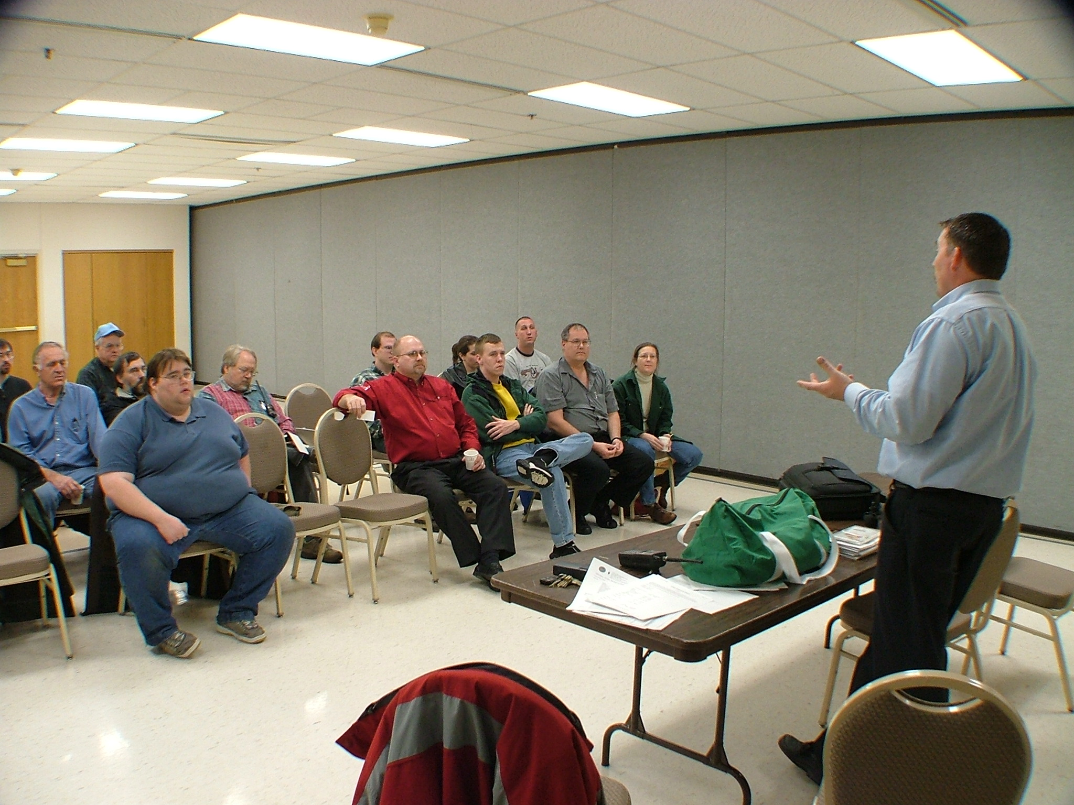

About a dozen of us signed up, and attended the classes. The training began on Wednesday, January 14th, 2004, and ran to completion on Wednesday March 17th, 2004. We had two weeks off before the final class, due to scheduling conflicts, so the total class time was 8 weeks, at 3 hours per week, or 24 hours total. The classes were team-taught by Bill D’Agostino and Russ Lalim.

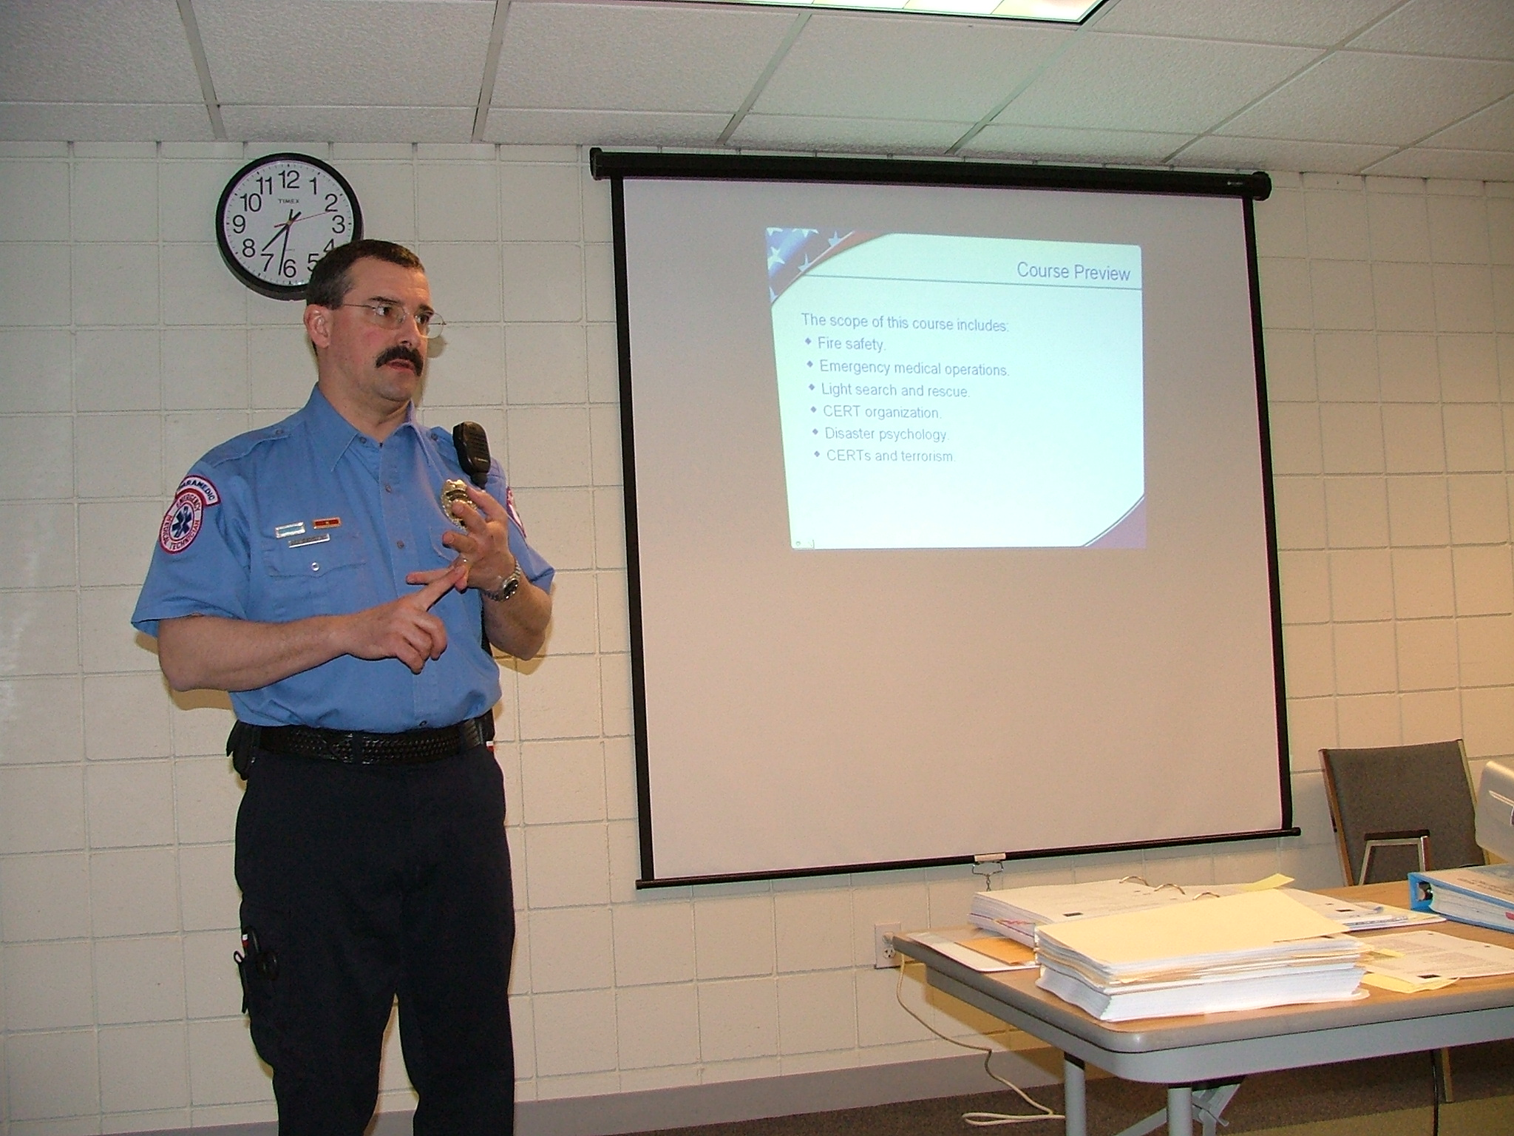
Some of the sessions were designed as traditional lectures, and others had a much more hands-on approach.
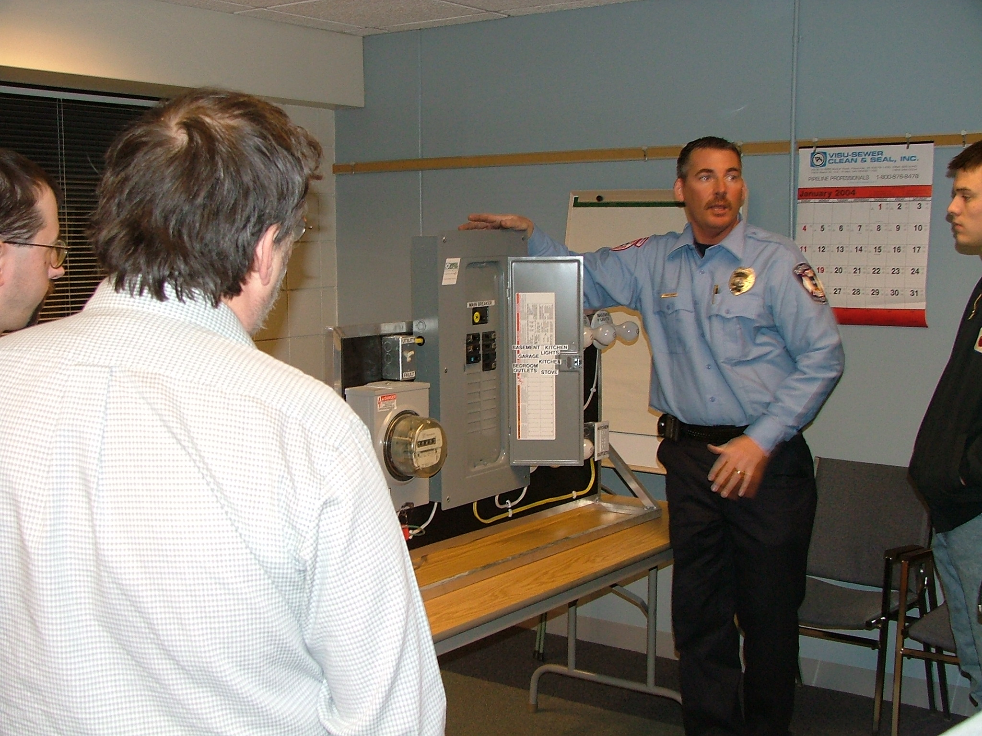
In the photo above, Russ is showing the class the proper way to safely shut off electrical utility service to a building that has been damaged in a disaster. This might be necessary if electrocution hazards or fire were hampering the rescue of the structure’s occupants.
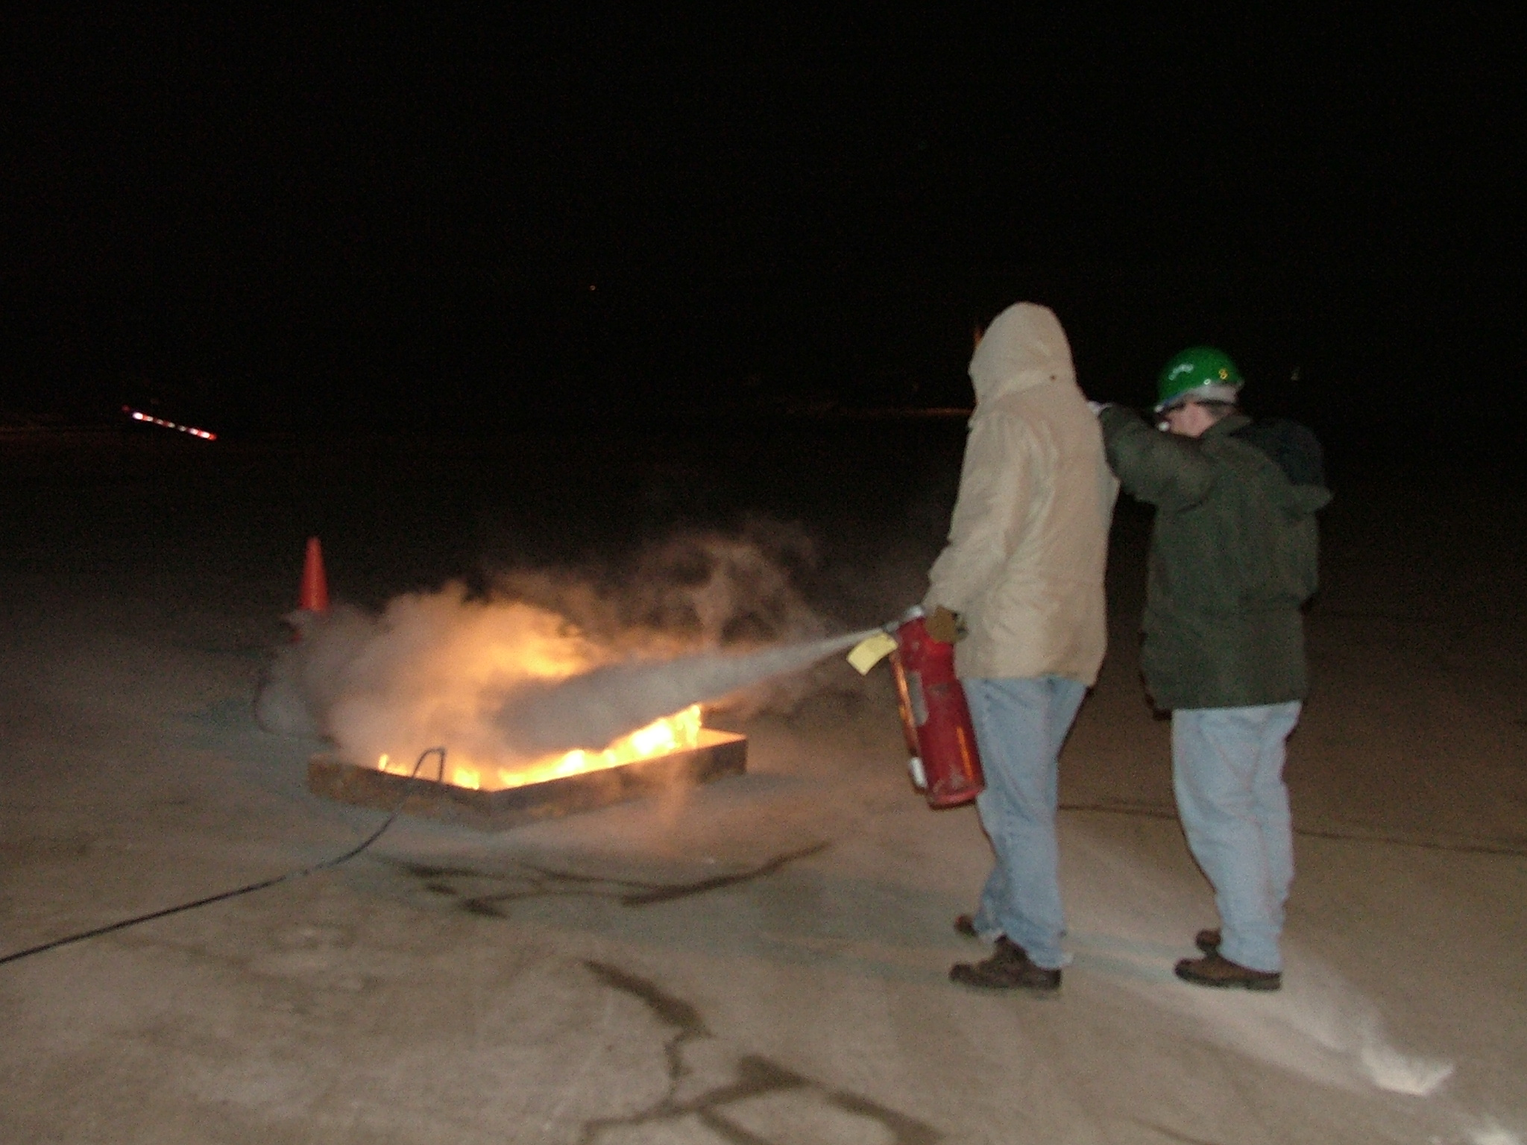
We also got some hands-on training in the proper use of fire extinguishers. Of course, the night that this exercise was originally scheduled happened to be a night with severely cold weather, so we postponed this outdoor exercise to the second-to-last week of the class. It was still pretty cold out there!
The last session was devoted to a simulated disaster exercise. All of the participants and instructors were greatly pleased at how well the exercise was executed, and how much benefit we derived from bringing along our handheld radios to stay in communication during the whole search/rescue/medical care simulation. The “Incident Commander” was in constant contact with all of his teams, and the teams used their radios instead of “runners” to convey progress reports, request materials needed to perform a rescue, etc. It was a great culmination to a great course.
If you are interested, more CERT classes are planned for the future, and you are encouraged to sign up!

HF Mobile, First Installations
by Jim Rice, NØOA

Antenna restrictions in your neighborhood, not enough time to operate from the home QTH, lots of time in the car traveling to and from work locations, heading out on an extended vacation, or just looking for the next challenge in this cornucopia that we call HAM radio? Then HF mobile deserves a look. In this article, I will review some of my personal experiences and lessons learned when I decided to delve into HF mobile.

So, why did I get started? I have always been a HAM that likes to operate in a variety of locations. Scouting has been the source of that love. For that reason, I have a fairly good collection of mobile HF equipment because mobile HF equipment is a lot easier to set up in tents and on picnic tables that my base set. My Icom IC-706MkIIG, antenna tuners and Hamsticks are all made for mobile operation. In fact, this equipment spent most of its time in the back of my Explorer ready for the next campout. But, when I had the occasion to be in South Dakota on business, and it looked like I was going to miss “a sched” with a friend of mine because I wasn’t going to make it home on time, I decided it was time to start installing this equipment in my car for mobile operation.

My mobile HF installation has evolved over time. So, let me walk through the various steps of the installation process.

The obvious source for coax and power to get my mobile HF setup running was to use the connections for my Yaesu FT-90 radio. By using these connections, I could switch in the 706 when I needed it and swap it back out when I wanted to use the FT-90. The challenge with this solution is the FT-90 is mounted in a rear wheel well of my Explorer and connected with a remote head kit to the front of the car. While I own a remote head kit for the Icom IC-706, the path to the front of the car is FAR too long for the 706 remote head kit… But, I’ll deal with one challenge at a time.

Since my first installation was made “on the fly”, it was a pretty makeshift setup. First of all, I needed an antenna mount. So I disconnected the coax from my Yaesu FT-90 UHF/VHF radio and connected it to the 706, and I replaced the 5/8-wave antenna with a Comet UHV-6 HF antenna. The mount that I use for the 5/8-wave antenna is the biggest “trunk lip” mount that Comet makes, and it is more than capable of hosting the UHV-6 antenna. The UHV-6 HF antenna has been a nice field antenna for me and (most importantly) I happened to have the NMO to PL259 adapter that I needed to allow it to fit on the mount. With my antenna on the top of the car, I was ready for the next step.

Power. Power is one of the biggest challenges for HF mobile operation. The 15 to 20 amp draw that is needed to run at 100 watts can be tricky. This isn’t something that you ever want to pull from a cigarette lighter outlet. Likewise, the power that I had in the back of the Explorer was taken from the battery with 18 gauge wire. When I hooked this up to the 706 (easy to do since all of my power connectors are Anderson Power Poles) and keyed CW, the voltage dropped from 12.5 volts to nearly 8 volts. Not a good thing at all. So, I hooked up the car battery to a deep cycle marine battery that I had in the back of the car, and hooked the 706 up to the deep cycle marine battery. This kept the deep cycle battery charged from the car, and kept the power at 13.8V to the radio – even under load. This isn’t something that I really wanted to keep in place long term. But, it worked great for my temporary installation.

I tuned in to one of the 3905-Century Club nets and listened along. The received signal was far better than I expected. Not as good as those dipoles at home, but what I could hear was perfectly readable. However, when I keyed up the radio I realized the SWR was worse than I had expected. So, I pulled the AT-180 antenna tuner out of the box and hooked it up to the IC-706. The AT-180 is an unbalanced antenna tuner and it takes its power from the radio. So, this hookup went quickly. It sure added to the pile of cable and connections in the back of my Explorer. But, one touch of the tune button on the radio and I had a perfect SWR match.

Now, I’ve been sitting in the back of my Explorer for about 45 minutes – actually at a truck stop – hooking all this stuff up in my car, and I want to get back onto the road and make some progress on my drive. But, my radio is all in the back of the car. So, it was time to add to the cable tangle and hook up the remote head kit for the IC-706. This head is pretty easy to hook-up. The biggest trick is to NOT lose that little screw that holds everything together. So, that little screw got taped to the radio with a chunk of ever-present duct tape. The cable was draped over the back seat up to the front, and I was on the road again.

Now, the astute HF mobile operator will notice right away what I forgot to take care of in this installation. After making my first couple of contacts on the 20 meter county hunter net, my radio started to turn itself off, randomly change frequency and mode, and in general, act like it was losing its mind. Yep, you got it (probably faster than I did) – I forgot to ground this whole setup. I had a radio, long lengths of power cord, a tuner, a remote head kit – all floating along an infinite ground plane. Frankly, I’m lucky I didn’t damage the radio. So, a stop at another truck stop and some screwdriver time with a chunk of turn signal wire and I was back on the air operating happily without a hitch.

So, that’s the story of how I got started with HF mobile. I have since run much better power to the radio directly from the car battery, moved the radio and tuner under the back seat of the Explorer. I’ve run a separate coax and antenna mount (putting my FT-90 back in service). Last but not least, I routed the remote head kit so that the radio head is mounted overhead in a convenient location for driver operation. I’ve also added a CW key to the installation. But, all of that is fodder for another newsletter article. In the meantime, consider giving HF mobile a try and we can talk about your experiences on the 147.21.
73 from NØOA

Portable Ham Radio Operation
by Mark J. Neuman, KCØITP

A new facet to the Ham radio hobby is portable, and especially man mobile, HF operations. The explosive growth in this type of operation has been made possible by radios like the Yaesu FT-817, which is a small, battery operated, full-featured HF radio, that allows you to transport an HF rig just about anywhere with ease. Now I realize that you could have hauled your FT-100 or IC-706 into the field a long time ago, but these rigs, and the large batteries needed to power them, are not something I would want to carry for any great distance.
Once the FT-817 came out, many hams came up with a number of portable antenna concepts. One that seems to have taken hold is the “buddipole”, which was invented by Bud, W3FF (see www.buddipole.com). This antenna can either be purchased or home brewed (www.qsl.net/w3ff), as I have done, out of PVC pipe and a Radio Shack antenna whip. This antenna can be broken down into short packable sections, which are then re-assembled at your operation site to provide a resonant dipole. This removes the need to bring along an antenna tuner. I made a number of design changes to my homebrewed buddipole. First, I made it a full-length dipole for 10, 12 and 15 meters. Second, I made the 17 and 20 meters loading coils larger in diameter, in order to try to improve efficiency. Finally, I used threaded pipe ends instead of slip ends, which, in my opinion, strengthened the antenna and make it less likely to wiggle loose when used man mobile. I have been quite pleased with the performance of this antenna, and antenna performance is very important when operating QRP.
So now what do you do? Well, pack up your radio, a small battery if you want or need, your portable antenna set up, and take a hike, as short as the nearest picnic table or as long as the middle of the BWCA. At the other end, you assemble your antenna, hook it all up, tune to 18.157.5 or 14.342.5 (among other calling frequencies), and call CQ HFPACK.
What is HFPACK?? It is a group of hams interested in portable operations, including man mobile HF, that get a kick out of long distance low power operations from interesting locations. They can be found at www.hfpack.com.
I, for one, enjoy the great outdoors. Portable operations allow me to be radio-active in the field, or even on the picnic table on my deck. My portable set up consists of a Yaseu FT-817, a 7.5 amp hour gel cell battery, my buddipole antenna, coax, and a Heil Traveler headset. All of this gear fits into a small gym bag. As a Boy Scout leader, I have had the opportunity to operate from a number of field locations, and I am looking forward to portable operations from the BWCA this summer.
So if you hear me calling CQ HFPACK, give me a shout (even if you are at home), and if you are interested in portable operations yourself I can be reached at kc0itp@tcrc.org. I am ready to share my experiences and ideas, and am always looking for a reason to go camping.

MFJ-259B Antenna Analyzer
by Larry Jenkins, KØLEJ

Toys, Toys and Toys (He who dies with the most toys wins?)

Last week, I purchased a used MFJ-259B Antenna Analyzer to add to my “toy” collection. For those who are not familiar with it, the MFJ-259B analyzer is used to help in building and troubleshooting antennas in the HF and VHF bands. I write this after only having played with the new toy for a short time, about one hour. This article describes my initial impressions and observations. I will write a more detailed analysis once I get a chance to use the features beyond the most basic of functionality. I do realize that most antenna work should be done in the cold harsh winter, but I’m going to risk waiting until the weather warms up a bit before doing some serious work.

Is an antenna analyzer really needed?

I have been looking at purchasing an antenna analyzer for the past several months. Like a lot of people, I have a radio that has a built in SWR indicator that gives you an “idea” of what the antenna is doing. I have noticed that this feature is on most recent-vintage radios, but I have also noticed that the SWR indicator only shows if there is (or is not) a reasonable level of match, but not detailed values. To help in figuring out what my antennas are doing I purchased the standard SWR meters for both HF and VHF. These meters generally worked well in showing how closely the antenna systems are matched to the radio. The “big” drawback to using a standard SWR meter is that I needed to transmit a signal to make use of the meter. I am not too keen on generating QRM just to play with home made antennas, so an antenna analyzer seemed like a good investment.

What does an antenna analyzer do?

The MFJ-259B is a pretty feature-rich device that allows you to measure and tune antennas without having to generate a lot of interference on the bands. MFJ states that the 259B analyzer reads SWR, complex RF impedance, resistance, reactance and phase. The analyzer can also be used to test coax loss, coax length, inductance, capacitance as well as host of other tests. Overall, this represents a pretty big suite of tests from a small 7” box that can be purchased for a little over $200 (MFJ also sells it directly for $259.95). For those who are limited in the amount they want to spend, MFJ offers other lower cost models starting at $74.95. The lower cost models are called “SWR Analyzers” and are very useful for building and tuning antennas. The lower cost analyzers don’t offer the advanced features found in the MFJ-259B (or MFJ-269), but if your need is to simply configure your antenna these lower cost solutions will likely work just fine.

My initial observations:

I live in an “antenna restricted” community where we are not allowed to have any outside antennas. My current antenna configuration consists of two Hamsticks in a home made dipole mount that sits in a tripod on the deck attached to the back of my house. For 2 Meter FM, I built a J-pole out of 300 Ohm twin lead. The J-pole is hanging on the inside of a screened in porch out the back of the house. Talk about an “antenna farm” in the cities!!

I initially hooked up the analyzer to the Hamstick dipole antenna and set the band switch to the proper setting. I turned on the analyzer and rotated the tune know until the display showed the lowest SWR reading. To my surprise, the frequency shown on the display was 14.180 MHz., pretty much where I expected it to be. Very nice. I also found that the antenna had a 2:1 SWR for almost the entire phone section of the 20 Meter band. Not bad for tuning with the SWR indicator built into the radio.

The second antenna, the 2 Meter J-pole, didn’t fare so well. The ideal frequency for that antenna was 151 MHz. -- just a wee bit out of our allowed frequencies. Even at that frequency, the SWR was fairly high at 1.7:1. At our favorite frequency of 147.210/147.810 the SWR was 2.3:1 – still workable, but getting to the point were the radio is likely folding back the RF output. Using the analyzer I was able to make “minor” adjustments to the antenna, but when you only are working with six or so small wires on either side of a 300 Ohm twin lead (Menards special) you can’t expect too much bandwidth. After a bit of playing with the antenna configuration, I finally decided that I should undergo the time-tested rite of passage, and build a “plumber’s delight” for use on 2 Meters. Maybe I can squeeze that project in one of these first weekends!

What I learned after an hour of playing:

The MFJ-259B is a fantastic toy! I was able to see the resonant frequency of the antenna system (antenna and coax), the match at the desired frequency, and the bandwidth of the antenna system. All of this was accomplished in just a few minutes, without having to use a radio or creating QRM.

I didn’t have time to play with a lot of the advanced features of the analyzer. I hope to do some more experimenting in the coming weeks. After I get more comfortable with the analyzer, I’ll write a more extensive review of the MFJ-259B. I plan to also include information on the newer MFJ-269 analyzer that includes UHF capabilities along with some other lower cost options for those that want to tune antennas on a budget. Stay tuned….
MFJ-259B  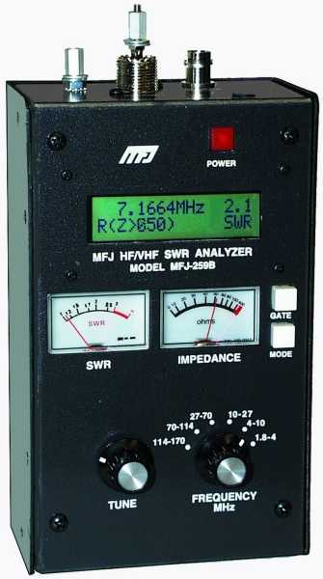 | MFJ-269  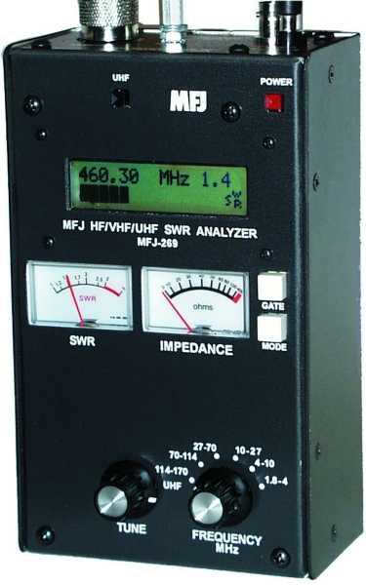

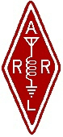 | Twin Cities Repeater Club, Inc.  P.O. Box 11534  St. Paul, MN 55111-0534 |  | Place  Stamp  Here

Your Membership Dues Have Expired.
Please Renew your Membership Today!

Join the Twin Cities Repeater Club!
P.O. Box 11534, St. Paul, MN 55111-0534
http://www.tcrc.org
Fill out this Membership Application Form, and mail it with your check for $25.00 payable to the Twin Cities Repeater Club, to the mailing address listed above. You can also fill out this form electronically at the web address listed above, and either send us a check, or pay online using the PayPal system.
Name Callsign License Class
Address City State Zip
Home Phone Work Phone Computer Phone
Ok to list your address in club publications? ___No ___Yes
Ok to list your phone in club publications? ___No ___Yes
Are you available for Emergency Service? ___No ___Yes
Are you a member of the ARRL? ___No ___Yes
Are you a member of Metro Skywarn? ___No ___Yes, spotter ID:___________________________________
Are you a member of ARES? ___No ___Yes
Would you like an autodial speed dial number? ___No ___Yes, to phone #___________________________________
Would you like a club ID badge? ___No ___Yes (free to new members, otherwise $5.00)
What is your internet e-mail adress, if any? ___None
Would you like an e-mail alias set up, so that mail sent to yourcallsign@tcrc.org gets redirected to the e-mail address you listed above? This can be handy on the air! ___No ___Yes
Do you want a copy of the TCRC Handbook? ___No ___Yes (add $9.50, which includes postage)
Do you want a TCRC binder to hold it? ___No ___Yes (Add $5.50 to the above)
This is ___New Application ___Renewal ___Other Change __Callsign update, old call was ________________________

